# CREDIT SUISSE GROUP AG (CS) - SNP500 - FTSE100

INSIGHTS INTO THE UK AND US ECONOMIES USING MACHINE LEARNING TECHNIQUES SUCH AS LINEAR REGRESSION AND NEURAL NETWORKS, BASED ON STOCK MARKET DATA.



Kiran Basnet

1. CREDIT SUISSE BACKGROUND

Credit Suisse is a Swiss multinational investment bank and financial services company that was founded in 1856. The company has a long history of providing banking and financial services to individuals, corporations, and governments around the world.

In recent years, Credit Suisse has been facing significant financial problems, which have put pressure on the global banking system. One of the key issues has been the recent takeover of Credit Suisse by its larger rival UBS, which resulted in the investment of bondholders being wiped out. The bondholders who owned about $17 billion of risky Credit Suisse debt were left with nothing after the takeover.

The problem at Credit Suisse centers around the hierarchy of who should lose out first when a bank struggles. On one hand, investors who bought risky AT1 bonds (Additional Tier 1 bank debt) should expect to lose money when a bank runs into trouble. However, there are questions because Credit Suisse’s shareholders will not be wiped out completely but are set to be compensated in the emergency takeover with UBS shares worth the equivalent of Sfr 0.76 (£0.67) a share.

AT1 bonds, also known as Additional Tier 1 bonds, are a type of debt instrument issued by banks to raise capital. They are hybrid securities that combine characteristics of both bonds and equity, and are designed to increase the safety buffers of banks in times of financial stress. If a bank's capital levels fall below a certain level, the AT1 bonds can be converted into equity, which helps to reduce the bank's debts and increase its capitalization. These bonds were introduced after the 2008 financial crisis as a way to "bail in" failing banks, by imposing losses on investors rather than relying on taxpayer-funded bailouts. As a result, AT1 bonds are considered riskier than other types of debt, and investors are typically offered a higher return to compensate for this risk.

In [ ]:

**import** yfinance **as** yf **import** pandas **as** pd **import** numpy **as** np

**import** matplotlib.pyplot **as** plt

**import** seaborn **as** sns **import** requests **import** lxml

**import** appdirs **import** pytz **import** frozendict

**from** bs4 **import** BeautifulSoup

**import** html5lib

**import** pandas_datareader **as** pdr

**from** sklearn.cluster **import** KMeans **from** sklearn.decomposition **import** PCA **import** tensorflow **as** tf

**import** keras

**from** keras.models **import** Sequential **from** keras.layers **import** Dense **import** torch

**import** xgboost **as** xgb

**import** ta

**import** warnings warnings**.**filterwarnings("ignore")

To assess the financial stability of companies like Credit Suisse, we can perform various analyses using tools like Python. For example, we can use Python to perform a financial ratio analysis, which would involve calculating various ratios such as the debt-to-equity ratio, the current ratio, and the return on equity. This analysis would give us a good understanding of the company's financial health and help us determine whether it is likely to face any financial problems in the future.

Another useful tool for predicting the financial stability of companies is machine learning algorithms. For example, we could use algorithms like decision trees, random forests, and neural networks to analyze the financial data of companies and make predictions about their future performance. These algorithms could be trained on historical financial data and used to identify patterns and trends in the data. This would allow us to make more informed decisions about investing in companies like Credit Suisse.

## U.S MARKET

The S&P 500 can have a significant impact on the global economy due to the sheer size and influence of the US economy, which is the largest in the world. The performance of the S&P 500 can affect not only the US economy but also other countries and regions that are closely tied to the US economy through trade, investment, and other forms of economic activity.

When the S&P 500 performs well, it can boost investor confidence and lead to increased investment in the US economy, which can, in turn, stimulate economic growth and job creation. A strong US economy can also increase demand for goods and services from other countries, thereby supporting economic growth around the world.

Conversely, when the S&P 500 performs poorly, it can have negative ripple effects on the global economy. A decline in the US stock market can reduce investor confidence and lead to a reduction in investment and economic activity, both in the US and in other countries that are closely tied to the US economy.

Moreover, the S&P 500 can serve as a bellwether for broader trends in the global economy. Changes in the index can reflect shifts in consumer behavior, changes in the regulatory environment, and other factors that can have far-reaching impacts on the global economy.

In [2]:

df **=** pd**.**read_csv('https://pkgstore.datahub.io/core/s-and-p-500-companies/ df**.**tail()

Out[2]:

Symbol Name Sector

500 YUM Yum! Brands Consumer Discretionary

501 ZBRA Zebra Technologies Information Technology

502 ZBH Zimmer Biomet Health Care

503 ZION Zions Bancorp Financials

504 ZTS Zoetis Health Care

In [3]:

df**.**to_csv('SNP500.csv')

In [4]:

df**.**columns **=** df**.**columns**.**str**.**lower() companies **=** df**.**name**.**unique() companies

Out[4]:

array(['3M', 'A. O. Smith', 'Abbott Laboratories', 'AbbVie', 'Abiomed', 'Accenture', 'Activision Blizzard', 'ADM', 'Adobe',

'Advance Auto Parts', 'Advanced Micro Devices', 'AES Corp', 'Aflac', 'Agilent Technologies', 'Air Products & Chemicals', 'Akamai Technologies', 'Alaska Air Group', 'Albemarle Corporation

',

'Alexandria Real Estate Equities', 'Align Technology', 'Allegion'

,

'Alliant Energy', 'Allstate Corp', 'Alphabet (Class A)', 'Alphabet (Class C)', 'Altria Group', 'Amazon', 'Amcor', 'Ameren Corp', 'American Airlines Group',

'American Electric Power', 'American Express', 'American International Group', 'American Tower', 'American Water Works', 'Ameriprise Financial', 'AmerisourceBergen', 'Ametek', 'Amgen', 'Amphenol',

'Analog Devices', 'Ansys', 'Anthem', 'Aon', 'APA Corporation', 'Apple', 'Applied Materials', 'Aptiv', 'Arista Networks', 'Arthur J. Gallagher & Co.', 'Assurant', 'AT&T', 'Atmos Energy', 'Autodesk', 'Automatic Data Processing', 'AutoZone',

'AvalonBay Communities', 'Avery Dennison', 'Baker Hughes', 'Ball Corp', 'Bank of America', 'Bath & Body Works Inc.',

'Baxter International', 'Becton Dickinson', 'Berkshire Hathaway', 'Best Buy', 'Bio-Rad Laboratories', 'Bio-Techne', 'Biogen', 'BlackRock', 'BNY Mellon', 'Boeing', 'Booking Holdings', 'BorgWarner', 'Boston Properties', 'Boston Scientific',

'Bristol Myers Squibb', 'Broadcom',

'Broadridge Financial Solutions', 'Brown & Brown', 'Brown–Forman'

,

'C. H. Robinson', 'Cadence Design Systems',

'Caesars Entertainment', 'Campbell Soup', 'Capital One Financial'

,

'Cardinal Health', 'CarMax', 'Carnival Corporation',

'Carrier Global', 'Catalent', 'Caterpillar', 'Cboe Global Markets

',

'CBRE', 'CDW', 'Celanese', 'Centene Corporation', 'CenterPoint Energy', 'Ceridian', 'Cerner', 'CF Industries', 'Charles River Laboratories', 'Charles Schwab Corporation', 'Charter Communications', 'Chevron Corporation',

'Chipotle Mexican Grill', 'Chubb', 'Church & Dwight', 'Cigna', 'Cincinnati Financial', 'Cintas Corporation', 'Cisco Systems', 'Citigroup', 'Citizens Financial Group', 'Citrix Systems', 'Clorox', 'CME Group', 'CMS Energy', 'Coca-Cola Company', 'Cognizant Technology Solutions', 'Colgate-Palmolive', 'Comcast', 'Comerica', 'Conagra Brands', 'ConocoPhillips',

'Consolidated Edison', 'Constellation Brands', 'Copart', 'Corning

',

'Corteva', 'Costco', 'Coterra', 'Crown Castle', 'CSX', 'Cummins', 'CVS Health', 'D. R. Horton', 'Danaher Corporation',

'Darden Restaurants', 'DaVita', 'Deere & Co.', 'Delta Air Lines', 'Dentsply Sirona', 'Devon Energy', 'DexCom', 'Diamondback Energy'

,

'Digital Realty Trust', 'Discover Financial Services',

'Discovery (Series A)', 'Discovery (Series C)', 'Dish Network', 'Dollar General', 'Dollar Tree', 'Dominion Energy',

"Domino's Pizza", 'Dover Corporation', 'Dow', 'DTE Energy', 'Duke Energy', 'Duke Realty Corp', 'DuPont', 'DXC Technology', 'Eastman Chemical', 'Eaton Corporation', 'eBay', 'Ecolab', 'Edison International', 'Edwards Lifesciences', 'Electronic Arts'

,

'Eli Lilly & Co', 'Emerson Electric Company', 'Enphase Energy', 'Entergy', 'EOG Resources', 'Equifax', 'Equinix',

'Equity Residential', 'Essex Property Trust',

'Estée Lauder Companies', 'Etsy', 'Everest Re', 'Evergy', 'Eversource Energy', 'Exelon', 'Expedia Group', 'Expeditors', 'Extra Space Storage', 'ExxonMobil', 'F5 Networks', 'Facebook', 'Fastenal', 'Federal Realty Investment Trust', 'FedEx', 'Fidelity National Information Services', 'Fifth Third Bancorp', 'First Republic Bank', 'FirstEnergy', 'Fiserv', 'Fleetcor', 'FMC Corporation', 'Ford', 'Fortinet', 'Fortive',

'Fortune Brands Home & Security', 'Fox Corporation (Class A)', 'Fox Corporation (Class B)', 'Franklin Resources',

'Freeport-McMoRan', 'Gap', 'Garmin', 'Gartner', 'Generac Holdings

',

'General Dynamics', 'General Electric', 'General Mills', 'General Motors', 'Genuine Parts', 'Gilead Sciences',

'Global Payments', 'Globe Life', 'Goldman Sachs', 'Halliburton', 'Hanesbrands', 'Hasbro', 'HCA Healthcare', 'Healthpeak Properties

',

'Henry Schein', 'Hess Corporation', 'Hewlett Packard Enterprise', 'Hilton Worldwide', 'Hologic', 'Home Depot', 'Honeywell', 'Hormel

',

'Host Hotels & Resorts', 'Howmet Aerospace', 'HP', 'Humana', 'Huntington Bancshares', 'Huntington Ingalls Industries', 'IBM', 'IDEX Corporation', 'Idexx Laboratories', 'IHS Markit', 'Illinois Tool Works', 'Illumina', 'Incyte', 'Ingersoll Rand', 'Intel', 'Intercontinental Exchange',

'International Flavors & Fragrances', 'International Paper', 'Interpublic Group', 'Intuit', 'Intuitive Surgical', 'Invesco', 'IPG Photonics', 'IQVIA', 'Iron Mountain', 'J. B. Hunt',

'Jack Henry & Associates', 'Jacobs Engineering Group', 'JM Smucker', 'Johnson & Johnson', 'Johnson Controls',

'JPMorgan Chase', 'Juniper Networks', 'Kansas City Southern', "Kellogg's", 'KeyCorp', 'Keysight Technologies', 'Kimberly-Clark'

,

'Kimco Realty', 'Kinder Morgan', 'KLA Corporation', 'Kraft Heinz'

,

'Kroger', 'L3Harris Technologies', 'LabCorp', 'Lam Research', 'Lamb Weston', 'Las Vegas Sands', 'Leggett & Platt', 'Leidos', 'Lennar', 'Lincoln National', 'Linde', 'Live Nation Entertainment

',

'LKQ Corporation', 'Lockheed Martin', 'Loews Corporation', "Lowe's", 'Lumen Technologies', 'LyondellBasell', 'M&T Bank', 'Marathon Oil', 'Marathon Petroleum', 'MarketAxess', 'Marriott International', 'Marsh & McLennan',

'Martin Marietta Materials', 'Masco', 'Mastercard', 'Match Group'

,

'McCormick & Company', "McDonald's", 'McKesson Corporation', 'Medtronic', 'Merck & Co.', 'MetLife', 'Mettler Toledo', 'MGM Resorts International', 'Microchip Technology',

'Micron Technology', 'Microsoft', 'Mid-America Apartments', 'Moderna', 'Mohawk Industries', 'Molson Coors Beverage Company', 'Mondelez International', 'Monolithic Power Systems',

'Monster Beverage', "Moody's Corporation", 'Morgan Stanley', 'Motorola Solutions', 'MSCI', 'Nasdaq', 'NetApp', 'Netflix', 'Newell Brands', 'Newmont', 'News Corp (Class A)',

'News Corp (Class B)', 'NextEra Energy', 'Nielsen Holdings', 'Nike', 'NiSource', 'Norfolk Southern', 'Northern Trust', 'Northrop Grumman', 'NortonLifeLock',

'Norwegian Cruise Line Holdings', 'NRG Energy', 'Nucor', 'Nvidia'

,

'NVR', 'NXP', "O'Reilly Automotive", 'Occidental Petroleum', 'Old Dominion Freight Line', 'Omnicom Group', 'Oneok', 'Oracle', 'Organon & Co.', 'Otis Worldwide', 'Paccar',

'Packaging Corporation of America', 'Parker-Hannifin', 'Paychex', 'Paycom', 'PayPal', 'Penn National Gaming', 'Pentair',

"People's United Financial", 'PepsiCo', 'PerkinElmer', 'Pfizer', 'Philip Morris International', 'Phillips 66',

'Pinnacle West Capital', 'Pioneer Natural Resources',

'PNC Financial Services', 'Pool Corporation', 'PPG Industries', 'PPL', 'Principal Financial Group', 'Procter & Gamble', 'Progressive Corporation', 'Prologis', 'Prudential Financial', 'PTC', 'Public Service Enterprise Group', 'Public Storage', 'PulteGroup', 'PVH', 'Qorvo', 'Qualcomm', 'Quanta Services', 'Quest Diagnostics', 'Ralph Lauren Corporation',

'Raymond James Financial', 'Raytheon Technologies', 'Realty Income Corporation', 'Regency Centers',

'Regeneron Pharmaceuticals', 'Regions Financial Corporation', 'Republic Services', 'ResMed', 'Robert Half International', 'Rockwell Automation', 'Rollins', 'Roper Technologies',

'Ross Stores', 'Royal Caribbean Group', 'S&P Global', 'Salesforce

',

'SBA Communications', 'Schlumberger', 'Seagate Technology', 'Sealed Air', 'Sempra Energy', 'ServiceNow', 'Sherwin-Williams', 'Simon Property Group', 'Skyworks Solutions', 'Snap-on', 'Southern Company', 'Southwest Airlines', 'Stanley Black & Decker

',

'Starbucks', 'State Street Corporation', 'Steris',

'Stryker Corporation', 'SVB Financial', 'Synchrony Financial', 'Synopsys', 'Sysco', 'T-Mobile US', 'T. Rowe Price',

'Take-Two Interactive', 'Tapestry', 'Target Corporation',

'TE Connectivity', 'Teledyne Technologies', 'Teleflex', 'Teradyne

',

'Tesla', 'Texas Instruments', 'Textron', 'The Cooper Companies', 'The Hartford', 'The Hershey Company', 'The Mosaic Company', 'The Travelers Companies', 'The Walt Disney Company',

'Thermo Fisher Scientific', 'TJX Companies',

'Tractor Supply Company', 'Trane Technologies', 'TransDigm Group'

,

'Trimble', 'Truist Financial', 'Twitter', 'Tyler Technologies', 'Tyson Foods', 'U.S. Bancorp', 'UDR', 'Ulta Beauty',

'Under Armour (Class A)', 'Under Armour (Class C)',

'Union Pacific', 'United Airlines', 'United Parcel Service', 'United Rentals', 'UnitedHealth Group',

'Universal Health Services', 'Valero Energy', 'Ventas', 'Verisign

',

'Verisk Analytics', 'Verizon Communications',

'Vertex Pharmaceuticals', 'VF Corporation', 'ViacomCBS', 'Viatris

',

'Visa', 'Vornado Realty Trust', 'Vulcan Materials',

'W. R. Berkley Corporation', 'W. W. Grainger', 'Wabtec', 'Walgreens Boots Alliance', 'Walmart', 'Waste Management', 'Waters Corporation', 'WEC Energy Group', 'Wells Fargo', 'Welltower', 'West Pharmaceutical Services', 'Western Digital', 'Western Union', 'WestRock', 'Weyerhaeuser',

'Whirlpool Corporation', 'Williams Companies',

'Willis Towers Watson', 'Wynn Resorts', 'Xcel Energy', 'Xilinx', 'Xylem', 'Yum! Brands', 'Zebra Technologies', 'Zimmer Biomet', 'Zions Bancorp', 'Zoetis'], dtype=object)

In [5]:

us_500 **=** []

ticker **=** df**.**symbol**.**unique()

**for** i **in** ticker: us_500**.**append(i)

In [6]:

us_500[:10]

Out[6]:

In [7]:

['MMM', 'AOS', 'ABT', 'ABBV', 'ABMD', 'ACN', 'ATVI', 'ADM', 'ADBE', 'AAP ']

[*********************100%***********************] 505 of 505 completed

*# Load the data into a pandas DataFrame*

us_price_data **=** yf**.**download(us_500, start**=**"2023-03-13", end**=**"2023-03-20") us_price_data**.**dropna(axis**=**1, inplace**=True**)

21 Failed downloads:

* NLOK: No timezone found, symbol may be delisted
* DISCK: No timezone found, symbol may be delisted
* VIAC: No timezone found, symbol may be delisted
* FBHS: No timezone found, symbol may be delisted
* KSU: No timezone found, symbol may be delisted
* BF.B: No data found for this date range, symbol may be delisted
* BRK.B: No timezone found, symbol may be delisted
* BLL: No timezone found, symbol may be delisted
* PBCT: No timezone found, symbol may be delisted
* WLTW: No timezone found, symbol may be delisted
* DRE: No timezone found, symbol may be delisted
* NLSN: No timezone found, symbol may be delisted
* ABMD: No data found for this date range, symbol may be delisted
* TWTR: No data found, symbol may be delisted
* FB: No timezone found, symbol may be delisted
* CERN: No timezone found, symbol may be delisted
* ANTM: No timezone found, symbol may be delisted
* INFO: No timezone found, symbol may be delisted
* DISCA: No timezone found, symbol may be delisted
* CTXS: No timezone found, symbol may be delisted
* XLNX: No timezone found, symbol may be delisted

In [8]:

us_price_data**.**shape

Out[8]: (5, 484)

In [9]:

df_weekly **=** pd**.**DataFrame(data**=**us_price_data) df_weekly**.**columns **=** df_weekly**.**columns**.**str**.**title() df_weekly

|  |  |  |  |  |  |  |  |
| --- | --- | --- | --- | --- | --- | --- | --- |
| Out[9]: | Date | A | Aal | Aap | Aapl | Abbv | Abc A |
|  | 2023- |  |  |  |  |  |  |
|  | 03-13 | 136.690002 | 14.85 | 124.360001 | 150.470001 | 151.949997 | 148.369995 98.19000 |
|  | 00:00:00 |  |  |  |  |  |  |
|  | 2023- |  |  |  |  |  |  |
|  | 03-14 | 138.399994 | 14.66 | 121.699997 | 152.589996 | 153.850006 | 149.289993 98.55000 |
|  | 00:00:00 |  |  |  |  |  |  |
|  | 2023- |  |  |  |  |  |  |
|  | 03-15 | 134.029999 | 13.86 | 121.769997 | 152.990005 | 154.059998 | 149.610001 97.80000 |
|  | 00:00:00 |  |  |  |  |  |  |
|  | 2023- |  |  |  |  |  |  |
|  | 03-16 | 136.820007 | 14.12 | 122.029999 | 155.850006 | 155.300003 | 152.050003 99.02999 |
|  | 00:00:00 |  |  |  |  |  |  |
|  | 2023- |  |  |  |  |  |  |
|  | 03-17 | 133.179993 | 13.98 | 119.400002 | 155.000000 | 154.220001 | 152.020004 97.01000 |
|  | 00:00:00 |  |  |  |  |  |  |

5 rows × 484 columns

## ONE WEEK STOCK PRICE CORRELATION ANALYSIS AMONG TOP 20 US COMPANIES

In [10]:

*# Compute the correlation matrix*

corr_matrix **=** us_price_data**.**corr()

*# Find the top 20 most correlated pairs of companies* corr_pairs **=** corr_matrix**.**unstack()**.**sort_values(ascending**=False**) corr_pairs **=** corr_pairs[corr_pairs **!=** 1]**.**drop_duplicates()[:20] corr_pairs **=** pd**.**DataFrame(corr_pairs)**.**reset_index()

In [11]:

cmap **=** 'Greens' sns**.**set_style("white") plt**.**figure(figsize**=**(20, 20))

sns**.**heatmap(corr_matrix**.**loc[corr_pairs**.**iloc[:,0], corr_pairs**.**iloc[:,1]], plt**.**title("Top 20 most correlated pairs of companies for US 500") plt**.**show()

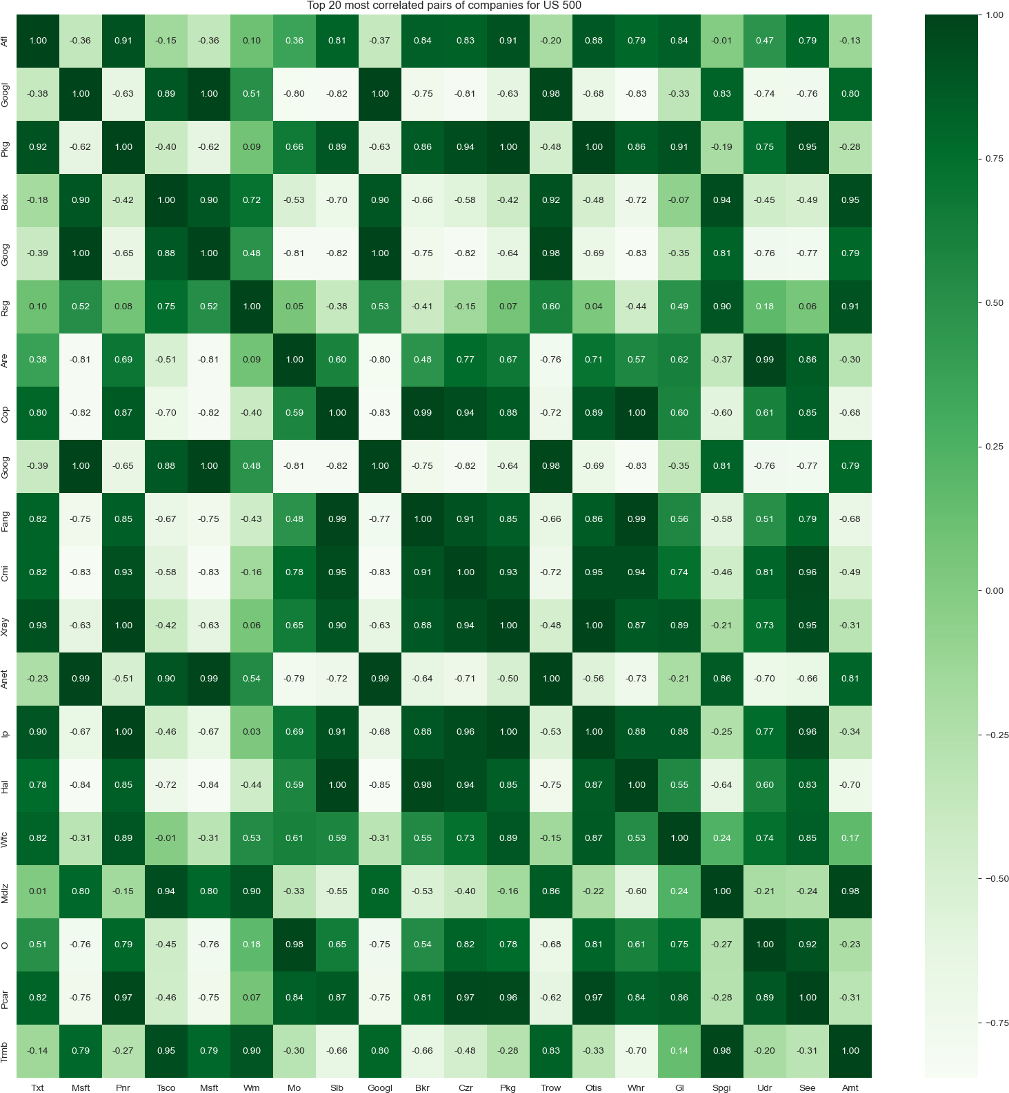

## ANALYSIS OF SIX MONTHS DATA SET OF TOP US 500 COMPANIES

In [12]:

us_price_data **=** yf**.**download(us_500, start**=**"2022-09-21", end**=**"2023-03-21") us_price_data**.**dropna(axis**=**1, inplace**=True**)

[*********************100%***********************] 505 of 505 completed

20 Failed downloads:

* NLOK: No timezone found, symbol may be delisted
* DISCK: No timezone found, symbol may be delisted
* VIAC: No timezone found, symbol may be delisted
* FBHS: No timezone found, symbol may be delisted
* KSU: No timezone found, symbol may be delisted
* BF.B: No data found for this date range, symbol may be delisted
* BRK.B: No timezone found, symbol may be delisted
* BLL: No timezone found, symbol may be delisted
* PBCT: No timezone found, symbol may be delisted
* WLTW: No timezone found, symbol may be delisted
* DRE: No timezone found, symbol may be delisted
* NLSN: No timezone found, symbol may be delisted
* TWTR: No data found, symbol may be delisted
* FB: No timezone found, symbol may be delisted
* CERN: No timezone found, symbol may be delisted
* ANTM: No timezone found, symbol may be delisted
* INFO: No timezone found, symbol may be delisted
* DISCA: No timezone found, symbol may be delisted
* CTXS: No timezone found, symbol may be delisted
* XLNX: No timezone found, symbol may be delisted

In [13]:

us_price_data[:5]

|  |  |  |  |  |  |  |  |
| --- | --- | --- | --- | --- | --- | --- | --- |
| Out[13]: | A | AAL | AAP | AAPL | ABBV | ABC | A |
|  | Date |  |  |  |  |  |  |
|  | 2022- |  |  |  |  |  |  |
|  | 09-21 126.480003 | 13.23 | 165.500000 | 153.720001 | 137.588730 | 139.119995 | 100.6500 |
|  | 00:00:00 |  |  |  |  |  |  |
|  | 2022- |  |  |  |  |  |  |
|  | 09-22 124.389999 | 12.71 | 164.110001 | 152.740005 | 140.236374 | 140.009995 | 101.0700 |
|  | 00:00:00 |  |  |  |  |  |  |
|  | 2022- |  |  |  |  |  |  |
|  | 09-23 123.480003 | 12.21 | 160.500000 | 150.429993 | 140.285400 | 137.199997 | 100.6800 |
|  | 00:00:00 |  |  |  |  |  |  |
|  | 2022- |  |  |  |  |  |  |
|  | 09-26 122.309998 | 11.86 | 157.679993 | 150.770004 | 138.471298 | 136.350006 | 99.8399 |
|  | 00:00:00 |  |  |  |  |  |  |
|  | 2022- |  |  |  |  |  |  |
|  | 09-27 121.610001 | 12.27 | 159.309998 | 151.759995 | 138.971390 | 135.440002 | 98.3300 |
|  | 00:00:00 |  |  |  |  |  |  |

5 rows × 484 columns

In [14]:

us_price_data**.**shape

Out[14]:

(124, 484)

TOP 20 LESS VOLATILE COMPANIES IN SNP500 (LAST 6 MONTHS)

## Now we are building an algortihms for seprating top less volatile companies for investment.

This code is using technical analysis to identify less volatile companies in the SNP500 index. It calculates the relative strength index (RSI) for each company's stock prices using the ta.momentum.RSIIndicator function from the ta library. It then filters the companies where the RSI is below 30, which is considered oversold and potentially undervalued. Finally, it selects the top 20 less volatile companies based on the RSI and sorts them in ascending order using the sort_values method. The resulting companies are stored in the safe_companies variable.

In [32]:

*#less volatile companies based on technical analysis*

rsi_data **=** pd**.**DataFrame()

**for** col **in** us_price_data**.**columns:

rsi **=** ta**.**momentum**.**RSIIndicator(us_price_data[col])**.**rsi() rsi_data[col] **=** rsi

*#companies with RSI < 30*

low_rsi **=** rsi_data**.**iloc[**-**1] **<** 30

In [33]:

*#top 20 less volatile companies*

safe_companies **=** low_rsi**.**sort_values()**.**index[:20]

In [34]:

*# Plot the prices of the top 20 safe companies as an area graph*

plt**.**style**.**use('dark_background') plt**.**figure(figsize**=**(20,6))

us_price_data[safe_companies]**.**plot(kind**=**'area', alpha**=**0.5, stacked**=False**, plt**.**title("Top 20 less volatile companies in US 500", fontsize**=**20) plt**.**xlabel("Date", fontsize**=**16)

plt**.**ylabel("Adjusted Close Price", fontsize**=**16) plt**.**xticks(fontsize**=**12)

plt**.**yticks(fontsize**=**12)

plt**.**grid(linestyle**=**'--', color**=**'gray', alpha**=**0.7) plt**.**show()

plt**.**close()

<Figure size 2000x600 with 0 Axes>

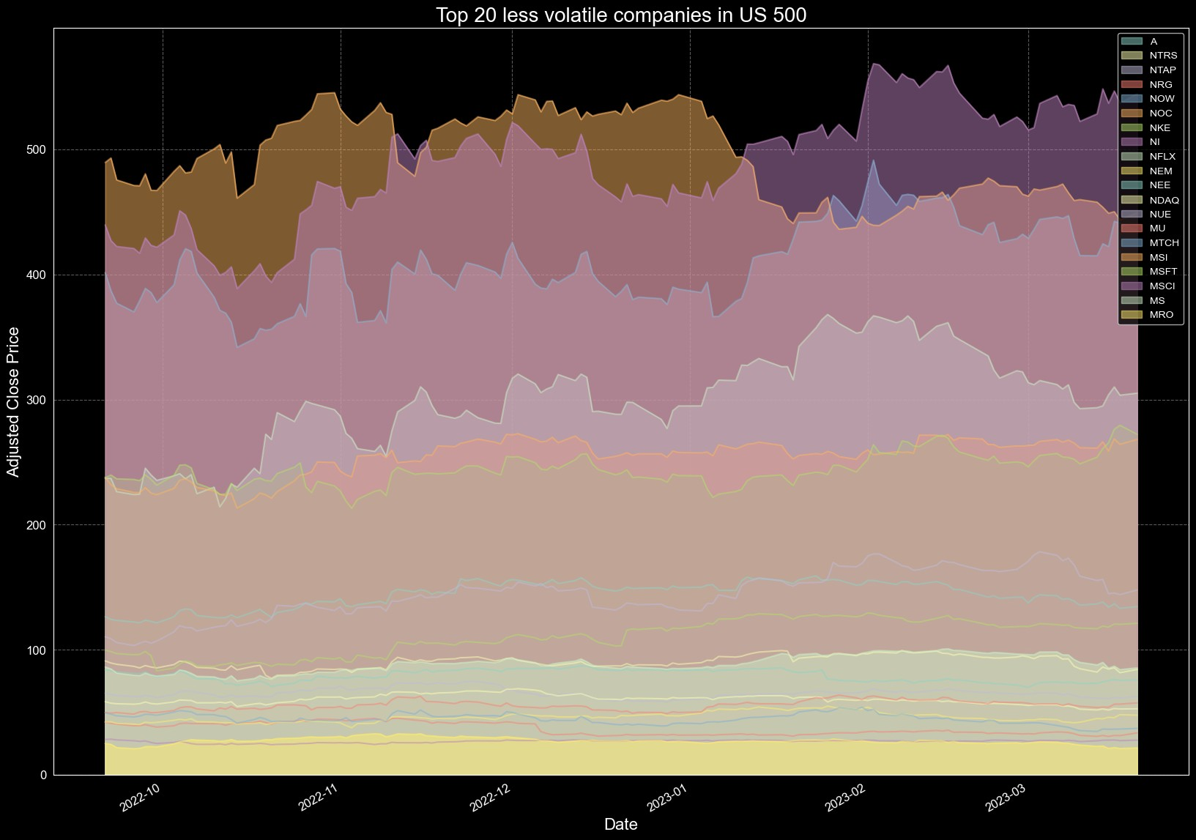

TOP 10 HIGH SHARE PRICE AND LOW SHARE PRICE IN SNP500 (lAST SIX MONTHS)

In [35]:

high_price_companies **=** us_price_data**.**max()**.**sort_values(ascending**=False**)**.**i low_price_companies **=** us_price_data**.**max()**.**sort_values()**.**index[:10]

In [36]:

*#top high share price companies as an area graph* plt**.**style**.**use('dark_background') plt**.**figure(figsize**=**(20,6))

us_price_data[high_price_companies]**.**plot(kind**=**'area', alpha**=**0.5, stacked**=** plt**.**title("Top 10 high share price companies in US 500", fontsize**=**20) plt**.**xlabel("Date", fontsize**=**16)

plt**.**ylabel("Adjusted Close Price", fontsize**=**16) plt**.**xticks(fontsize**=**12)

plt**.**yticks(fontsize**=**12)

plt**.**grid(linestyle**=**'--', color**=**'gray', alpha**=**0.7) plt**.**show()

plt**.**close()

<Figure size 2000x600 with 0 Axes>

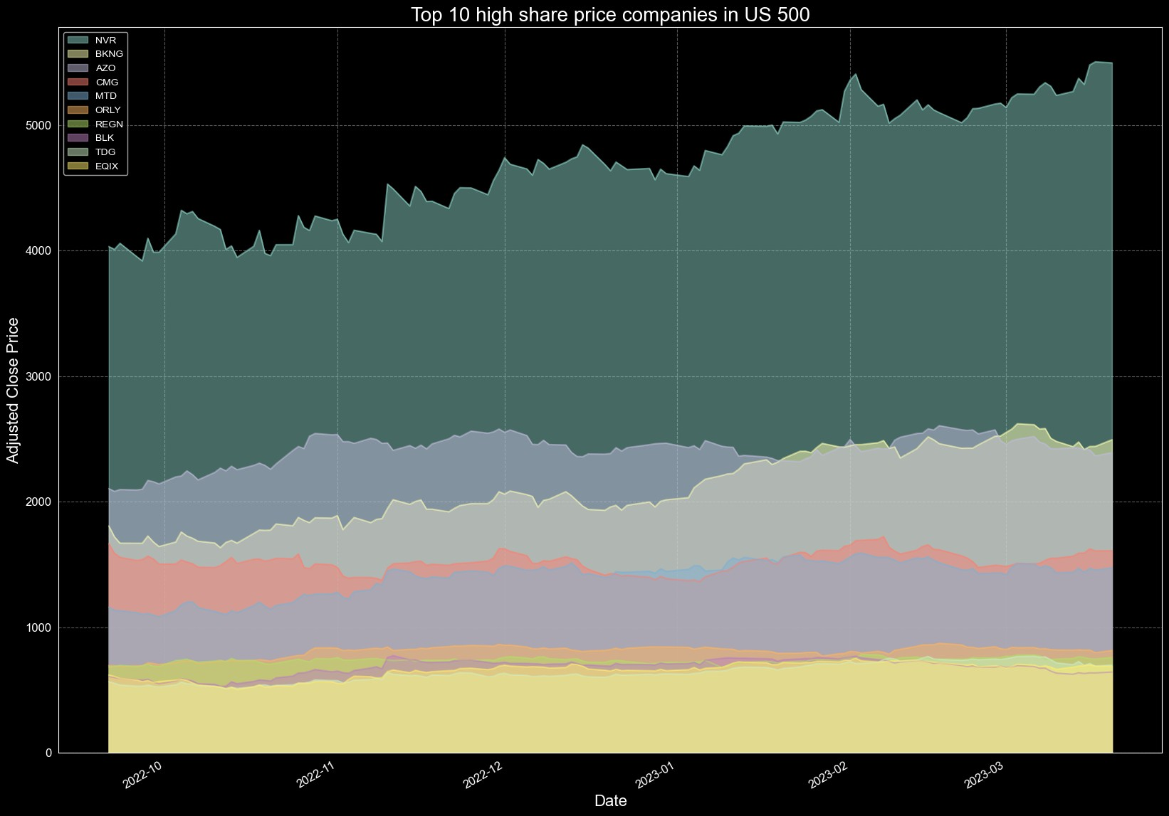

In [37]:

*# Plot the prices of top low share price companies as an area graph*

plt**.**style**.**use('dark_background') plt**.**figure(figsize**=**(20,6))

us_price_data[low_price_companies]**.**plot(kind**=**'area', alpha**=**0.5, stacked**=F** plt**.**title("Top 10 low share price companies in US 500", fontsize**=**20) plt**.**xlabel("Date", fontsize**=**16)

plt**.**ylabel("Adjusted Close Price", fontsize**=**16) plt**.**xticks(fontsize**=**12)

plt**.**yticks(fontsize**=**12)

plt**.**grid(linestyle**=**'--', color**=**'gray', alpha**=**0.7) plt**.**show()

plt**.**close()

<Figure size 2000x600 with 0 Axes>

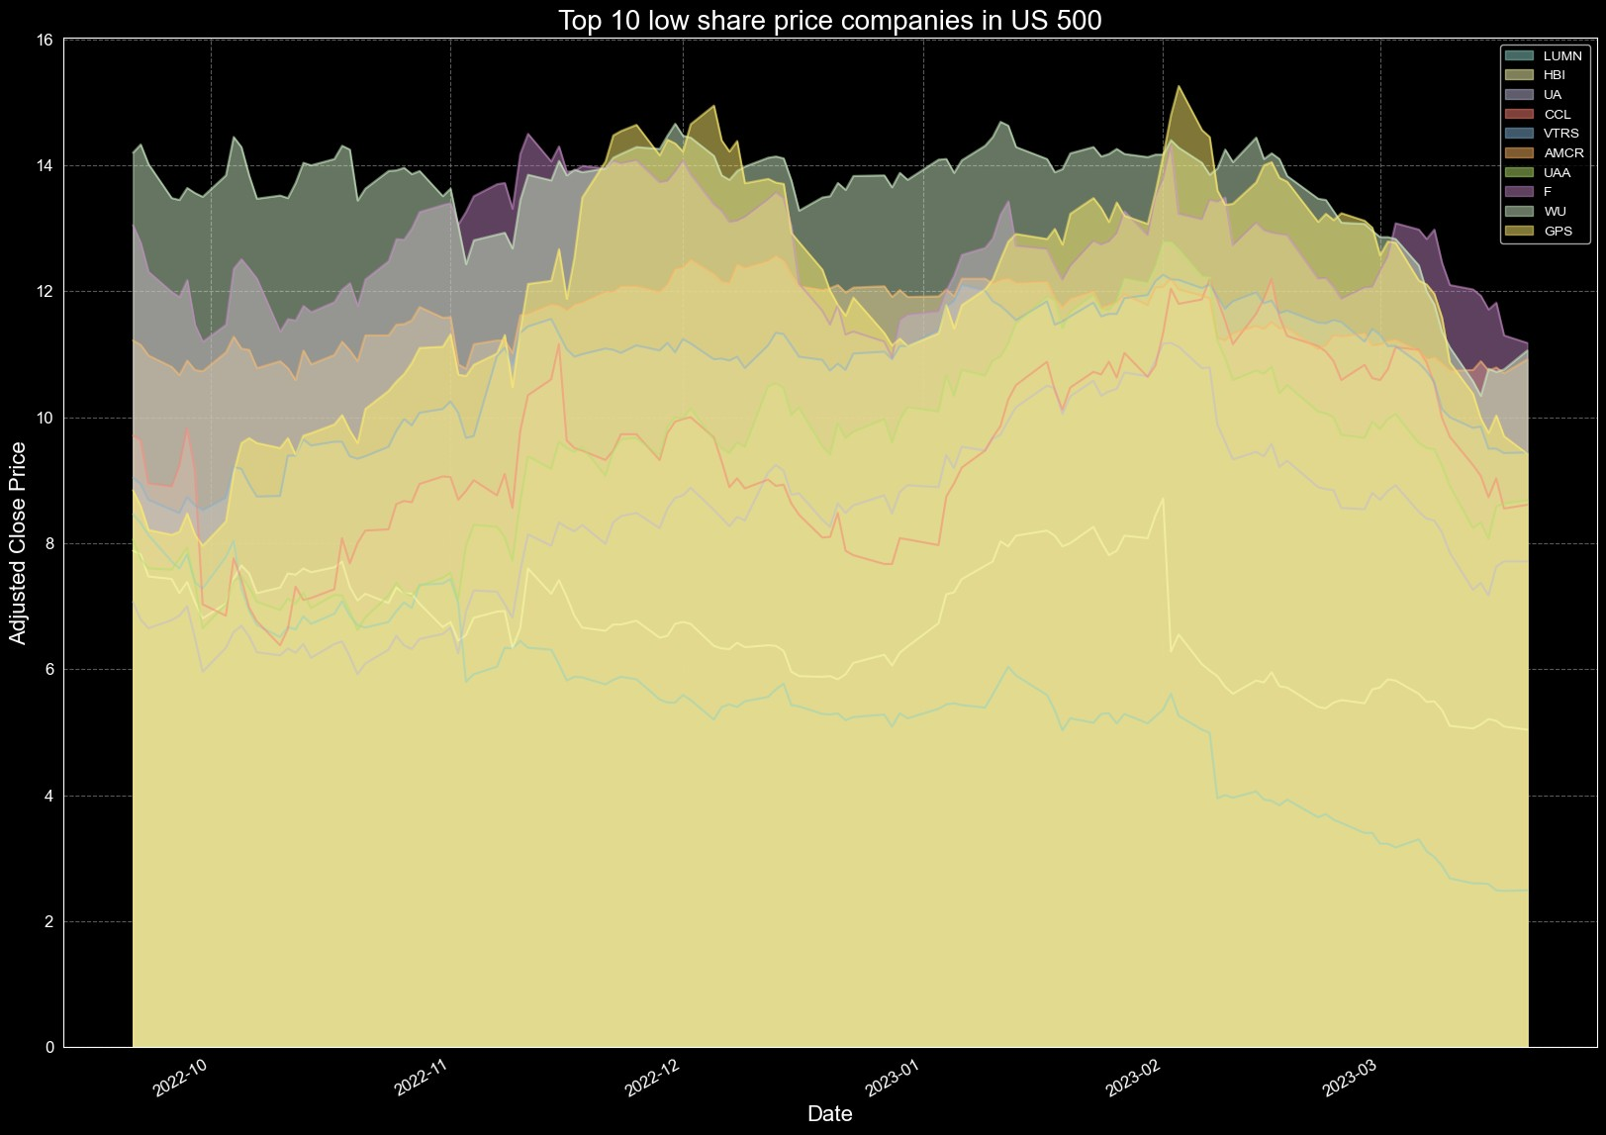

## U.K MARKET

The FTSE 100 is a stock market index that gauges the performance of the 100 largest publicly-traded companies in the United Kingdom. It is widely considered as a top indicator of the UK stock market's health and the overall UK economy.

The FTSE 100 also has a significant influence on the global economy since the UK is among the largest economies in the world and a key player in global trade and investment. The index's performance can impact not only the UK economy but also other nations and regions closely associated with the UK economy through trade, investment, and other forms of economic activity.

When the FTSE 100 performs well, it can foster investor confidence and lead to increased investment in the UK economy. This can, in turn, fuel economic growth and job creation. A robust UK economy can also increase demand for goods and services from other countries, thereby supporting worldwide economic growth.

On the flip side, when the FTSE 100 performs poorly, it can create negative ripple effects throughout the global economy. A downturn in the UK stock market can lower investor confidence and result in a reduction in investment and economic activity, both in the UK and in other nations closely tied to the UK economy.

In [38]:

ftse100_ticker **=** ["AAL.L", "ABF.L", "ADM.L", "ADN.L", "AGK.L", "AMEC.L",

"ANTO.L", "ARM.L", "ASHM.L", "AV.L", "AZN.L", "BA.L",

"BARC.L", "BATS.L", "BG.L", "BLND.L", "BLT.L", "BNZL.L"

"BP.L", "BRBY.L", "BSY.L", "BT-A.L", "CCL.L", "CNA.L",

"CPG.L", "CPI.L", "CRDA.L", "CRH.L", "CSCG.L", "DGE.L",

"EMG.L", "ENRC.L", "EVR.L", "EXPN.L", "FRES.L", "GFS.L"

"GKN.L", "GLEN.L", "GSK.L", "HL.L", "HMSO.L", "HSBA.L",

"IAG.L", "IAP.L", "IHG.L", "IMI.L", "IMT.L", "IPR.L",

"ITRK.L", "ITV.L", "JMAT.L", "KAZ.L", "KGF.L", "LAND.L"

"LGEN.L", "LLOY.L", "MGGT.L", "MKS.L", "MRW.L", "NG.L",

"NXT.L", "OML.L", "PFC.L", "POLY.L", "PRU.L", "PSON.L",

"RB.L", "RBS.L", "RDSB.L", "REL.L", "REX.L", "RIO.L",

"RR.L", "RRS.L", "RSA.L", "RSL.L", "SAB.L", "SBRY.L",

"SDR.L", "SDRC.L", "SGE.L", "SHP.L", "SL.L", "SMIN.L",

"SN.L", "SRP.L", "SSE.L", "STAN.L", "SVT.L", "TATE.L",

"TLW.L", "TSCO.L", "ULVR.L", "UU.L", "VED.L", "VOD.L",

"WEIR.L", "WOS.L", "WPP.L", "WTB.L", "XTA.L"]

In [39]:

uk_price_data **=** yf**.**download(ftse100_ticker, start**=**"2023-03-13", end**=**"2023 uk_price_data**.**dropna(axis**=**1, inplace**=True**)

[*********************100%***********************] 101 of 101 completed

32 Failed downloads:

* GKN.L: No data found for this date range, symbol may be delisted
* IAP.L: No data found for this date range, symbol may be delisted
* VED.L: No data found for this date range, symbol may be delisted
* IMT.L: No data found for this date range, symbol may be delisted
* ENRC.L: No data found for this date range, symbol may be delisted
* RSL.L: No data found for this date range, symbol may be delisted
* SDRC.L: No timezone found, symbol may be delisted
* WOS.L: No data found for this date range, symbol may be delisted
* IPR.L: No data found for this date range, symbol may be delisted
* CSCG.L: No data found for this date range, symbol may be delisted
* AGK.L: No timezone found, symbol may be delisted
* ADN.L: No data found for this date range, symbol may be delisted
* XTA.L: No data found for this date range, symbol may be delisted
* RDSB.L: No timezone found, symbol may be delisted
* RSA.L: No timezone found, symbol may be delisted
* AMEC.L: No data found for this date range, symbol may be delisted
* BSY.L: No data found for this date range, symbol may be delisted
* SAB.L: No data found for this date range, symbol may be delisted
* SL.L: No data found for this date range, symbol may be delisted
* RRS.L: No data found for this date range, symbol may be delisted
* RB.L: No timezone found, symbol may be delisted
* REX.L: No data found for this date range, symbol may be delisted
* MGGT.L: No timezone found, symbol may be delisted
* BG.L: No data found for this date range, symbol may be delisted
* MRW.L: No timezone found, symbol may be delisted
* ARM.L: No data found for this date range, symbol may be delisted
* RBS.L: No timezone found, symbol may be delisted
* OML.L: No data found for this date range, symbol may be delisted
* KAZ.L: No timezone found, symbol may be delisted
* BLT.L: No data found for this date range, symbol may be delisted
* GFS.L: No timezone found, symbol may be delisted
* SHP.L: No data found for this date range, symbol may be delisted

In [40]:

df_weekly **=** pd**.**DataFrame(data**=**uk_price_data) df_weekly**.**columns **=** df_weekly**.**columns**.**str**.**title() df_weekly**.**tail(5)

|  |  |  |  |  |  |  |  |  |  |
| --- | --- | --- | --- | --- | --- | --- | --- | --- | --- |
| Out[40]: | Date | Aal.L | Abf.L | Adm.L | Anto.L | Ashm.L | Av.L | Azn.L |  |
|  | 2023- |  |  |  |  |  |  |  |  |
|  | 03-13 | 2649.128418 | 1948.0 | 1912.0 | 1500.5 | 235.800003 | 424.299988 | 10686.0 | 908.0 |
|  | 00:00:00 |  |  |  |  |  |  |  |  |
|  | 2023- |  |  |  |  |  |  |  |  |
|  | 03-14 | 2689.914062 | 1989.5 | 1920.0 | 1539.0 | 243.800003 | 428.600006 | 10686.0 | 938.0 |
|  | 00:00:00 |  |  |  |  |  |  |  |  |
|  | 2023- |  |  |  |  |  |  |  |  |
|  | 03-15 | 2485.500000 | 1900.0 | 1896.5 | 1445.5 | 233.800003 | 407.000000 | 10644.0 | 911.5 |
|  | 00:00:00 |  |  |  |  |  |  |  |  |
|  | 2023- |  |  |  |  |  |  |  |  |
|  | 03-16 | 2479.000000 | 1949.5 | 1954.5 | 1454.0 | 239.399994 | 415.000000 | 10798.0 | 916.7 |
|  | 00:00:00 |  |  |  |  |  |  |  |  |
|  | 2023- |  |  |  |  |  |  |  |  |
|  | 03-17 | 2504.000000 | 1901.5 | 1914.5 | 1444.0 | 231.199997 | 402.200012 | 10814.0 | 905.5 |
|  | 00:00:00 |  |  |  |  |  |  |  |  |

5 rows × 69 columns

In [41]:

*# Compute the correlation matrix*

corr_matrix **=** uk_price_data**.**corr()

*# Find the top 20 most correlated pairs of companies* corr_pairs **=** corr_matrix**.**unstack()**.**sort_values(ascending**=False**) corr_pairs **=** corr_pairs[corr_pairs **!=** 1]**.**drop_duplicates()[:20] corr_pairs **=** pd**.**DataFrame(corr_pairs)**.**reset_index()

In [42]:

cmap **=** 'Greens' sns**.**set_style("white") plt**.**figure(figsize**=**(20, 20))

sns**.**heatmap(corr_matrix**.**loc[corr_pairs**.**iloc[:,0], corr_pairs**.**iloc[:,1]], plt**.**title("Top 20 most correlated pairs of companies for US 500") plt**.**show()

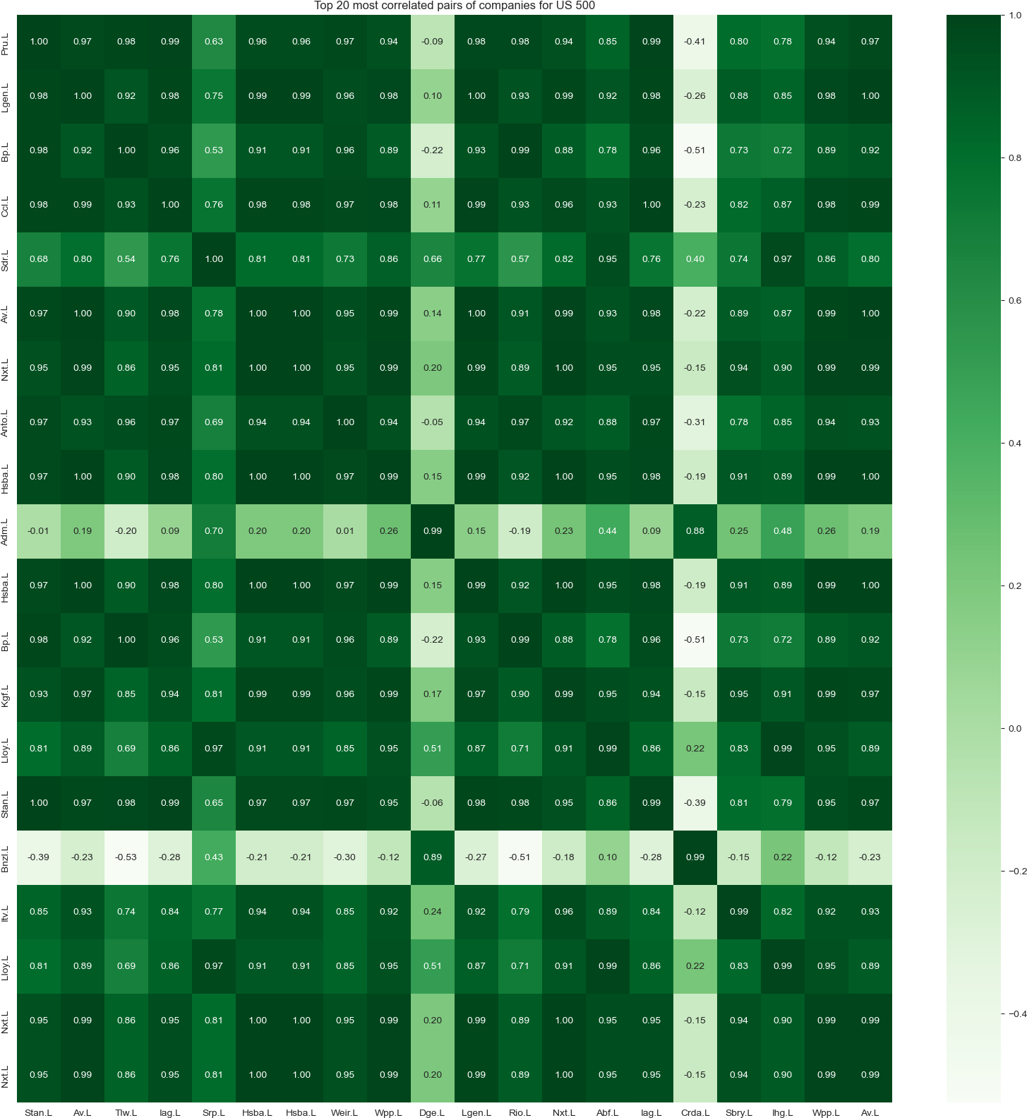

## ANALYSIS OF SIX MONTHS DATA SET OF TOP UK 100 COMPANIES

In [43]:

uk_price_data **=** yf**.**download(ftse100_ticker, start**=**"2022-09-21", end**=**"2023 uk_price_data**.**dropna(axis**=**1, inplace**=True**)

[*********************100%***********************] 101 of 101 completed

32 Failed downloads:

* GKN.L: No data found for this date range, symbol may be delisted
* IAP.L: No data found for this date range, symbol may be delisted
* VED.L: No data found for this date range, symbol may be delisted
* IMT.L: No data found for this date range, symbol may be delisted
* ENRC.L: No data found for this date range, symbol may be delisted
* RSL.L: No data found for this date range, symbol may be delisted
* SDRC.L: No timezone found, symbol may be delisted
* WOS.L: No data found for this date range, symbol may be delisted
* IPR.L: No data found for this date range, symbol may be delisted
* CSCG.L: No data found for this date range, symbol may be delisted
* AGK.L: No timezone found, symbol may be delisted
* ADN.L: No data found for this date range, symbol may be delisted
* XTA.L: No data found for this date range, symbol may be delisted
* RDSB.L: No timezone found, symbol may be delisted
* RSA.L: No timezone found, symbol may be delisted
* AMEC.L: No data found for this date range, symbol may be delisted
* BSY.L: No data found for this date range, symbol may be delisted
* SAB.L: No data found for this date range, symbol may be delisted
* SL.L: No data found for this date range, symbol may be delisted
* RRS.L: No data found for this date range, symbol may be delisted
* RB.L: No timezone found, symbol may be delisted
* REX.L: No data found for this date range, symbol may be delisted
* MGGT.L: No timezone found, symbol may be delisted
* BG.L: No data found for this date range, symbol may be delisted
* MRW.L: No timezone found, symbol may be delisted
* ARM.L: No data found for this date range, symbol may be delisted
* RBS.L: No timezone found, symbol may be delisted
* OML.L: No data found for this date range, symbol may be delisted
* KAZ.L: No timezone found, symbol may be delisted
* BLT.L: No data found for this date range, symbol may be delisted
* GFS.L: No timezone found, symbol may be delisted
* SHP.L: No data found for this date range, symbol may be delisted

### TOP 20 LESS VOLATILE COMPANIES IN FTSE100 (LAST 6 MONTHS)

In [44]:

*#less volatile companies based on technical analysis*

rsi_data **=** pd**.**DataFrame()

**for** col **in** uk_price_data**.**columns:

rsi **=** ta**.**momentum**.**RSIIndicator(uk_price_data[col])**.**rsi() rsi_data[col] **=** rsi

*#companies with RSI < 30*

low_rsi **=** rsi_data**.**iloc[**-**1] **<** 30

In [45]:

*#top 20 less volatile companies*

safe_companies **=** low_rsi**.**sort_values()**.**index[:20]

In [46]:

*# Plot the prices of the top 20 safe companies as an area graph*

plt**.**style**.**use('dark_background') plt**.**figure(figsize**=**(20,6))

uk_price_data[safe_companies]**.**plot(kind**=**'area', alpha**=**0.5, stacked**=False**, plt**.**title("Top 20 less volatile companies in FTSE100", fontsize**=**20) plt**.**xlabel("Date", fontsize**=**16)

plt**.**ylabel("Adjusted Close Price", fontsize**=**16) plt**.**xticks(fontsize**=**12)

plt**.**yticks(fontsize**=**12)

plt**.**grid(linestyle**=**'--', color**=**'gray', alpha**=**0.7) plt**.**show()

plt**.**close()

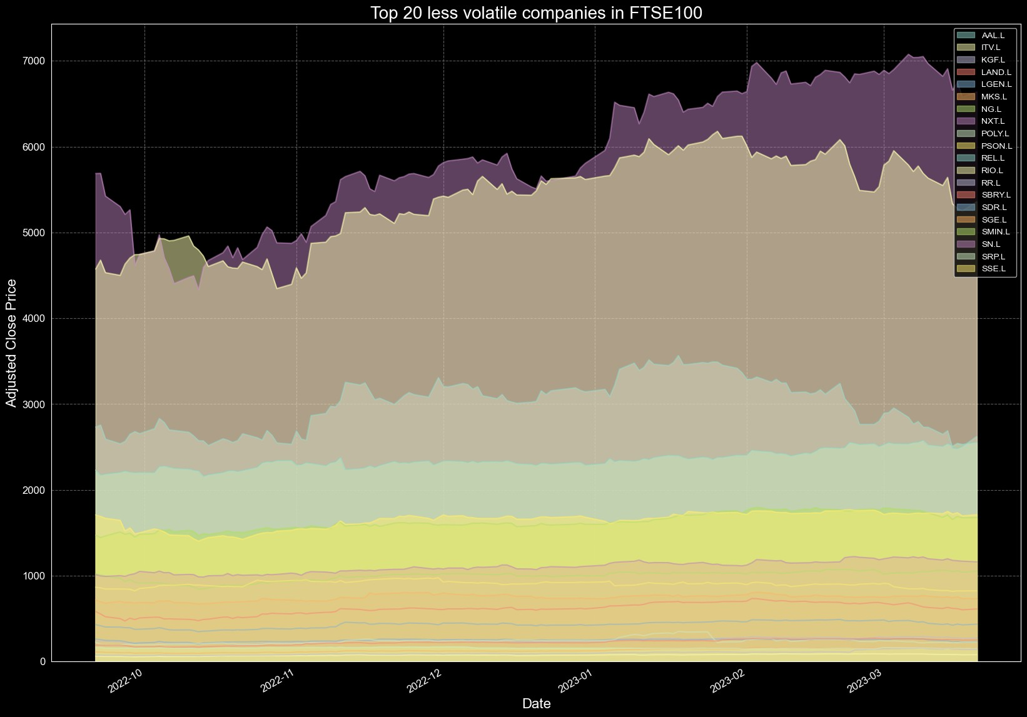<Figure size 2000x600 with 0 Axes>

### TOP 10 HIGH SHARE PRICE AND LOW SHARE PRICE IN FTSE100 (lAST SIX MONTHS)

In [47]:

high_price_companies **=** uk_price_data**.**max()**.**sort_values(ascending**=False**)**.**i low_price_companies **=** uk_price_data**.**max()**.**sort_values()**.**index[:10]

In [48]:

*#top high share price companies as an area graph* plt**.**style**.**use('dark_background') plt**.**figure(figsize**=**(20,6))

uk_price_data[high_price_companies]**.**plot(kind**=**'area', alpha**=**0.5, stacked**=** plt**.**title("Top 10 high share price companies in FTSE100", fontsize**=**20) plt**.**xlabel("Date", fontsize**=**16)

plt**.**ylabel("Adjusted Close Price", fontsize**=**16) plt**.**xticks(fontsize**=**12)

plt**.**yticks(fontsize**=**12)

plt**.**grid(linestyle**=**'--', color**=**'gray', alpha**=**0.7) plt**.**show()

plt**.**close()

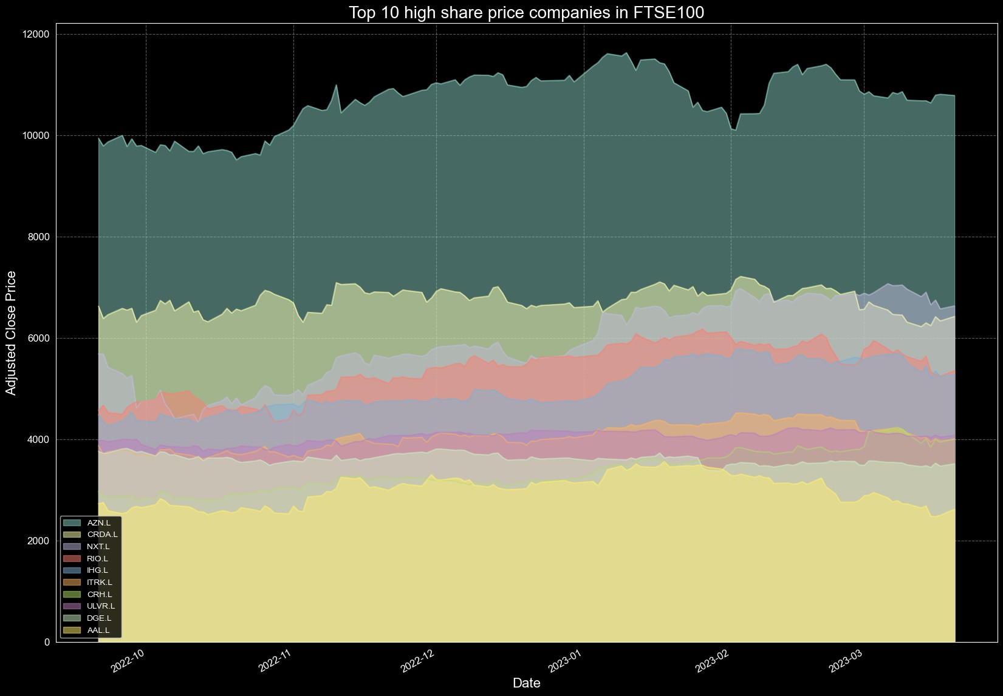<Figure size 2000x600 with 0 Axes>

In [49]:

*# Plot the prices of top low share price companies as an area graph*

plt**.**style**.**use('dark_background') plt**.**figure(figsize**=**(20,6))

uk_price_data[low_price_companies]**.**plot(kind**=**'area', alpha**=**0.5, stacked**=F** plt**.**title("Top 10 low share price companies in FTSE100", fontsize**=**20) plt**.**xlabel("Date", fontsize**=**16)

plt**.**ylabel("Adjusted Close Price", fontsize**=**16) plt**.**xticks(fontsize**=**12)

plt**.**yticks(fontsize**=**12)

plt**.**grid(linestyle**=**'--', color**=**'gray', alpha**=**0.7) plt**.**show()

plt**.**close()

<Figure size 2000x600 with 0 Axes>

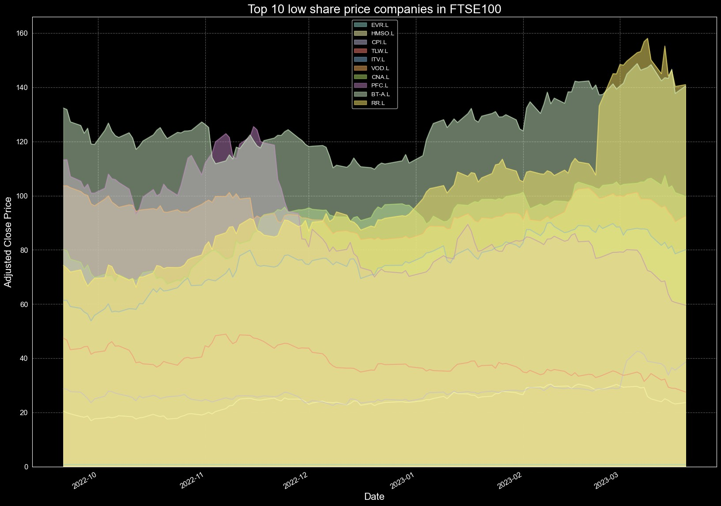

## BONDS



Bonds are debt securities that are issued by governments, corporations, and other entities to raise capital. They are essentially loans that investors make to the issuer in exchange for periodic interest payments and the return of the face value of the bond when it matures.

* 1. Government bonds: Bonds issued by national, state, or local governments.
  2. Corporate bonds: Bonds issued by corporations to raise capital for various purposes, such as funding expansion plans or repaying existing debt.
  3. Municipal bonds: Bonds issued by cities, counties, or other local government entities to finance public projects or services.
  4. Treasury bonds: Bonds issued by the federal government to finance the national debt and support the economy.
  5. Agency bonds: Bonds issued by government-sponsored entities, such as Freddie Mac and Fannie Mae.
  6. High-yield bonds: Also known as junk bonds, these are bonds issued by companies with lower credit ratings and therefore higher risk of default. They offer higher yields to compensate for this risk.
  7. Floating-rate bonds: Bonds with a variable interest rate that changes periodically based on a benchmark rate, such as the London Interbank Offered Rate (LIBOR).
  8. Convertible bonds: Bonds that can be converted into a specified number of shares of the issuer's common stock.
  9. Zero-coupon bonds: Bonds that are sold at a discount to face value and pay no periodic interest, but instead pay the full face value when they mature.
  10. Asset-backed bonds: Bonds backed by a specific asset, such as a mortgage or consumer loan.
  11. Floating rate notes (FRNs): Similar to floating-rate bonds, but usually issued by financial institutions.
  12. Exchange-traded bonds (ETBs): Bonds that are traded on an exchange, like stocks.
  13. Foreign bonds: Bonds issued by a foreign entity, such as a foreign government or corporation.
  14. Perpetual bonds: Bonds with no maturity date, meaning they pay interest indefinitely.
  15. Callable bonds: Bonds that can be redeemed by the issuer before the maturity date.
  16. Puttable bonds: Bonds that can be sold back to the issuer before the maturity date.

bonds can be seen as a hedge against inflation, as the interest paid on bonds usually increases with inflation. This means that as the cost of goods and services increases, the return on bonds increases as well, helping to offset some of the negative effects of inflation.

However, during periods of high inflation, the value of bonds can decline due to the increased cost of borrowing and declining purchasing power of the currency. This can result in losses for bondholders.

During a recession, the demand for bonds usually increases as investors seek safe, low-risk investments. This can lead to lower interest rates and an increase in bond prices. However, if the recession is severe and long-lasting, it can lead to a decline in the creditworthiness of many companies, resulting in declining bond prices and increased risk of default.

## TECHNICAL ANALYSIS

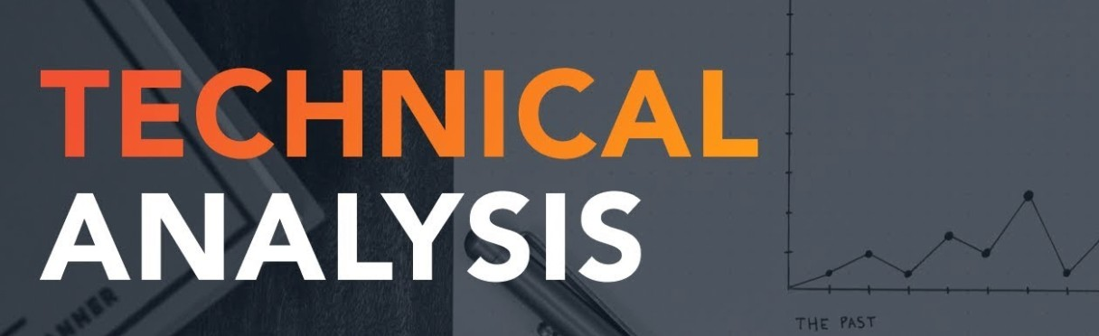

* 1. Long-term investments: A long-term investment is typically an investment with a holding period of more than one year. When considering a long-term investment in a company, it is important to conduct a fundamental analysis of the company at least once a year. This will provide an updated view of the company's financial performance, stability, and growth prospects. Based on this information, you can adjust your investment strategy accordingly to ensure your investment aligns with your long-term goals.
  2. Short-term investments: A short-term investment is typically an investment with a holding period of less than one year. When considering a short-term investment in a company, it is important to conduct a fundamental analysis more frequently, such as every quarter or every six months. This will provide an updated view of the company's financial performance and stability, which can change quickly in the short term. Based on this information, you can adjust your investment strategy accordingly to ensure your investment aligns with your short-term goals.
  3. High-risk investments: High-risk investments are investments that carry a higher level of risk, such as stocks in small, unproven companies or stocks in industries that are facing challenges. When considering a high-risk investment, it is important to conduct a fundamental analysis more frequently to stay informed about the financial performance and stability of the company. This will help you make informed decisions about the investment and minimize the risks associated with the investment.
  4. Low-risk investments: Low-risk investments are investments that carry a lower level of risk, such as bonds or blue-chip stocks. When considering a low-risk investment, it may not be necessary to conduct a fundamental analysis as frequently as you would for a high-risk investment. However, it is still important to review the investment regularly and conduct a fundamental analysis as needed to ensure your investment aligns with your goals.

1. Total Period of Trading (Maximum Chart)

In [50]:

ticker **=** "CS"

stock **=** yf**.**download(ticker) stock**.**shape

Out[50]:

In [51]:

stock**.**tail()

[*********************100%***********************] 1 of 1 completed

(7012, 6)

|  |  |  |  |  |  |  |  |
| --- | --- | --- | --- | --- | --- | --- | --- |
| Out[51]: | Date | Open | High | Low | Close | Adj Close | Volume |
|  | 2023-03-16 | 2.30 | 2.32 | 2.11 | 2.16 | 2.16 | 224765200 |
|  | 2023-03-17 | 2.05 | 2.10 | 1.94 | 2.01 | 2.01 | 136229600 |
|  | 2023-03-20 | 0.91 | 1.08 | 0.90 | 0.94 | 0.94 | 375645900 |
|  | 2023-03-21 | 0.97 | 1.00 | 0.94 | 0.97 | 0.97 | 210272500 |
|  | 2023-03-22 | 0.94 | 0.96 | 0.91 | 0.92 | 0.92 | 100043800 |

In [52]:

plt**.**style**.**use('dark_background') plt**.**figure(figsize**=**(30,15))

plt**.**grid(**True**, color**=**'grey', linewidth**=**0.3)

plt**.**fill_between(stock**.**index, 0, stock['Close'], color**=**"red", label**=**'Cred plt**.**xlabel('Years', fontsize**=**14)

plt**.**ylabel('Close Price (£)', fontsize**=**14) plt**.**legend(loc**=**'center left', fontsize**=**14)

plt**.**suptitle("Financial Performance Comparison", fontsize**=**16, y**=**0.93) plt**.**show()

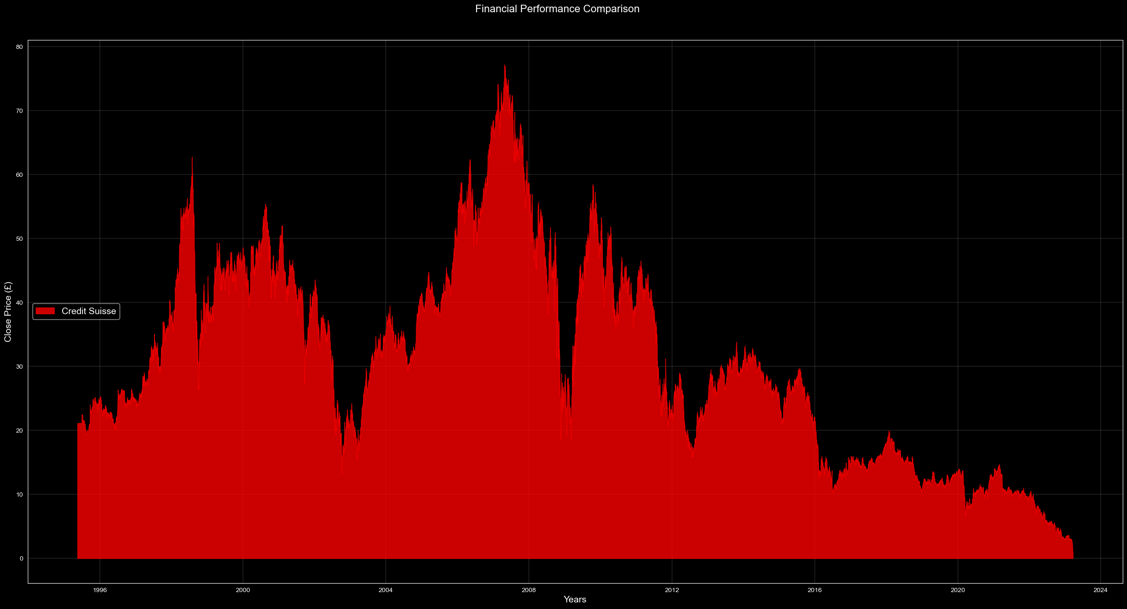

In [53]:

plt**.**style**.**use('dark_background') plt**.**figure(figsize**=**(30,15))

plt**.**plot(stock['Open'], color**=**'tab:green', label**=**'Open Price') plt**.**plot(stock['Close'], color**=**'tab:red', label**=**'Close Price') plt**.**plot(stock['Adj Close'], color**=**'tab:blue', label**=**'Adj Close Price') plt**.**title("Credit Suisse Group AG (CS) Stock Price", fontsize**=**18) plt**.**xlabel("Year", fontsize**=**14)

plt**.**ylabel("Price (USD)", fontsize**=**14) plt**.**xticks(fontsize**=**12) plt**.**yticks(fontsize**=**12) plt**.**legend(fontsize**=**14)

plt**.**grid(linestyle**=**'--', color**=**'gray', alpha**=**0.5) plt**.**show()

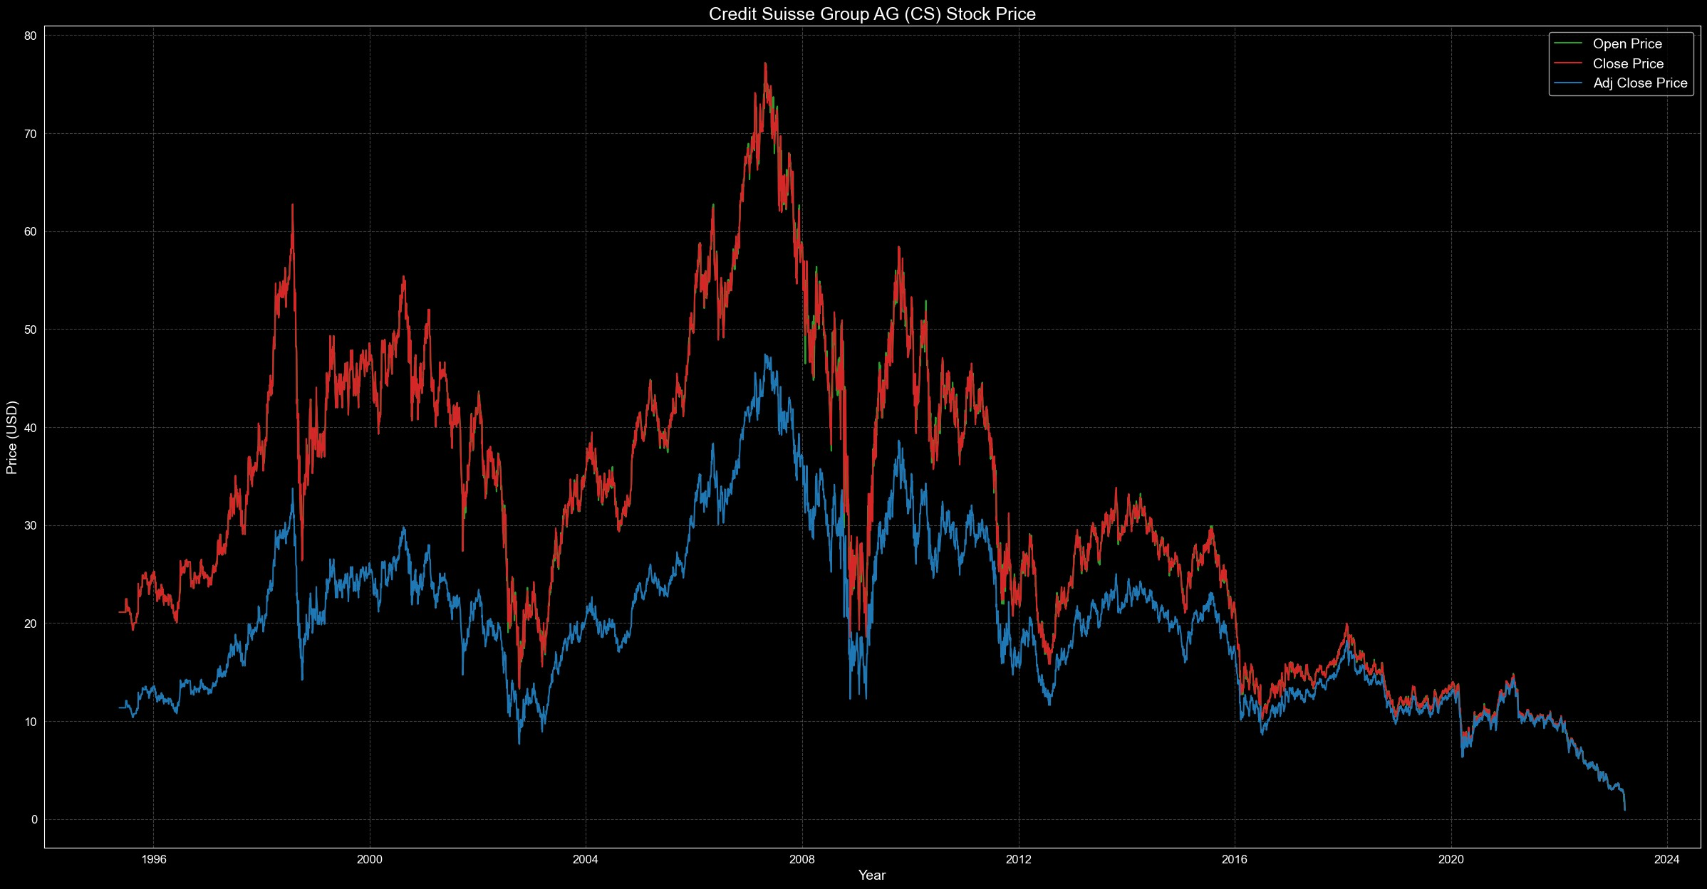

## ThresholdClassifier Algortihms Design by Hemant Thapa

This classifier will work with respect to time series analysis, it can be varies from 1months, 6months, 1years, 5years, 10years, and Total trading years. The algorithm takes in a list of numerical data, calculates the mean value of the data, and sets the threshold value to be equal to the mean. The algorithm then iterates through each value in the data list and compares it to the threshold value. If the value is greater than the threshold value, the algorithm classifies it as a 1 (positive class), otherwise, it classifies it as a 0 (negative class).

It will help to you identifies the positive and negative trade over your trading period.

In [59]:

**class** ThresholdClassifier:

**def** init (self, threshold: float): self**.**threshold **=** threshold

**def** classify(self, data: List[float]): self**.**mean **=** sum(data) **/** len(data) self**.**threshold **=** self**.**mean classifications **=** []

**for** value **in** data:

**if** value **>** self**.**threshold: classifications**.**append(1)

**else**:

classifications**.**append(0)

**return** classifications

In [60]:

classifier **=** ThresholdClassifier(0.5)

In [61]:

**class** ThresholdPlot:

**def** init (self, data, classification): self**.**data **=** data

self**.**classification **=** classification

**def** plot(self): plt**.**style**.**use('dark_background') plt**.**figure(figsize**=**(30,7)) plt**.**xlabel("Time", fontsize**=**14)

plt**.**ylabel("Price (£)", color**=**"tab:red", fontsize**=**14) plt**.**plot(self**.**data**.**index, self**.**data, color**=**"tab:red") plt**.**twinx()

plt**.**ylabel("Classification", color**=**"tab:blue", fontsize**=**14) plt**.**plot(self**.**data**.**index, self**.**classification, color**=**"tab:blue") plt**.**axhline(y**=**0.5, color**=**"gray", linestyle**=**"--", alpha**=**0.8) plt**.**title("Binary Classifications", fontsize**=**20, color**=**"White") plt**.**grid(linestyle**=**'--', color**=**'gray', alpha**=**0.2)

plt**.**show()

colors **=** []

**for** value **in** self**.**classification:

**if** value **>** 0.5: colors**.**append("tab:green")

#### else:

colors**.**append("tab:red")

plt**.**style**.**use('dark_background') plt**.**figure(figsize**=**(30,7)) plt**.**xlabel("Time", fontsize**=**14)

plt**.**ylabel("Price (£)", color**=**"tab:red", fontsize**=**14) plt**.**plot(self**.**data**.**index, self**.**data, color**=**"tab:red") plt**.**tick_params(axis**=**"both", labelsize**=**12) plt**.**twinx()

plt**.**ylabel("Classification", color**=**"tab:blue", fontsize**=**14) plt**.**scatter(self**.**data**.**index, self**.**classification, color**=**colors) plt**.**tick_params(axis**=**"both", labelsize**=**12)

plt**.**title("Binary Classifications", fontsize**=**18, color**=**"White") plt**.**grid(linestyle**=**'--', color**=**'gray', alpha**=**0.2)

plt**.**show()

In [62]:

classifier **=** ThresholdClassifier(0.5)

classification **=** classifier**.**classify(stock['Close']**.**tolist()) plot **=** ThresholdPlot(stock['Close'], classification) plot**.**plot()

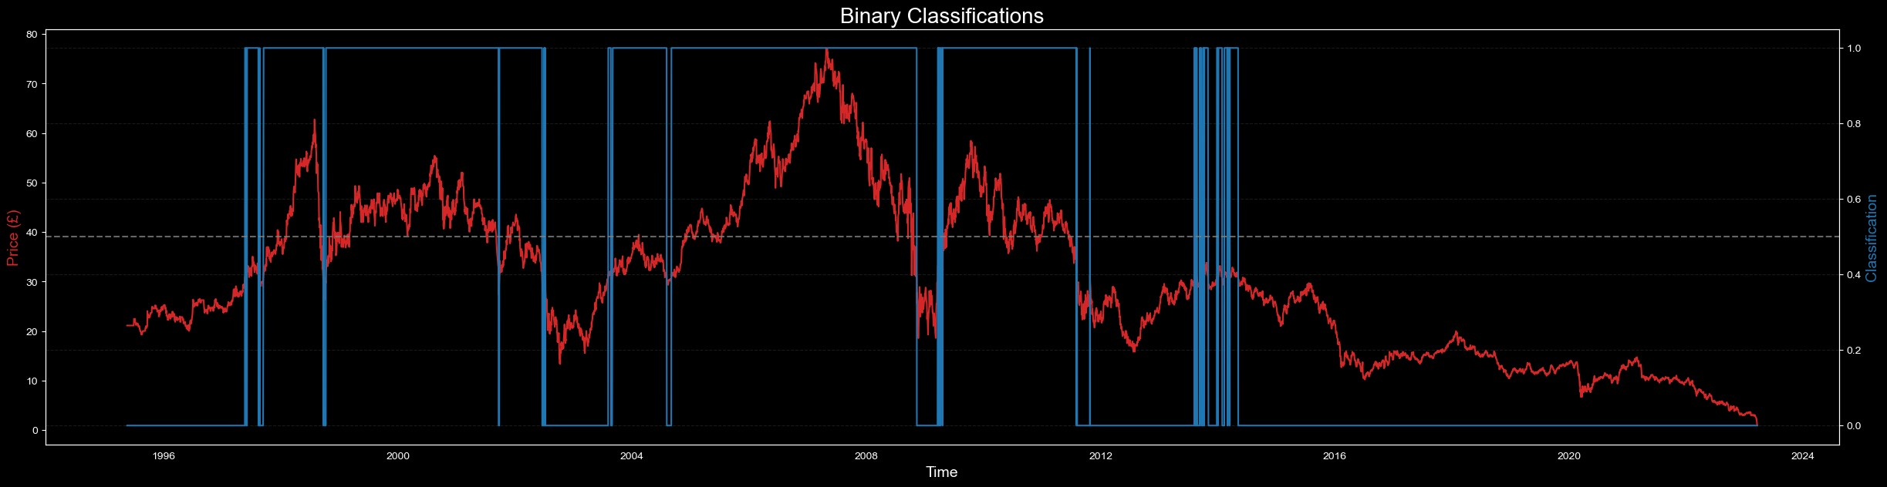

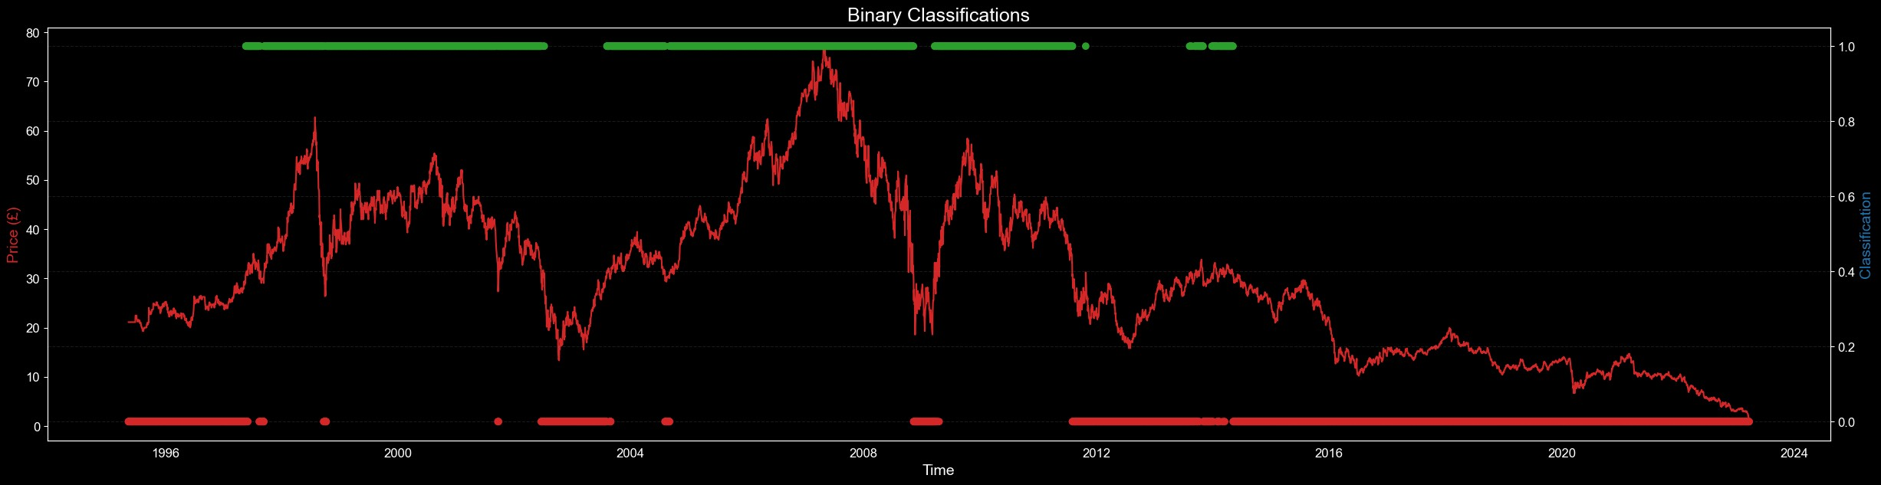

10 YEAR CHART

In [63]:

ticker **=** "CS"

stock **=** yf**.**download(ticker, start**=**"2013-01-01", end**=**"2023-03-20") stock**.**shape

Out[63]:

In [64]:

plt**.**style**.**use('dark_background') plt**.**figure(figsize**=**(35,10))

plt**.**plot(stock['Close'], color**=**'tab:red', label**=**'Close Price') plt**.**title("Credit Suisse Group AG (CS) Stock Price", fontsize**=**18) plt**.**xlabel("Year", fontsize**=**14)

plt**.**ylabel("Price (USD)", fontsize**=**14) plt**.**xticks(fontsize**=**12) plt**.**yticks(fontsize**=**12) plt**.**legend(fontsize**=**14)

plt**.**grid(linestyle**=**'--', color**=**'gray', alpha**=**0.7) plt**.**show()

[*********************100%***********************] 1 of 1 completed

(2570, 6)

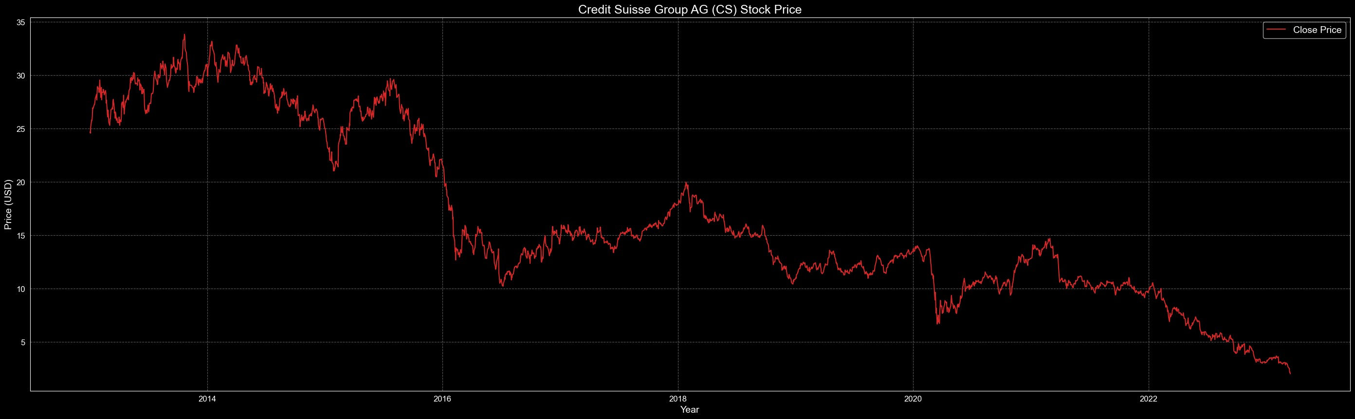

In [65]:

classifier **=** ThresholdClassifier(0.5)

classification **=** classifier**.**classify(stock['Close']**.**tolist()) plot **=** ThresholdPlot(stock['Close'], classification) plot**.**plot()

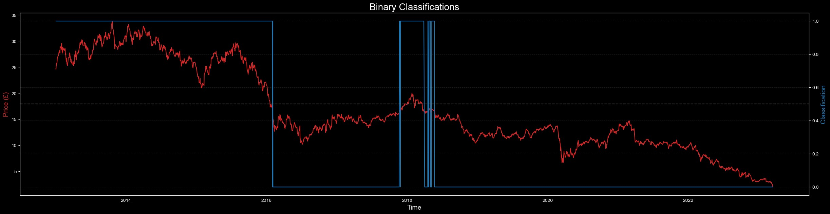

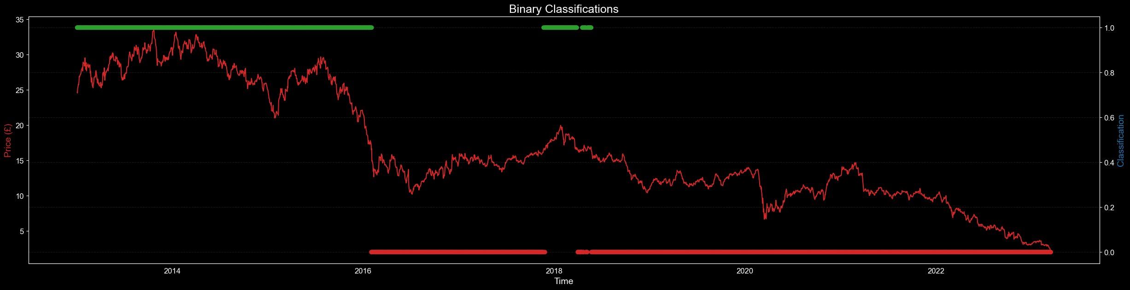

5 YEAR CHART

In [66]:

ticker **=** "CS"

stock **=** yf**.**download(ticker, start**=**"2018-01-01", end**=**"2023-03-20") stock**.**shape

Out[66]:

In [67]:

plt**.**style**.**use('dark_background') plt**.**figure(figsize**=**(35,10))

plt**.**plot(stock['Close'], color**=**'tab:red', label**=**'Close Price') plt**.**title("Credit Suisse Group AG (CS) Stock Price", fontsize**=**18) plt**.**xlabel("Year", fontsize**=**14)

plt**.**ylabel("Price (USD)", fontsize**=**14) plt**.**xticks(fontsize**=**12) plt**.**yticks(fontsize**=**12) plt**.**legend(fontsize**=**14)

plt**.**grid(linestyle**=**'--', color**=**'gray', alpha**=**0.7) plt**.**show()

[*********************100%***********************] 1 of 1 completed

(1311, 6)

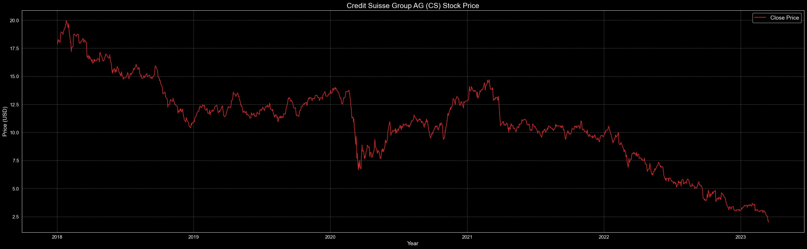

In [68]:

classifier **=** ThresholdClassifier(0.5)

classification **=** classifier**.**classify(stock['Close']**.**tolist()) plot **=** ThresholdPlot(stock['Close'], classification) plot**.**plot()

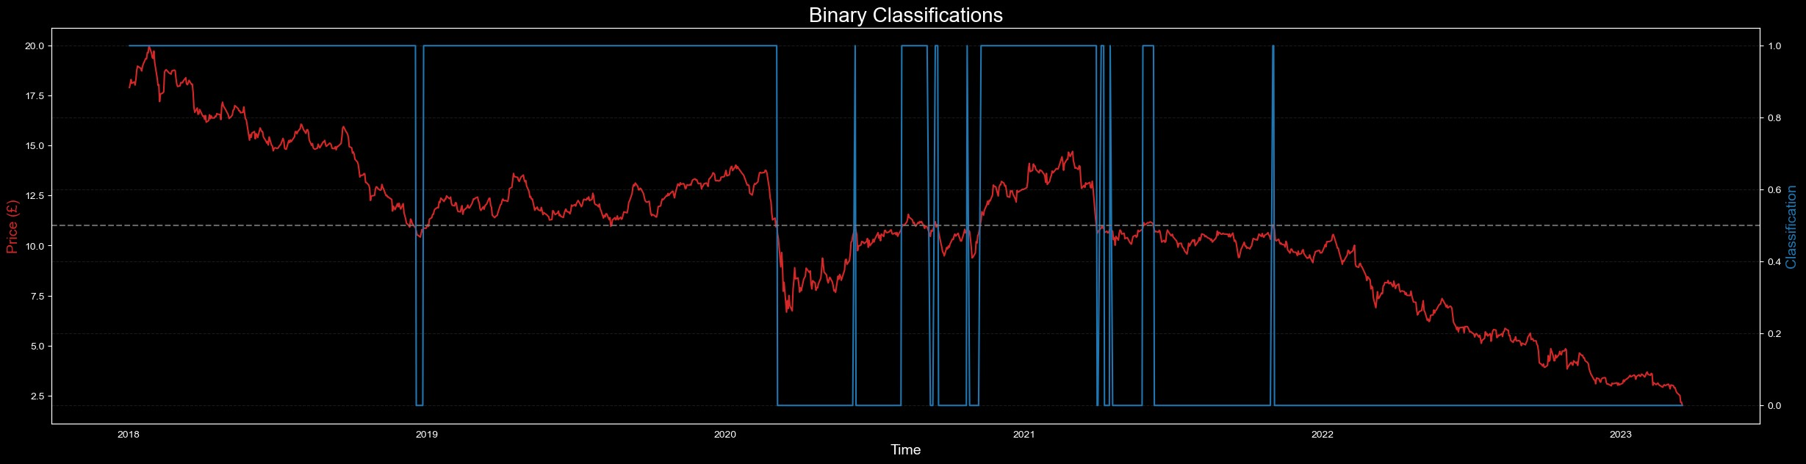

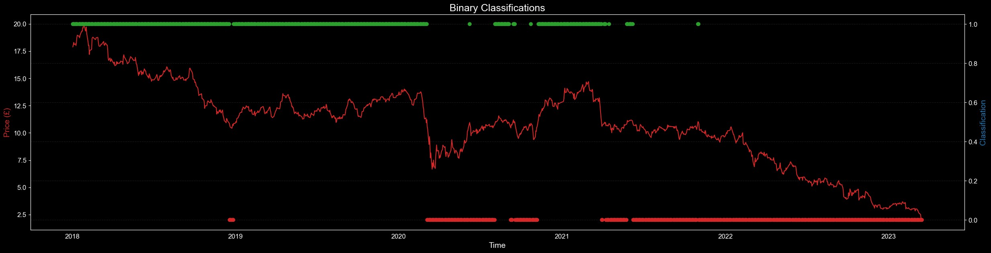

1 YEAR CHART

In [69]:

ticker **=** "CS"

stock **=** yf**.**download(ticker, start**=**"2022-01-01", end**=**"2023-03-20") stock**.**shape

Out[69]:

In [70]:

plt**.**style**.**use('dark_background') plt**.**figure(figsize**=**(35,10))

plt**.**plot(stock['Close'], color**=**'tab:red', label**=**'Close Price') plt**.**title("Credit Suisse Group AG (CS) Stock Price", fontsize**=**18) plt**.**xlabel("Year", fontsize**=**14)

plt**.**ylabel("Price (USD)", fontsize**=**14) plt**.**xticks(fontsize**=**12) plt**.**yticks(fontsize**=**12) plt**.**legend(fontsize**=**14)

plt**.**grid(linestyle**=**'--', color**=**'gray', alpha**=**0.7) plt**.**show()

[*********************100%***********************] 1 of 1 completed

(303, 6)

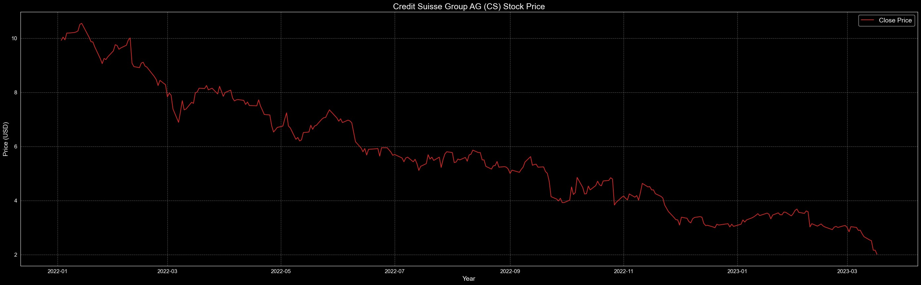

In [71]:

classifier **=** ThresholdClassifier(0.5)

classification **=** classifier**.**classify(stock['Close']**.**tolist()) plot **=** ThresholdPlot(stock['Close'], classification) plot**.**plot()

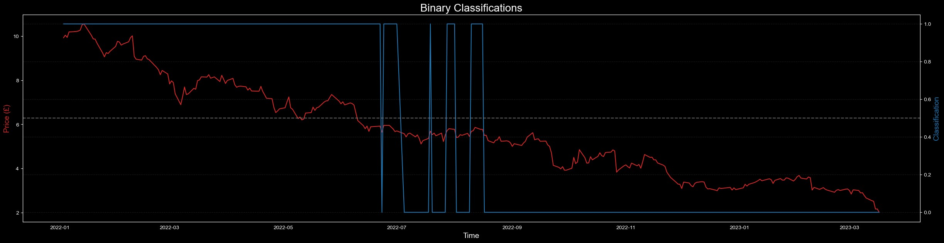

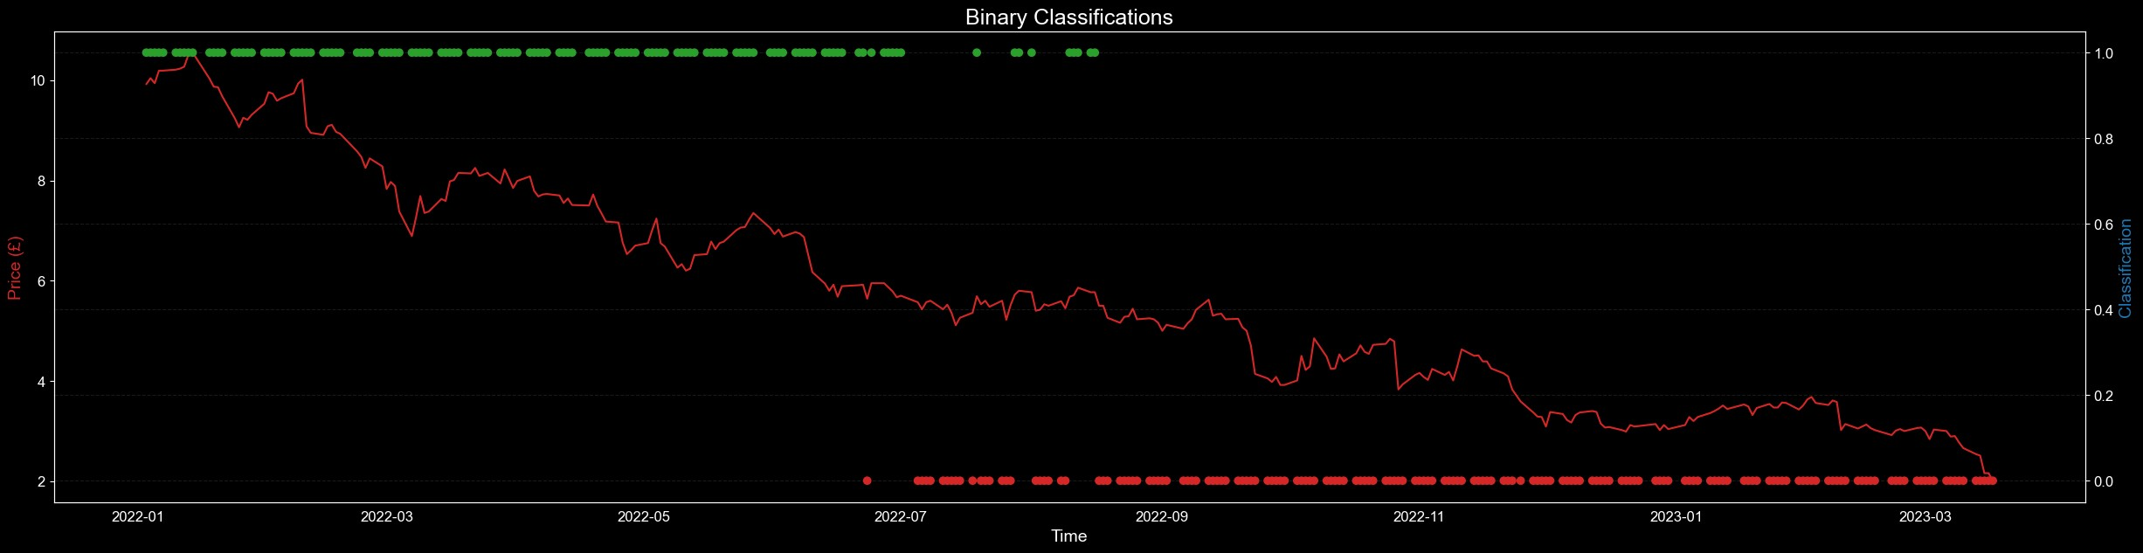

6 MONTHS CHART

In [72]:

ticker **=** "CS"

stock **=** yf**.**download(ticker, start**=**"2022-09-20", end**=**"2023-03-20") stock**.**shape

Out[72]:

In [73]:

plt**.**style**.**use('dark_background') plt**.**figure(figsize**=**(35,10))

plt**.**plot(stock['Close'], color**=**'tab:red', label**=**'Close Price') plt**.**title("Credit Suisse Group AG (CS) Stock Price", fontsize**=**18) plt**.**xlabel("Year", fontsize**=**14)

plt**.**ylabel("Price (USD)", fontsize**=**14) plt**.**xticks(fontsize**=**12) plt**.**yticks(fontsize**=**12) plt**.**legend(fontsize**=**14)

plt**.**grid(linestyle**=**'--', color**=**'gray', alpha**=**0.7) plt**.**show()

[*********************100%***********************] 1 of 1 completed

(124, 6)

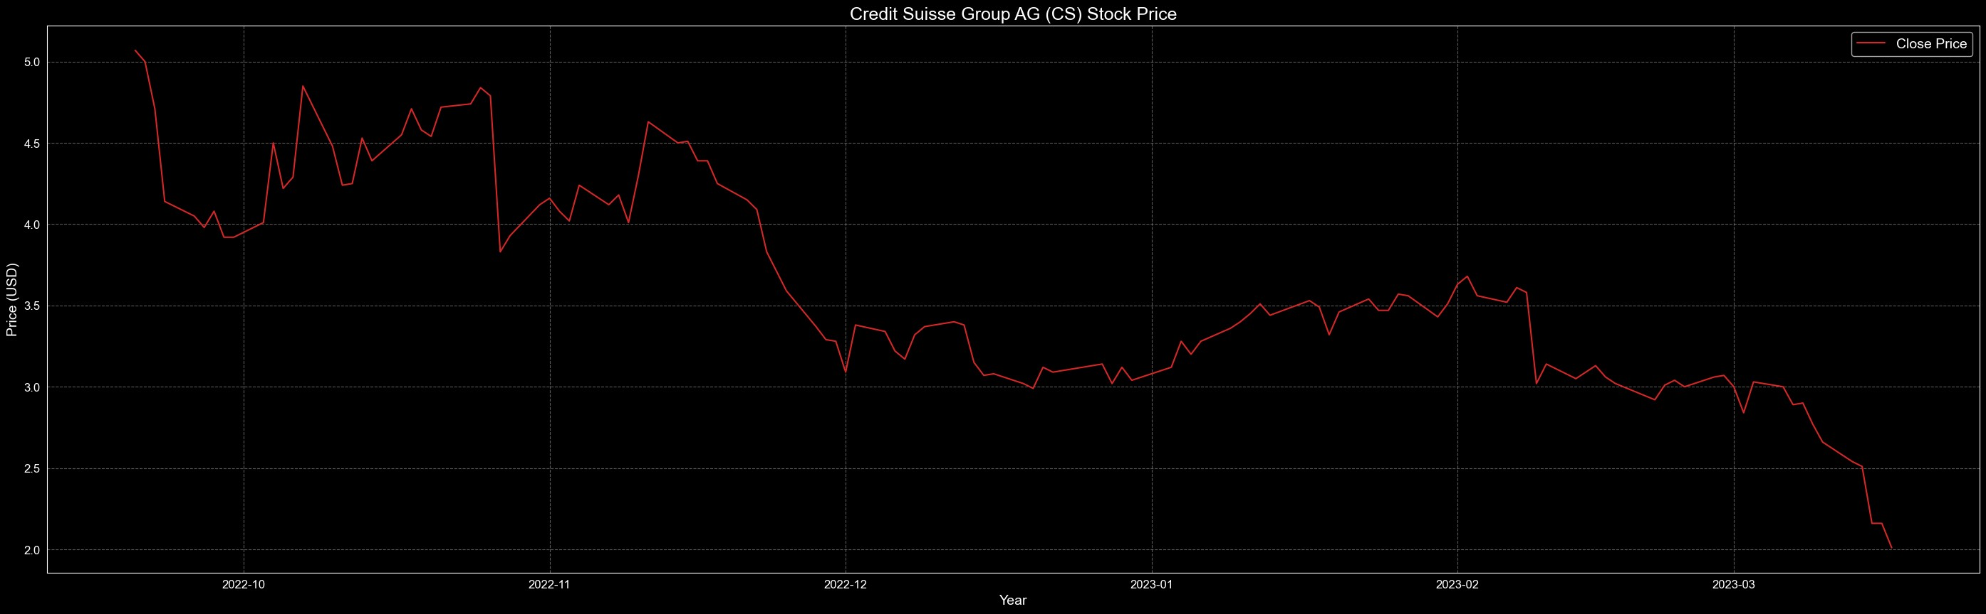

In [74]:

classifier **=** ThresholdClassifier(0.5)

classification **=** classifier**.**classify(stock['Close']**.**tolist()) plot **=** ThresholdPlot(stock['Close'], classification) plot**.**plot()

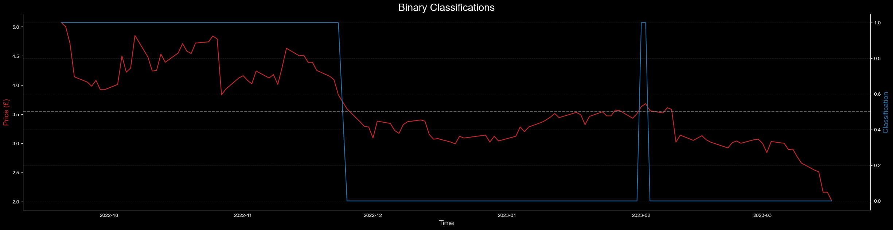

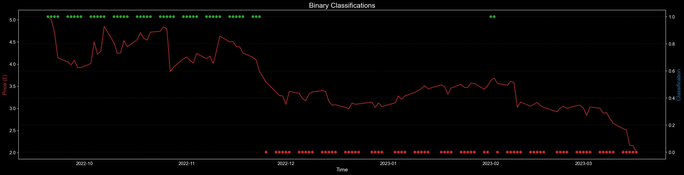

# LINEAR REGRESSION MODEL

Credit Suisse is one of the largest financial institutions in the world, and as such, its performance can have ripple effects on the global economy. Credit Suisse provides a range of financial services, including investment banking, wealth management, and asset management, and its operations span across multiple countries and regions.

The performance of Credit Suisse can affect the global economy in several ways. For example, if Credit Suisse performs well, it can attract investment and stimulate economic growth in the countries and regions where it operates. Conversely, if Credit Suisse experiences financial difficulties, it can lead to a reduction in investment and economic activity, which can have negative effects on the global economy.

Moreover, the collapse or failure of a major financial institution like Credit Suisse can have systemic effects on the global economy, particularly if it triggers a broader financial crisis. The failure of Lehman Brothers in 2008, for example, had far-reaching impacts on the global economy and was a major contributor to the global financial crisis that followed.

Credit Suisse's impact on the S&P 500 may be limited as Credit Suisse is a Swiss financial institution and is not included in the S&P 500 index. However, as a major global financial institution, the performance of Credit Suisse can still have indirect effects on the US economy and, by extension, the S&P 500.

Credit Suisse experiences financial difficulties, it may reduce its investment in the US and may even reduce its lending to US companies and individuals, which can affect the US economy and the performance of the S&P 500. Additionally, if Credit Suisse's financial difficulties are severe enough, it could contribute to broader economic trends and developments that could indirectly affect the S&P 500.

MAX CHART - CREDIT SUISSE AND SNP500

In [78]:

credit_suisse **=** yf**.**Ticker("CS")**.**history(period**=**"max") snp500 **=** yf**.**Ticker("^GSPC")**.**history(period**=**"max") ftse100 **=** yf**.**Ticker("^FTSE")**.**history(period**=**"max")

In [79]:

**from** forex_python.converter **import** CurrencyRates

In [80]:

c **=** CurrencyRates()

exchange_rate **=** c**.**get_rate('GBP', 'USD') ftse100["Close"] **=** ftse100["Close"] **\*** exchange_rate ftse100["Open"] **=** ftse100["Open"] **\*** exchange_rate ftse100["High"] **=** ftse100["High"] **\*** exchange_rate ftse100["Low"] **=** ftse100["Low"] **\*** exchange_rate

In [81]:

ftse100**.**tail(2)

Out[81]:

Open High Low Close Volume Div

In [82]:

plt**.**style**.**use('dark_background') plt**.**figure(figsize**=**(15,7))

plt**.**grid(**True**, color**=**'grey', linewidth**=**0.3)

plt**.**plot(snp500**.**index, snp500['Close'], alpha**=**0.2, color**=**"#00bfff", linew plt**.**fill_between(ftse100**.**index, 0, ftse100['Close'], color**=**"orange", labe plt**.**fill_between(snp500**.**index, 0, snp500['Close'], color**=**"#00bfff", label plt**.**fill_between(credit_suisse**.**index, 0, credit_suisse['Close'], color**=**"r plt**.**legend(loc**=**'center left', fontsize**=**14)

plt**.**suptitle("Financial Performance Comparison", fontsize**=**16, y**=**0.93) plt**.**show()

Date

00:00:00+00:00

|  |  |  |  |  |
| --- | --- | --- | --- | --- |
| 2023-03-22 9224.960334 | 9285.430083 | 9187.380641 | 9262.416900 | 892439300 |
| 2023-03-23 9262.465911 | 9262.465911 | 9151.429080 | 9164.967547 | 0 |

00:00:00+00:00

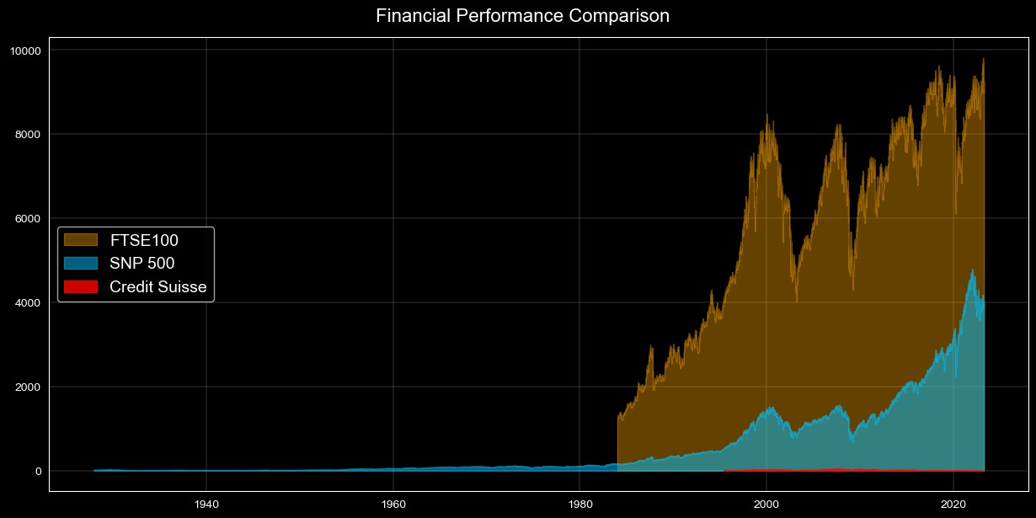

SNP500 is the oldest index in Global finance, The S&P 500 is not a stock itself, but rather a stock market index that measures the performance of the 500 largest publicly traded companies in the United States. The index was first introduced in 1923 by Standard & Poor's Financial Services and has undergone several revisions since then. first S&P 500 index fund was introduced by Vanguard in 1976.

The FTSE 100 Index was launched on January 3, 1984, by the Financial Times Stock Exchange. well, Credit Suisse Group AG, a Swiss multinational investment bank, was first established in 1856, but it did not go public until 1997. It was listed on the Zurich and New York stock exchanges on October 31, 1997.

5 YEAR CHART

A 5-year chart can also provide a more accurate representation of a company's financial performance over time. Short-term fluctuations and market noise may be smoothed out, giving a clearer picture of the company's growth and stability.

Credit Suisse

In [83]:

ticker **=** "CS"

stock **=** yf**.**download(ticker, start**=**"2018-03-20", end**=**"2023-03-20") stock**.**shape

Out[83]:

In [84]:

plt**.**style**.**use('dark_background') plt**.**figure(figsize**=**(35,10))

plt**.**plot(stock**.**index, stock['Close'], label**=**'Credit Suisse', color**=**"red") plt**.**fill_between(stock**.**index, stock['Close'], 0, alpha**=**0.3, color**=**'royalb plt**.**title('SNP500 Stock Price', fontsize**=**20, color**=**"White") plt**.**xlabel("Time", fontsize**=**14)

plt**.**ylabel("Price ($)", fontsize**=**14) plt**.**legend(loc**=**'best') plt**.**tick_params(axis**=**"both", labelsize**=**12) plt**.**grid(linestyle**=**'--', color**=**'gray', alpha**=**0.7) plt**.**show()

[*********************100%***********************] 1 of 1 completed

(1258, 6)

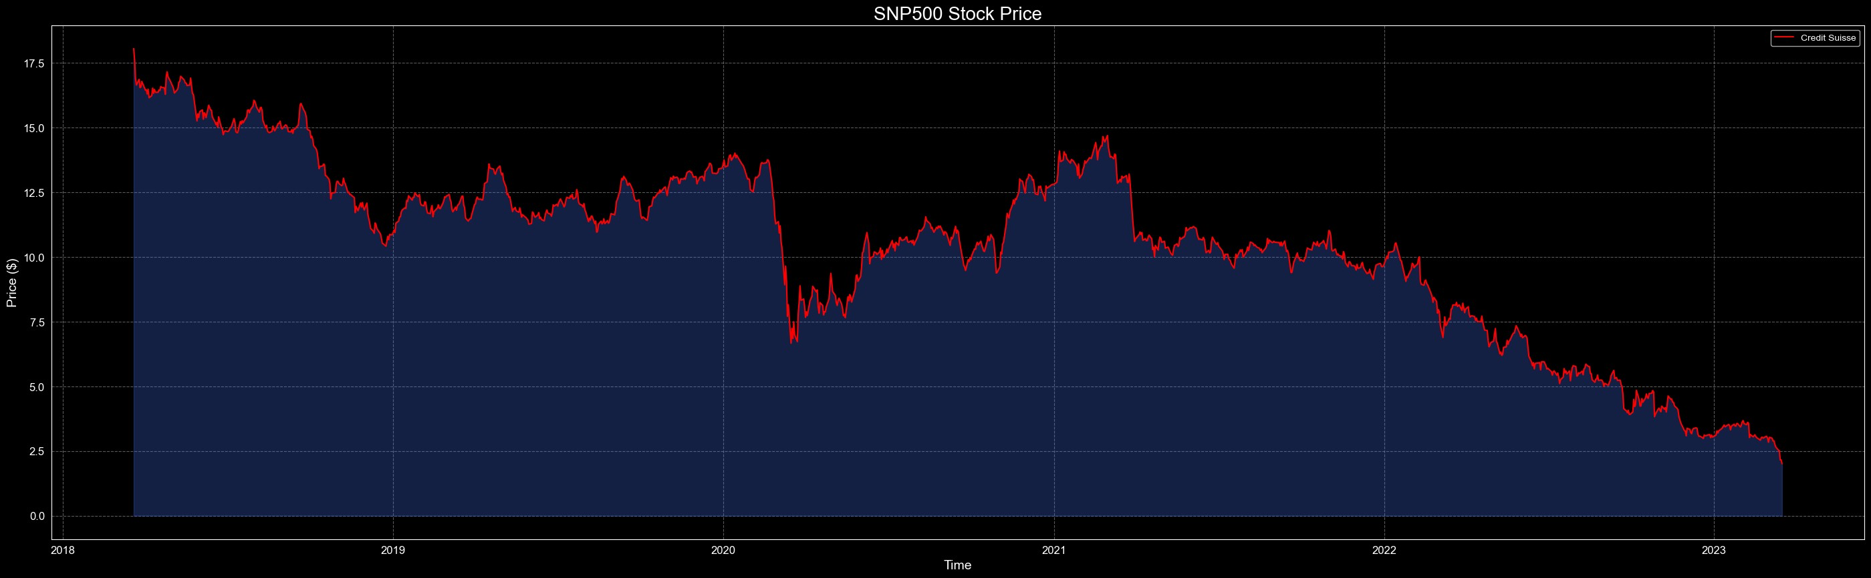

### SNP500

In [85]:

ticker2 **=** "^GSPC"

stock2 **=** yf**.**download(ticker2, start**=**"2018-03-20", end**=**"2023-03-20") stock2**.**shape

Out[85]:

[*********************100%***********************] 1 of 1 completed

(1258, 6)

In [86]:

plt**.**style**.**use('dark_background') plt**.**figure(figsize**=**(35,10))

plt**.**plot(stock2**.**index, stock2['Close'], label**=**'SNP500', color**=**"red") plt**.**fill_between(stock2**.**index, stock2['Close'], 0, alpha**=**0.3,color**=**'orang plt**.**title('SNP500 Stock Price', fontsize**=**20, color**=**"White") plt**.**xlabel("Time", fontsize**=**14)

plt**.**ylabel("Price (£)", fontsize**=**14) plt**.**legend(loc**=**'best') plt**.**tick_params(axis**=**"both", labelsize**=**12) plt**.**grid(linestyle**=**'--', color**=**'gray', alpha**=**0.7) plt**.**show()

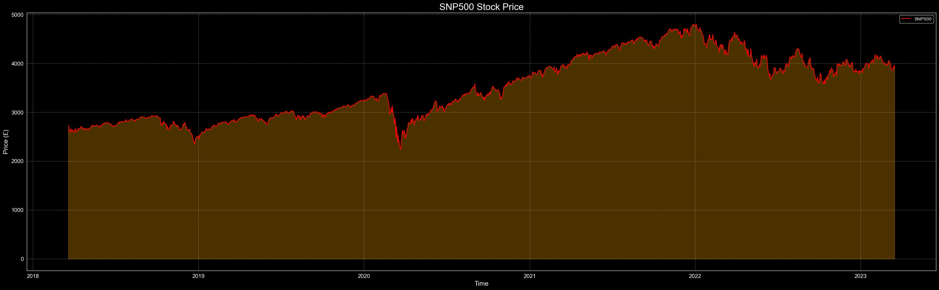

## FTSE100

In [87]:

ticker3 **=** "^FTSE"

stock3 **=** yf**.**download(ticker3, start**=**"2018-03-20", end**=**"2023-03-20") stock3**.**shape

Out[87]:

In [88]:

plt**.**style**.**use('dark_background') plt**.**figure(figsize**=**(35,10))

plt**.**plot(stock3**.**index, stock3['Close'], label**=**'FTSE100', color**=**"red") plt**.**fill_between(stock3**.**index, stock3['Close'], 0, alpha**=**0.3,color**=**'pink' plt**.**title('FTSE100 Stock Price', fontsize**=**20, color**=**"White") plt**.**xlabel("Time", fontsize**=**14)

plt**.**ylabel("Price ($)", fontsize**=**14) plt**.**legend(loc**=**'best') plt**.**tick_params(axis**=**"both", labelsize**=**12) plt**.**grid(linestyle**=**'--', color**=**'gray', alpha**=**0.7) plt**.**show()

[*********************100%***********************] 1 of 1 completed

(1261, 6)

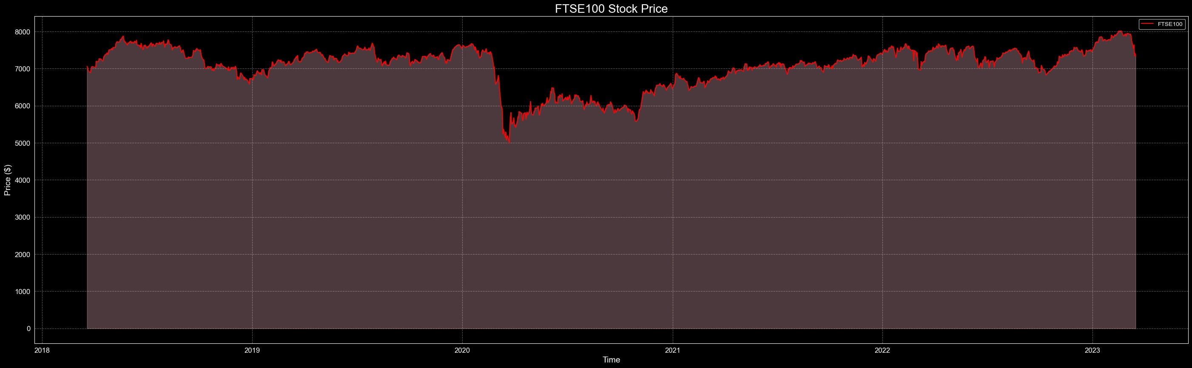

# SKLEARN LINEAR REGRESSION



In [39]:

**from** sklearn.linear_model **import** LinearRegression **from** sklearn.model_selection **import** train_test_split **from** datetime **import** datetime

|  |  |  |
| --- | --- | --- |
|  | | PRICE ANALYSIS |
| TEN YEAR TIME SERIES ANALYSIS |
| In | [40]: | cs **=** yf**.**Ticker("CS")  data **=** cs**.**history(period**=**"10y") |
| In | [41]: | data['Date_ordinal'] **=** [datetime**.**toordinal(d) **for** d **in** data**.**index] |
|  |  | X_train, X_test, y_train, y_test **=** train_test_split(data['Date_ordinal']**.** |
| In | [42]: | *# Create a linear regression model*  model **=** LinearRegression() |
|  |  |  |
| In | [43]: | *# Train the model*  model**.**fit(X_train, y_train) |

Out[43]:

LinearRegression()

▾ LinearRegression

In [44]:

*# Predict the values*

y_pred **=** model**.**predict(X_test)

In [45]:

*# Convert ordinal value back to date*

X_test **=** [datetime**.**fromordinal(int(d)) **for** d **in** X_test**.**flatten()]

In [46]:

plt**.**style**.**use('dark_background') plt**.**figure(figsize**=**(35,15))

sns**.**scatterplot(x**=**X_test, y**=**y_test, label**=**'Actual', color**=**'blue') plt**.**plot(X_test, y_pred, label**=**'Predicted', color**=**'red') plt**.**title('Linear Regression Model - 10 year chart', fontsize**=**30, color**=**" plt**.**xlabel("SNP500 ($)", fontsize**=**20, fontweight**=**'bold') plt**.**ylabel("Credit Suisse ($)", fontsize**=**20, fontweight**=**'bold') plt**.**tick_params(axis**=**"both", labelsize**=**16)

plt**.**grid(linestyle**=**'--', color**=**'gray', alpha**=**0.7) plt**.**show()

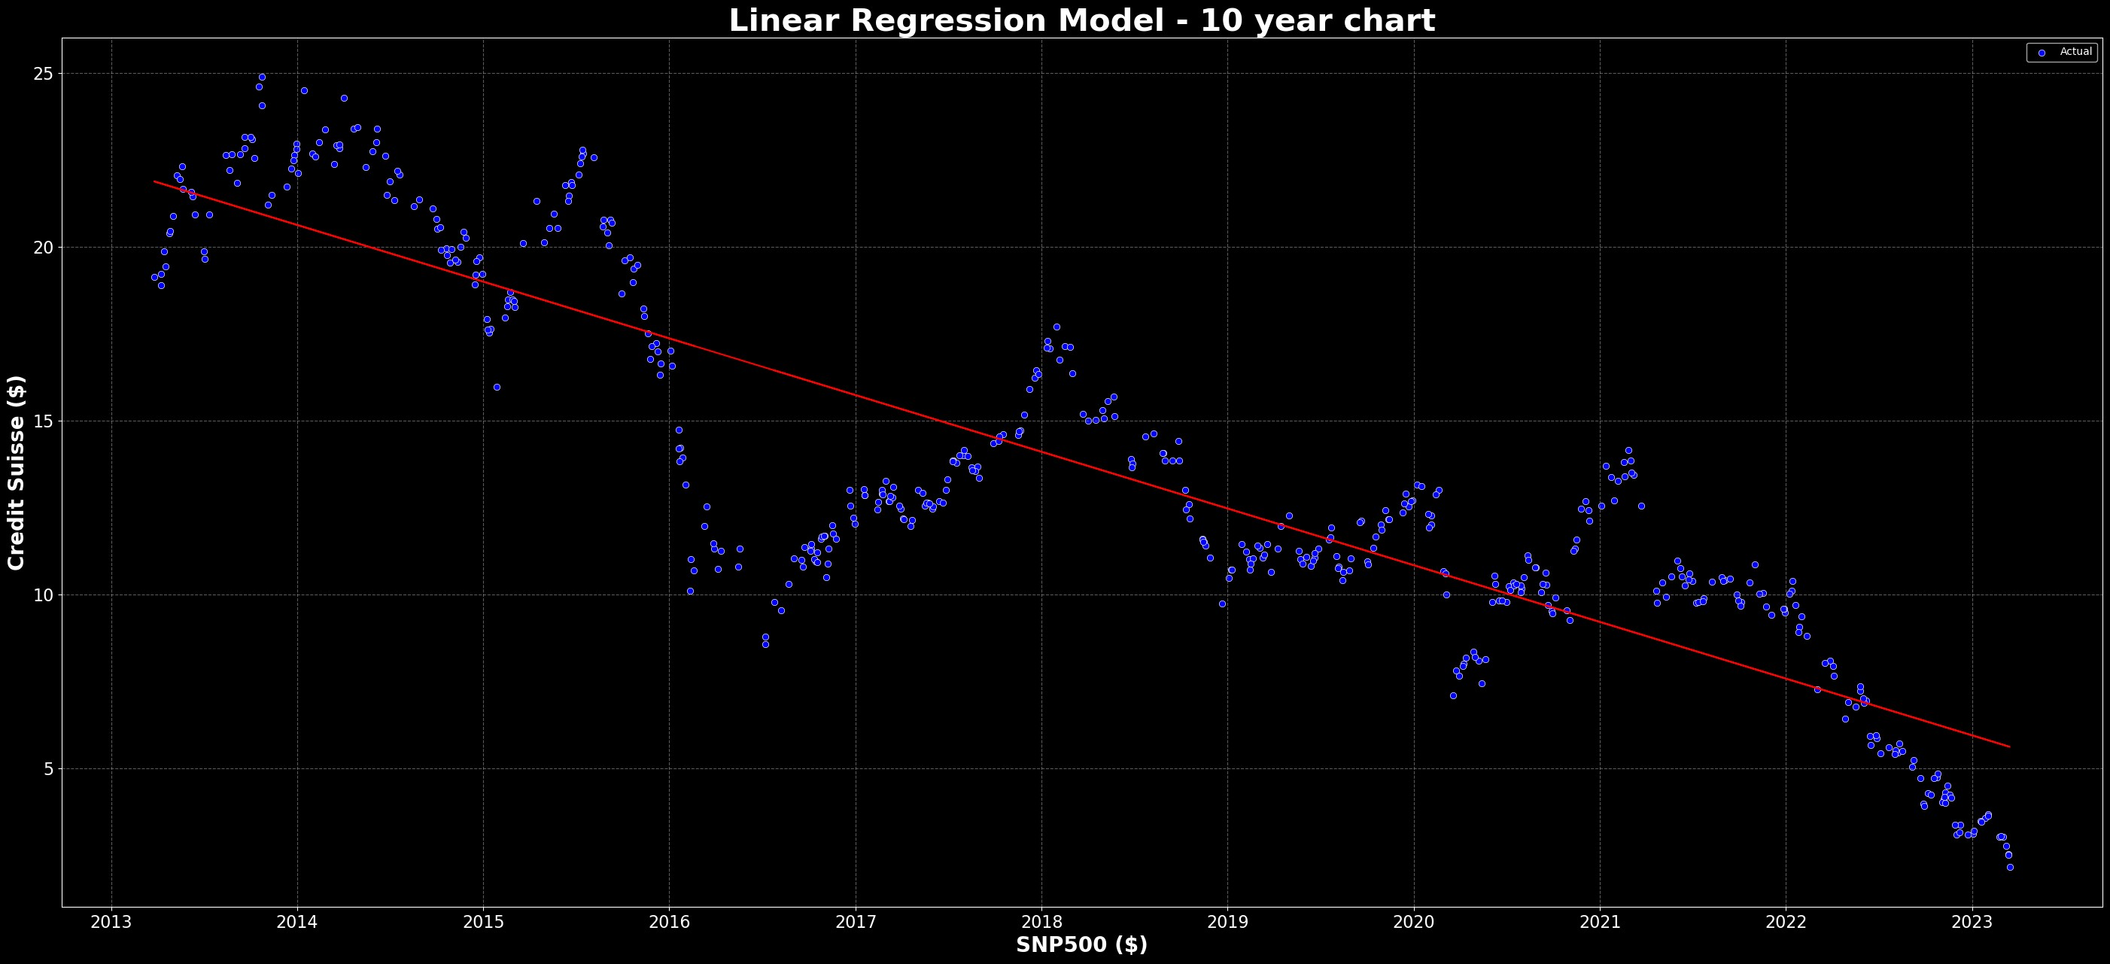

|  |  |  |
| --- | --- | --- |
|  | | FIVE YEAR TIME SERIES ANALYSIS |
| In | [47]: | cs **=** yf**.**Ticker("CS")  data **=** cs**.**history(period**=**"5y") |
| In | [48]: | data['Date_ordinal'] **=** [datetime**.**toordinal(d) **for** d **in** data**.**index] |
|  |  | X_train, X_test, y_train, y_test **=** train_test_split(data['Date_ordinal']**.** |
| In | [49]: | *# Create a linear regression model*  model **=** LinearRegression() |
|  |  |  |
| In | [50]: | *# Train the model*  model**.**fit(X_train, y_train) |

Out[50]:

LinearRegression()

▾ LinearRegression

In [51]:

*# Predict the values*

y_pred **=** model**.**predict(X_test)

In [52]:

*# Convert ordinal value back to date*

X_test **=** [datetime**.**fromordinal(int(d)) **for** d **in** X_test**.**flatten()]

In [53]:

plt**.**style**.**use('dark_background') plt**.**figure(figsize**=**(35,15))

sns**.**scatterplot(x**=**X_test, y**=**y_test, label**=**'Actual', color**=**'blue') plt**.**plot(X_test, y_pred, label**=**'Predicted', color**=**'red') plt**.**title('Linear Regression Model - 5 year chart', fontsize**=**30, color**=**"W plt**.**xlabel("SNP500 ($)", fontsize**=**20, fontweight**=**'bold') plt**.**ylabel("Credit Suisse ($)", fontsize**=**20, fontweight**=**'bold') plt**.**tick_params(axis**=**"both", labelsize**=**16)

plt**.**grid(linestyle**=**'--', color**=**'gray', alpha**=**0.7) plt**.**show()

### ONE YEAR TIME SERIES ANALYSIS

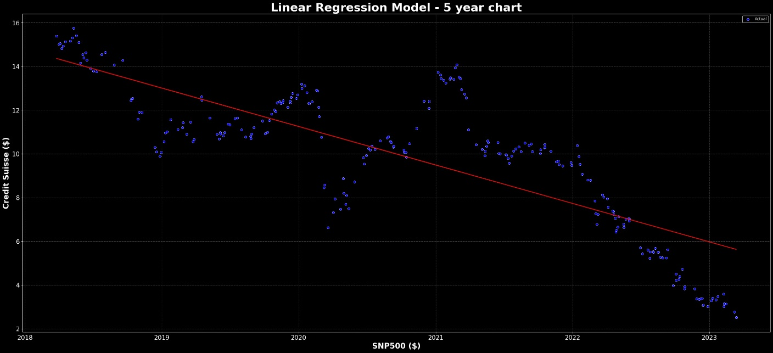

Reg

e(

In [54]:

cs **=** yf**.**Ticker("CS")

data **=** cs**.**history(period**=**"1y")

In [55]:

data['Date_ordinal'] **=** [datetime**.**toordinal(d) **for** d **in** data**.**index] X_train, X_test, y_train, y_test **=** train_test_split(data['Date_ordinal']**.**

In [56]:

*# Create a linear regression model*

model **=** LinearRegression()

In [57]:

*# Train the model*

model**.**fit(X_train, y_train)

Out[57]:

LinearRegression()

▾ LinearRegression

In [58]:

*# Predict the values*

y_pred **=** model**.**predict(X_test)

In [59]:

*# Convert ordinal value back to date*

X_test **=** [datetime**.**fromordinal(int(d)) **for** d **in** X_test**.**flatten()]

In [60]:

plt**.**style**.**use('dark_background') plt**.**figure(figsize**=**(35,15))

sns**.**scatterplot(x**=**X_test, y**=**y_test, label**=**'Actual', color**=**'blue') plt**.**plot(X_test, y_pred, label**=**'Predicted', color**=**'red') plt**.**title('Linear Regression Model - 1 year chart', fontsize**=**30, color**=**"W plt**.**xlabel("SNP500 ($)", fontsize**=**20, fontweight**=**'bold') plt**.**ylabel("Credit Suisse ($)", fontsize**=**20, fontweight**=**'bold') plt**.**tick_params(axis**=**"both", labelsize**=**16)

plt**.**grid(linestyle**=**'--', color**=**'gray', alpha**=**0.7) plt**.**show()

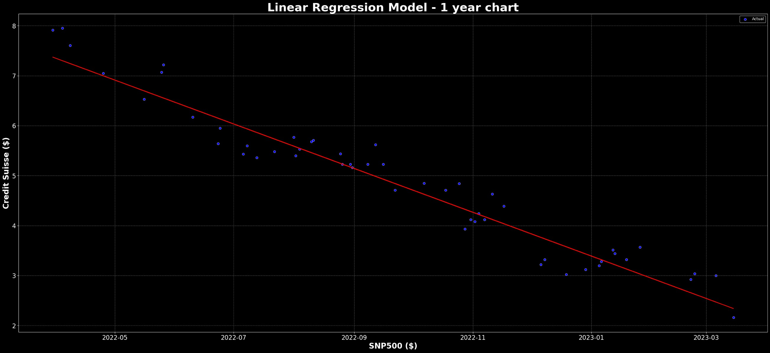

|  |  |  |
| --- | --- | --- |
|  | | VOLUME ANALYSIS |
| In | [100… | cs **=** yf**.**Ticker("CS")  data **=** cs**.**history(period**=**"max") |
| In | [101… | data['Date_ordinal'] **=** [datetime**.**toordinal(d) **for** d **in** data**.**index] |
|  |  | X_train, X_test, y_train, y_test **=** train_test_split(data['Date_ordinal']**.** |
| In | [102… | *# Create a linear regression model*  model **=** LinearRegression() |
|  |  |  |
| In | [103… | *# Train the model*  model**.**fit(X_train, y_train) |

Out[103]:

LinearRegression()

▾ LinearRegression

In [104…

*# Predict the values*

y_pred **=** model**.**predict(X_test)

In [105…

*# Convert ordinal value back to date*

X_test **=** [datetime**.**fromordinal(int(d)) **for** d **in** X_test**.**flatten()]

In [106…

**from** matplotlib.ticker **import** FuncFormatter

In [109…

plt**.**style**.**use('dark_background') plt**.**figure(figsize**=**(35,15))

plt**.**gca()**.**yaxis**.**set_major_formatter(FuncFormatter(**lambda** x, _: '{:.0f}'**.**f sns**.**scatterplot(x**=**X_test, y**=**y_test, label**=**'Actual', color**=**'blue') plt**.**plot(X_test, y_pred, label**=**'Predicted', color**=**'red') plt**.**title('Linear Regression Model', fontsize**=**30, color**=**"White", fontweig plt**.**xlabel("SNP500 ($)", fontsize**=**20, fontweight**=**'bold') plt**.**ylabel("Units", fontsize**=**20, fontweight**=**'bold') plt**.**tick_params(axis**=**"both", labelsize**=**16)

plt**.**grid(linestyle**=**'--', color**=**'gray', alpha**=**0.7) plt**.**show()

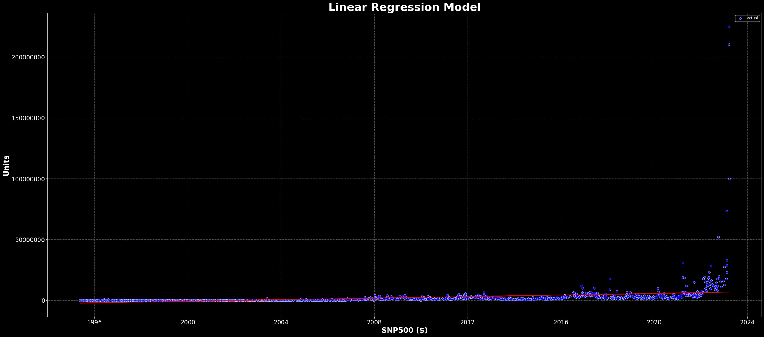

SNP500 & CREDIT SUISSE

### A common approach is to use between 1 to 5 years of historical data to train a linear regression model for stock market prediction. It is important to note that linear regression may not be the most appropriate model for predicting the stock market, as it assumes a linear relationship between the predictors and the target variable, which may not always hold in the complex and dynamic stock market. Linear regression using Machine Learning Library stills show price is moving into downwards directions.

THE UNITS ARE IN DOLLARS FOR SNP500 & CREDIT SUISSE

In [89]:

credit_suisse **=** yf**.**Ticker("CS")**.**history(period**=**"5y") snp500 **=** yf**.**Ticker("^GSPC")**.**history(period**=**"5y")

In [90]:

*# Preprocess the data by extracting the "Close" prices for Credit Suisse*

y **=** credit_suisse["Close"]**.**values

x **=** snp500["Close"]**.**values**.**reshape(**-**1, 1)

In [91]:

*#Linear Regression Model* model_reg **=** LinearRegression() model_reg

Out[91]:

LinearRegression()

▾ LinearRegression

In [92]:

*#Training Model*

model_reg**.**fit(x,y)

Out[92]:

LinearRegression()

▾ LinearRegression

In [93]:

pred_y **=** model_reg**.**predict(x)

In [94]:

pred_y**.**shape

Out[94]: (1258,)

In [95]:

plt**.**style**.**use('dark_background') plt**.**figure(figsize**=**(35,15))

sns**.**scatterplot(x**=**x**.**flatten(), y**=**y**.**flatten(), color**=**'tab:red', alpha**=**0.9) plt**.**plot(x, pred_y, color**=**'tab:blue', linewidth**=**2)

plt**.**title('Linear Regression Model', fontsize**=**30, color**=**"White", fontweig plt**.**xlabel("SNP500 ($)", fontsize**=**20, fontweight**=**'bold') plt**.**ylabel("Credit Suisse ($)", fontsize**=**20, fontweight**=**'bold') plt**.**tick_params(axis**=**"both", labelsize**=**16)

plt**.**grid(linestyle**=**'--', color**=**'gray', alpha**=**0.7) plt**.**show()

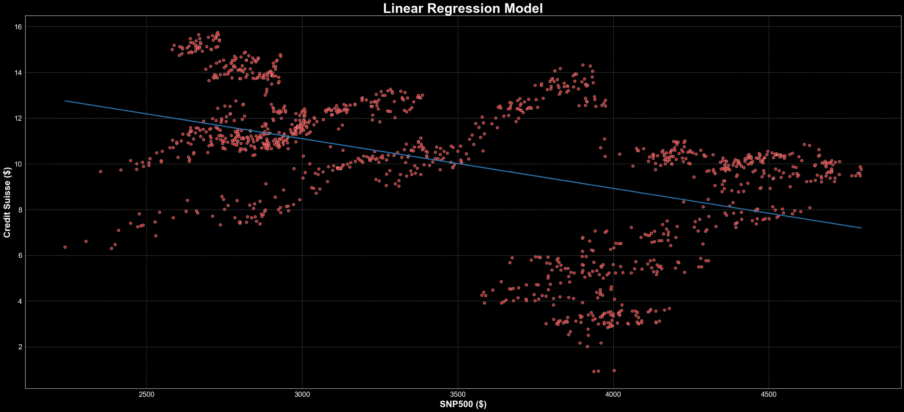

In [96]:

**from** sklearn.metrics **import** mean_squared_error

In [97]:

mse **=** mean_squared_error(y, pred_y) print("Mean squared error:", mse)

Mean squared error: 7.820189149817397

In [98]:

*# calculate the mean squared error* mse **=** np**.**mean((y **-** pred_y)**\*\***2) print("Mean Squared Error:", mse)

Mean Squared Error: 7.820189149817397

The mean squared error (MSE) value of 7.777455434440157 is a measure of the average squared differences between the actual values of the Credit Suisse stock prices and the predicted values of the stock prices based on the S&P 500 index.

This indicates that the model used to predict the Credit Suisse stock prices based on the S&P 500 index may have some degree of error or inaccuracy in its predictions.

The MSE value of 7.777455434440157 can be used as a reference for evaluating and comparing the performance of other predictive models for the same task.

It's difficult to say whether a mean squared error of 7.777455434440157 is good or bad without more context. Generally, a lower mean squared error indicates that the model is better at making predictions.

However, what is considered a "good" mean squared error can vary depending on the specific problem and the data being used. It's important to compare the mean squared error of a model to other models and to consider the practical implications of the error.

## FTSE100 & CREDIT SUISSE

THE UNITS ARE IN POUNDS FOR FTSE100 & CREDIT SUISSE

In [99]:

credit_suisse **=** yf**.**Ticker("CS")**.**history(period**=**"5y") ftse100 **=** yf**.**Ticker("^FTSE")**.**history(period**=**"5y")

In [100…

**from** forex_python.converter **import** CurrencyRates

In [101…

c **=** CurrencyRates()

exchange_rate **=** c**.**get_rate('USD', 'GBP')

credit_suisse["Close"] **=** credit_suisse["Close"] **\*** exchange_rate credit_suisse["Open"] **=** credit_suisse["Open"] **\*** exchange_rate credit_suisse["High"] **=** credit_suisse["High"] **\*** exchange_rate credit_suisse["Low"] **=** credit_suisse["Low"] **\*** exchange_rate

In [102… Out[102]:

credit_suisse**.**tail(1)

In [103…

ftse100**.**tail(1)

Date 2023-03-22

00:00:00-

04:00

Open High Low Close Volume Dividends Stock

Splits

0.76792 0.784258 0.743412 0.751581 100043800 0.0 0.0

Out[103]:

Open High Low Close Volume Divide

Date

2023-03-23

00:00:00+00:00

7566.839844 7566.839844 7476.129883 7487.700195 0

In [104…

*# Preprocess the data by extracting the "Close" prices for Credit Suisse*

y **=** credit_suisse["Close"]**.**values

x **=** ftse100["Close"]**.**values**.**reshape(**-**1, 1)

In [105…

y *#units are on pounds (credit suisse)*

Out[105]:

In [106…

array([12.40990942, 12.57388463, 12.33537459, ..., 0.76791963,

0.79242773, 0.75158093])

y**.**shape

Out[106]: (1258,) In [107…

x**.**shape

Out[107]: (1262, 1)

In [108…

x **=** x[4:]

In [109…

x**.**shape

Out[109]: (1258, 1) In [110…

*#Linear Regression Model* model_reg **=** LinearRegression() model_reg

Out[110]:

LinearRegression()

▾ LinearRegression

In [111…

*#Training Model*

model_reg**.**fit(x,y)

Out[111]:

LinearRegression()

▾ LinearRegression

In [112…

pred_y **=** model_reg**.**predict(x)

In [113…

pred_y**.**shape

Out[113]: (1258,)

In [114…

plt**.**style**.**use('dark_background') plt**.**figure(figsize**=**(35,15))

sns**.**scatterplot(x**=**x**.**flatten(), y**=**y**.**flatten(), color**=**'tab:blue', alpha**=**0.9 plt**.**plot(x, pred_y, color**=**'tab:red', linewidth**=**2)

plt**.**title('Linear Regression Model', fontsize**=**30, color**=**"White", fontweig plt**.**xlabel("FTSE100 (£)", fontsize**=**20, fontweight**=**'bold') plt**.**ylabel("Credit Suisse (£)", fontsize**=**20, fontweight**=**'bold') plt**.**tick_params(axis**=**"both", labelsize**=**16)

plt**.**grid(linestyle**=**'--', color**=**'gray', alpha**=**0.7) plt**.**show()

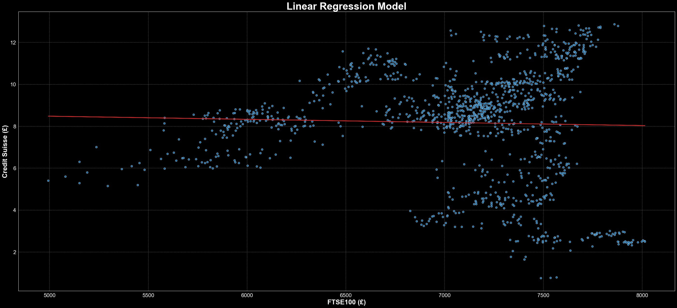

In [115…

mse **=** mean_squared_error(y, pred_y) print("Mean squared error:", mse)

Mean squared error: 6.5845920220289385

In [116…

*# calculate the mean squared error* mse **=** np**.**mean((y **-** pred_y)**\*\***2) print("Mean Squared Error:", mse)

Mean Squared Error: 6.5845920220289385

# NEURAL NETWORK REGRESSION



## CREDIT SUISSE & SNP500

In [143…

credit_suisse **=** yf**.**Ticker("CS")**.**history(period**=**"5y") snp500 **=** yf**.**Ticker("^GSPC")**.**history(period**=**"5y")

In [144…

*# Preprocess the data by extracting the "Close" prices for Credit Suisse*

y **=** credit_suisse["Close"]**.**values

x **=** snp500["Close"]**.**values**.**reshape(**-**1, 1)

In [145…

*# Preprocess the data* print(y**.**shape) print(x**.**shape)

(1258,)

(1258, 1)

In [146…

**from** keras.layers **import** Dense, Dropout

In [147…

*# Define activation and dropout parameters*

activation **=** 'relu' dropout_rate **=** 0.2

*# Initialize the neural network model*

model **=** Sequential()

*# Add layers with specified architecture*

**for** layer_size **in** [16, 32, 64, 128, 256]:

model**.**add(Dense(layer_size, input_shape**=**(1,), activation**=**activation)) model**.**add(Dropout(dropout_rate))

*# Add output layer with linear activation*

model**.**add(Dense(1, activation**=**'linear'))

In [148…

*# Compile the model with the specified loss function and optimizer* model**.**compile(loss**=**'mean_squared_error', optimizer**=**'adam', metrics**=**['mean *# Train the model*

model**.**fit(x, y, epochs**=**250, batch_size**=**32, verbose**=**1)

Epoch 1/250

40/40 [==============================] - 1s 3ms/step - loss: 13075.5029

* mean_squared_error: 13075.5029 Epoch 2/250

40/40 [==============================] - 0s 3ms/step - loss: 2591.7158 -

mean_squared_error: 2591.7158 Epoch 3/250

40/40 [==============================] - 0s 3ms/step - loss: 1449.1232 -

mean_squared_error: 1449.1232 Epoch 4/250

|  |  |  |  |  |  |
| --- | --- | --- | --- | --- | --- |
| 40/40 [==============================] | - 0s | 3ms/step | - loss: | 874.3273 | - |
| mean_squared_error: 874.3273 |  |  |  |  |  |
| Epoch 5/250 |  |  |  |  |  |
| 40/40 [==============================] | - 0s | 3ms/step | - loss: | 707.9475 | - |
| mean_squared_error: 707.9475 |  |  |  |  |  |
| Epoch 6/250 |  |  |  |  |  |
| 40/40 [==============================] | - 0s | 2ms/step | - loss: | 539.0250 | - |
| mean_squared_error: 539.0250 |  |  |  |  |  |
| Epoch 7/250 |  |  |  |  |  |
| 40/40 [==============================] | - 0s | 4ms/step | - loss: | 421.0649 | - |

mean_squared_error: 421.0649 Epoch 8/250

40/40 [==============================] - 0s 2ms/step - loss: 343.3991 -

mean_squared_error: 343.3991 Epoch 9/250

40/40 [==============================] - 0s 2ms/step - loss: 293.5563 -

mean_squared_error: 293.5563 Epoch 10/250

40/40 [==============================] - 0s 2ms/step - loss: 265.3694 -

mean_squared_error: 265.3694 Epoch 11/250

40/40 [==============================] - 0s 2ms/step - loss: 227.7009 -

mean_squared_error: 227.7009 Epoch 12/250

40/40 [==============================] - 0s 2ms/step - loss: 194.1156 -

mean_squared_error: 194.1156 Epoch 13/250

40/40 [==============================] - 0s 3ms/step - loss: 194.5367 -

mean_squared_error: 194.5367 Epoch 14/250

40/40 [==============================] - 0s 5ms/step - loss: 147.1288 -

mean_squared_error: 147.1288 Epoch 15/250

40/40 [==============================] - 0s 2ms/step - loss: 152.5828 -

mean_squared_error: 152.5828 Epoch 16/250

40/40 [==============================] - 0s 2ms/step - loss: 129.1334 -

mean_squared_error: 129.1334 Epoch 17/250

40/40 [==============================] - 0s 2ms/step - loss: 130.6100 -

mean_squared_error: 130.6100 Epoch 18/250

40/40 [==============================] - 0s 3ms/step - loss: 110.5337 -

mean_squared_error: 110.5337 Epoch 19/250

40/40 [==============================] - 0s 2ms/step - loss: 102.0994 -

mean_squared_error: 102.0994 Epoch 20/250

40/40 [==============================] - 0s 2ms/step - loss: 109.7932 -

mean_squared_error: 109.7932 Epoch 21/250

40/40 [==============================] - 0s 2ms/step - loss: 87.4296 - m

ean_squared_error: 87.4296 Epoch 22/250

40/40 [==============================] - 0s 2ms/step - loss: 84.9521 - m

ean_squared_error: 84.9521 Epoch 23/250

40/40 [==============================] - 0s 2ms/step - loss: 80.3151 - m

ean_squared_error: 80.3151 Epoch 24/250

40/40 [==============================] - 0s 2ms/step - loss: 79.6451 - m

ean_squared_error: 79.6451 Epoch 25/250

40/40 [==============================] - 0s 3ms/step - loss: 79.0324 - m

ean_squared_error: 79.0324 Epoch 26/250

40/40 [==============================] - 0s 3ms/step - loss: 70.1860 - m

ean_squared_error: 70.1860 Epoch 27/250

40/40 [==============================] - 0s 3ms/step - loss: 68.1494 - m

ean_squared_error: 68.1494 Epoch 28/250

40/40 [==============================] - 0s 3ms/step - loss: 63.8184 - m

ean_squared_error: 63.8184 Epoch 29/250

40/40 [==============================] - 0s 2ms/step - loss: 65.1780 - m

ean_squared_error: 65.1780 Epoch 30/250

40/40 [==============================] - 0s 3ms/step - loss: 55.1391 - m

ean_squared_error: 55.1391 Epoch 31/250

40/40 [==============================] - 0s 3ms/step - loss: 58.4757 - m

ean_squared_error: 58.4757 Epoch 32/250

40/40 [==============================] - 0s 2ms/step - loss: 54.3021 - m

ean_squared_error: 54.3021 Epoch 33/250

40/40 [==============================] - 0s 2ms/step - loss: 52.0620 - m

ean_squared_error: 52.0620 Epoch 34/250

40/40 [==============================] - 0s 2ms/step - loss: 50.5989 - m

ean_squared_error: 50.5989 Epoch 35/250

40/40 [==============================] - 0s 2ms/step - loss: 47.4356 - m

ean_squared_error: 47.4356 Epoch 36/250

40/40 [==============================] - 0s 2ms/step - loss: 48.7417 - m

ean_squared_error: 48.7417 Epoch 37/250

40/40 [==============================] - 0s 2ms/step - loss: 45.0190 - m

ean_squared_error: 45.0190 Epoch 38/250

40/40 [==============================] - 0s 2ms/step - loss: 41.9719 - m

ean_squared_error: 41.9719 Epoch 39/250

40/40 [==============================] - 0s 3ms/step - loss: 43.3884 - m

ean_squared_error: 43.3884 Epoch 40/250

40/40 [==============================] - 0s 2ms/step - loss: 44.4293 - m

ean_squared_error: 44.4293 Epoch 41/250

40/40 [==============================] - 0s 3ms/step - loss: 39.4684 - m

ean_squared_error: 39.4684 Epoch 42/250

40/40 [==============================] - 0s 2ms/step - loss: 40.5420 - m

ean_squared_error: 40.5420 Epoch 43/250

40/40 [==============================] - 0s 3ms/step - loss: 38.6888 - m

ean_squared_error: 38.6888 Epoch 44/250

40/40 [==============================] - 0s 2ms/step - loss: 35.9611 - m

ean_squared_error: 35.9611 Epoch 45/250

40/40 [==============================] - 0s 3ms/step - loss: 37.0057 - m

ean_squared_error: 37.0057 Epoch 46/250

40/40 [==============================] - 0s 2ms/step - loss: 37.4800 - m

ean_squared_error: 37.4800 Epoch 47/250

40/40 [==============================] - 0s 2ms/step - loss: 34.9991 - m

ean_squared_error: 34.9991 Epoch 48/250

40/40 [==============================] - 0s 2ms/step - loss: 35.2491 - m

ean_squared_error: 35.2491 Epoch 49/250

40/40 [==============================] - 0s 3ms/step - loss: 33.4743 - m

ean_squared_error: 33.4743 Epoch 50/250

40/40 [==============================] - 0s 2ms/step - loss: 34.2797 - m

ean_squared_error: 34.2797 Epoch 51/250

40/40 [==============================] - 0s 3ms/step - loss: 31.5830 - m

ean_squared_error: 31.5830 Epoch 52/250

40/40 [==============================] - 0s 3ms/step - loss: 31.3733 - m

ean_squared_error: 31.3733 Epoch 53/250

40/40 [==============================] - 0s 2ms/step - loss: 30.3685 - m

ean_squared_error: 30.3685 Epoch 54/250

40/40 [==============================] - 0s 2ms/step - loss: 30.6050 - m

ean_squared_error: 30.6050 Epoch 55/250

40/40 [==============================] - 0s 2ms/step - loss: 31.4028 - m

ean_squared_error: 31.4028 Epoch 56/250

40/40 [==============================] - 0s 2ms/step - loss: 31.4509 - m

ean_squared_error: 31.4509 Epoch 57/250

40/40 [==============================] - 0s 3ms/step - loss: 29.1246 - m

ean_squared_error: 29.1246 Epoch 58/250

40/40 [==============================] - 0s 2ms/step - loss: 26.3616 - m

ean_squared_error: 26.3616 Epoch 59/250

40/40 [==============================] - 0s 2ms/step - loss: 27.5851 - m

ean_squared_error: 27.5851 Epoch 60/250

40/40 [==============================] - 0s 2ms/step - loss: 27.0646 - m

ean_squared_error: 27.0646 Epoch 61/250

40/40 [==============================] - 0s 2ms/step - loss: 26.3113 - m

ean_squared_error: 26.3113 Epoch 62/250

40/40 [==============================] - 0s 2ms/step - loss: 29.0959 - m

ean_squared_error: 29.0959 Epoch 63/250

40/40 [==============================] - 0s 3ms/step - loss: 25.5723 - m

ean_squared_error: 25.5723 Epoch 64/250

40/40 [==============================] - 0s 2ms/step - loss: 26.4503 - m

ean_squared_error: 26.4503 Epoch 65/250

40/40 [==============================] - 0s 2ms/step - loss: 26.5493 - m

ean_squared_error: 26.5493 Epoch 66/250

40/40 [==============================] - 0s 3ms/step - loss: 24.8261 - m

ean_squared_error: 24.8261 Epoch 67/250

40/40 [==============================] - 0s 2ms/step - loss: 26.1670 - m

ean_squared_error: 26.1670 Epoch 68/250

40/40 [==============================] - 0s 2ms/step - loss: 25.4118 - m

ean_squared_error: 25.4118 Epoch 69/250

40/40 [==============================] - 0s 2ms/step - loss: 25.8555 - m

ean_squared_error: 25.8555 Epoch 70/250

40/40 [==============================] - 0s 3ms/step - loss: 26.4481 - m

ean_squared_error: 26.4481 Epoch 71/250

40/40 [==============================] - 0s 2ms/step - loss: 24.0890 - m

ean_squared_error: 24.0890 Epoch 72/250

40/40 [==============================] - 0s 2ms/step - loss: 24.9015 - m

ean_squared_error: 24.9015 Epoch 73/250

40/40 [==============================] - 0s 2ms/step - loss: 25.6150 - m

ean_squared_error: 25.6150 Epoch 74/250

40/40 [==============================] - 0s 2ms/step - loss: 24.6986 - m

ean_squared_error: 24.6986 Epoch 75/250

40/40 [==============================] - 0s 3ms/step - loss: 25.1208 - m

ean_squared_error: 25.1208 Epoch 76/250

40/40 [==============================] - 0s 2ms/step - loss: 24.5107 - m

ean_squared_error: 24.5107 Epoch 77/250

40/40 [==============================] - 0s 2ms/step - loss: 23.9236 - m

ean_squared_error: 23.9236 Epoch 78/250

40/40 [==============================] - 0s 2ms/step - loss: 23.5507 - m

ean_squared_error: 23.5507 Epoch 79/250

40/40 [==============================] - 0s 3ms/step - loss: 24.2132 - m

ean_squared_error: 24.2132 Epoch 80/250

40/40 [==============================] - 0s 2ms/step - loss: 23.8153 - m

ean_squared_error: 23.8153 Epoch 81/250

40/40 [==============================] - 0s 3ms/step - loss: 22.4952 - m

ean_squared_error: 22.4952 Epoch 82/250

40/40 [==============================] - 0s 2ms/step - loss: 23.1272 - m

ean_squared_error: 23.1272 Epoch 83/250

40/40 [==============================] - 0s 3ms/step - loss: 23.0064 - m

ean_squared_error: 23.0064 Epoch 84/250

40/40 [==============================] - 0s 3ms/step - loss: 23.9996 - m

ean_squared_error: 23.9996 Epoch 85/250

40/40 [==============================] - 0s 2ms/step - loss: 24.0745 - m

ean_squared_error: 24.0745 Epoch 86/250

40/40 [==============================] - 0s 3ms/step - loss: 22.6452 - m

ean_squared_error: 22.6452 Epoch 87/250

40/40 [==============================] - 0s 2ms/step - loss: 21.3872 - m

ean_squared_error: 21.3872 Epoch 88/250

40/40 [==============================] - 0s 5ms/step - loss: 22.6239 - m

ean_squared_error: 22.6239 Epoch 89/250

40/40 [==============================] - 0s 2ms/step - loss: 21.8676 - m

ean_squared_error: 21.8676 Epoch 90/250

40/40 [==============================] - 0s 2ms/step - loss: 22.3085 - m

ean_squared_error: 22.3085 Epoch 91/250

40/40 [==============================] - 0s 3ms/step - loss: 21.3830 - m

ean_squared_error: 21.3830 Epoch 92/250

40/40 [==============================] - 0s 2ms/step - loss: 22.2698 - m

ean_squared_error: 22.2698 Epoch 93/250

40/40 [==============================] - 0s 2ms/step - loss: 23.1638 - m

ean_squared_error: 23.1638 Epoch 94/250

40/40 [==============================] - 0s 2ms/step - loss: 21.5814 - m

ean_squared_error: 21.5814 Epoch 95/250

40/40 [==============================] - 0s 2ms/step - loss: 21.2446 - m

ean_squared_error: 21.2446 Epoch 96/250

40/40 [==============================] - 0s 3ms/step - loss: 20.4182 - m

ean_squared_error: 20.4182 Epoch 97/250

40/40 [==============================] - 0s 2ms/step - loss: 21.4031 - m

ean_squared_error: 21.4031 Epoch 98/250

40/40 [==============================] - 0s 2ms/step - loss: 21.0020 - m

ean_squared_error: 21.0020 Epoch 99/250

40/40 [==============================] - 0s 2ms/step - loss: 20.5760 - m

ean_squared_error: 20.5760 Epoch 100/250

40/40 [==============================] - 0s 2ms/step - loss: 21.0659 - m

ean_squared_error: 21.0659 Epoch 101/250

40/40 [==============================] - 0s 2ms/step - loss: 20.3631 - m

ean_squared_error: 20.3631 Epoch 102/250

40/40 [==============================] - 0s 2ms/step - loss: 20.5500 - m

ean_squared_error: 20.5500 Epoch 103/250

40/40 [==============================] - 0s 3ms/step - loss: 20.7849 - m

ean_squared_error: 20.7849 Epoch 104/250

40/40 [==============================] - 0s 2ms/step - loss: 19.7230 - m

ean_squared_error: 19.7230 Epoch 105/250

40/40 [==============================] - 0s 3ms/step - loss: 20.3916 - m

ean_squared_error: 20.3916 Epoch 106/250

40/40 [==============================] - 0s 2ms/step - loss: 20.8305 - m

ean_squared_error: 20.8305 Epoch 107/250

40/40 [==============================] - 0s 2ms/step - loss: 20.5666 - m

ean_squared_error: 20.5666 Epoch 108/250

40/40 [==============================] - 0s 2ms/step - loss: 21.1236 - m

ean_squared_error: 21.1236 Epoch 109/250

40/40 [==============================] - 0s 2ms/step - loss: 20.3115 - m

ean_squared_error: 20.3115 Epoch 110/250

40/40 [==============================] - 0s 2ms/step - loss: 19.9997 - m

ean_squared_error: 19.9997 Epoch 111/250

40/40 [==============================] - 0s 2ms/step - loss: 20.5746 - m

ean_squared_error: 20.5746 Epoch 112/250

40/40 [==============================] - 0s 3ms/step - loss: 19.5773 - m

ean_squared_error: 19.5773 Epoch 113/250

40/40 [==============================] - 0s 2ms/step - loss: 19.1643 - m

ean_squared_error: 19.1643 Epoch 114/250

40/40 [==============================] - 0s 2ms/step - loss: 19.2199 - m

ean_squared_error: 19.2199 Epoch 115/250

40/40 [==============================] - 0s 2ms/step - loss: 18.7475 - m

ean_squared_error: 18.7475 Epoch 116/250

40/40 [==============================] - 0s 2ms/step - loss: 19.3550 - m

ean_squared_error: 19.3550 Epoch 117/250

40/40 [==============================] - 0s 3ms/step - loss: 18.8713 - m

ean_squared_error: 18.8713 Epoch 118/250

40/40 [==============================] - 0s 3ms/step - loss: 18.9559 - m

ean_squared_error: 18.9559 Epoch 119/250

40/40 [==============================] - 0s 3ms/step - loss: 19.7615 - m

ean_squared_error: 19.7615 Epoch 120/250

40/40 [==============================] - 0s 2ms/step - loss: 19.4535 - m

ean_squared_error: 19.4535 Epoch 121/250

40/40 [==============================] - 0s 2ms/step - loss: 19.6416 - m

ean_squared_error: 19.6416 Epoch 122/250

40/40 [==============================] - 0s 3ms/step - loss: 20.0548 - m

ean_squared_error: 20.0548 Epoch 123/250

40/40 [==============================] - 0s 2ms/step - loss: 19.0815 - m

ean_squared_error: 19.0815 Epoch 124/250

40/40 [==============================] - 0s 3ms/step - loss: 18.5069 - m

ean_squared_error: 18.5069 Epoch 125/250

40/40 [==============================] - 0s 2ms/step - loss: 18.0554 - m

ean_squared_error: 18.0554 Epoch 126/250

40/40 [==============================] - 0s 2ms/step - loss: 17.7406 - m

ean_squared_error: 17.7406 Epoch 127/250

40/40 [==============================] - 0s 2ms/step - loss: 18.4253 - m

ean_squared_error: 18.4253 Epoch 128/250

40/40 [==============================] - 0s 2ms/step - loss: 18.7018 - m

ean_squared_error: 18.7018 Epoch 129/250

40/40 [==============================] - 0s 3ms/step - loss: 18.1460 - m

ean_squared_error: 18.1460 Epoch 130/250

40/40 [==============================] - 0s 2ms/step - loss: 18.3571 - m

ean_squared_error: 18.3571 Epoch 131/250

40/40 [==============================] - 0s 3ms/step - loss: 18.0887 - m

ean_squared_error: 18.0887 Epoch 132/250

40/40 [==============================] - 0s 2ms/step - loss: 18.6994 - m

ean_squared_error: 18.6994 Epoch 133/250

40/40 [==============================] - 0s 3ms/step - loss: 18.1112 - m

ean_squared_error: 18.1112 Epoch 134/250

40/40 [==============================] - 0s 2ms/step - loss: 17.2139 - m

ean_squared_error: 17.2139 Epoch 135/250

40/40 [==============================] - 0s 4ms/step - loss: 18.0543 - m

ean_squared_error: 18.0543 Epoch 136/250

40/40 [==============================] - 0s 2ms/step - loss: 18.6478 - m

ean_squared_error: 18.6478 Epoch 137/250

40/40 [==============================] - 0s 2ms/step - loss: 17.7722 - m

ean_squared_error: 17.7722 Epoch 138/250

40/40 [==============================] - 0s 3ms/step - loss: 17.3391 - m

ean_squared_error: 17.3391 Epoch 139/250

40/40 [==============================] - 0s 2ms/step - loss: 18.6678 - m

ean_squared_error: 18.6678 Epoch 140/250

40/40 [==============================] - 0s 2ms/step - loss: 18.1770 - m

ean_squared_error: 18.1770 Epoch 141/250

40/40 [==============================] - 0s 3ms/step - loss: 17.1418 - m

ean_squared_error: 17.1418 Epoch 142/250

40/40 [==============================] - 0s 3ms/step - loss: 17.3855 - m

ean_squared_error: 17.3855 Epoch 143/250

40/40 [==============================] - 0s 3ms/step - loss: 17.7665 - m

ean_squared_error: 17.7665 Epoch 144/250

40/40 [==============================] - 0s 2ms/step - loss: 17.1913 - m

ean_squared_error: 17.1913 Epoch 145/250

40/40 [==============================] - 0s 2ms/step - loss: 17.3754 - m

ean_squared_error: 17.3754 Epoch 146/250

40/40 [==============================] - 0s 3ms/step - loss: 17.7638 - m

ean_squared_error: 17.7638 Epoch 147/250

40/40 [==============================] - 0s 2ms/step - loss: 16.1936 - m

ean_squared_error: 16.1936 Epoch 148/250

40/40 [==============================] - 0s 2ms/step - loss: 17.2552 - m

ean_squared_error: 17.2552 Epoch 149/250

40/40 [==============================] - 0s 3ms/step - loss: 16.9114 - m

ean_squared_error: 16.9114 Epoch 150/250

40/40 [==============================] - 0s 2ms/step - loss: 16.3241 - m

ean_squared_error: 16.3241 Epoch 151/250

40/40 [==============================] - 0s 2ms/step - loss: 16.8424 - m

ean_squared_error: 16.8424 Epoch 152/250

40/40 [==============================] - 0s 3ms/step - loss: 16.1001 - m

ean_squared_error: 16.1001 Epoch 153/250

40/40 [==============================] - 0s 2ms/step - loss: 16.6930 - m

ean_squared_error: 16.6930 Epoch 154/250

40/40 [==============================] - 0s 2ms/step - loss: 16.3176 - m

ean_squared_error: 16.3176 Epoch 155/250

40/40 [==============================] - 0s 2ms/step - loss: 16.3215 - m

ean_squared_error: 16.3215 Epoch 156/250

40/40 [==============================] - 0s 2ms/step - loss: 16.5621 - m

ean_squared_error: 16.5621 Epoch 157/250

40/40 [==============================] - 0s 2ms/step - loss: 15.3555 - m

ean_squared_error: 15.3555 Epoch 158/250

40/40 [==============================] - 0s 2ms/step - loss: 15.7109 - m

ean_squared_error: 15.7109 Epoch 159/250

40/40 [==============================] - 0s 2ms/step - loss: 15.3414 - m

ean_squared_error: 15.3414 Epoch 160/250

40/40 [==============================] - 0s 3ms/step - loss: 16.2644 - m

ean_squared_error: 16.2644 Epoch 161/250

40/40 [==============================] - 0s 2ms/step - loss: 16.1623 - m

ean_squared_error: 16.1623 Epoch 162/250

40/40 [==============================] - 0s 3ms/step - loss: 15.4206 - m

ean_squared_error: 15.4206 Epoch 163/250

40/40 [==============================] - 0s 2ms/step - loss: 14.7894 - m

ean_squared_error: 14.7894 Epoch 164/250

40/40 [==============================] - 0s 2ms/step - loss: 15.1239 - m

ean_squared_error: 15.1239 Epoch 165/250

40/40 [==============================] - 0s 3ms/step - loss: 14.7255 - m

ean_squared_error: 14.7255 Epoch 166/250

40/40 [==============================] - 0s 2ms/step - loss: 14.4155 - m

ean_squared_error: 14.4155 Epoch 167/250

40/40 [==============================] - 0s 3ms/step - loss: 13.7582 - m

ean_squared_error: 13.7582 Epoch 168/250

40/40 [==============================] - 0s 2ms/step - loss: 14.1769 - m

ean_squared_error: 14.1769 Epoch 169/250

40/40 [==============================] - 0s 2ms/step - loss: 14.0338 - m

ean_squared_error: 14.0338 Epoch 170/250

40/40 [==============================] - 0s 3ms/step - loss: 14.1833 - m

ean_squared_error: 14.1833 Epoch 171/250

40/40 [==============================] - 0s 3ms/step - loss: 14.1001 - m

ean_squared_error: 14.1001 Epoch 172/250

40/40 [==============================] - 0s 2ms/step - loss: 13.2150 - m

ean_squared_error: 13.2150 Epoch 173/250

40/40 [==============================] - 0s 2ms/step - loss: 13.2836 - m

ean_squared_error: 13.2836 Epoch 174/250

40/40 [==============================] - 0s 3ms/step - loss: 12.9355 - m

ean_squared_error: 12.9355 Epoch 175/250

40/40 [==============================] - 0s 2ms/step - loss: 12.5637 - m

ean_squared_error: 12.5637 Epoch 176/250

40/40 [==============================] - 0s 2ms/step - loss: 12.3646 - m

ean_squared_error: 12.3646 Epoch 177/250

40/40 [==============================] - 0s 2ms/step - loss: 13.0804 - m

ean_squared_error: 13.0804 Epoch 178/250

40/40 [==============================] - 0s 3ms/step - loss: 12.1845 - m

ean_squared_error: 12.1845 Epoch 179/250

40/40 [==============================] - 0s 2ms/step - loss: 11.9448 - m

ean_squared_error: 11.9448 Epoch 180/250

40/40 [==============================] - 0s 2ms/step - loss: 12.2040 - m

ean_squared_error: 12.2040 Epoch 181/250

40/40 [==============================] - 0s 2ms/step - loss: 11.9123 - m

ean_squared_error: 11.9123 Epoch 182/250

40/40 [==============================] - 0s 3ms/step - loss: 11.7184 - m

ean_squared_error: 11.7184 Epoch 183/250

40/40 [==============================] - 0s 2ms/step - loss: 11.3563 - m

ean_squared_error: 11.3563 Epoch 184/250

40/40 [==============================] - 0s 2ms/step - loss: 11.3206 - m

ean_squared_error: 11.3206 Epoch 185/250

40/40 [==============================] - 0s 2ms/step - loss: 11.2025 - m

ean_squared_error: 11.2025 Epoch 186/250

40/40 [==============================] - 0s 2ms/step - loss: 11.2248 - m

ean_squared_error: 11.2248 Epoch 187/250

40/40 [==============================] - 0s 2ms/step - loss: 10.9849 - m

ean_squared_error: 10.9849 Epoch 188/250

40/40 [==============================] - 0s 2ms/step - loss: 10.7695 - m

ean_squared_error: 10.7695 Epoch 189/250

40/40 [==============================] - 0s 2ms/step - loss: 10.6082 - m

ean_squared_error: 10.6082 Epoch 190/250

40/40 [==============================] - 0s 2ms/step - loss: 10.9165 - m

ean_squared_error: 10.9165 Epoch 191/250

40/40 [==============================] - 0s 3ms/step - loss: 10.7122 - m

ean_squared_error: 10.7122 Epoch 192/250

40/40 [==============================] - 0s 2ms/step - loss: 10.4910 - m

ean_squared_error: 10.4910 Epoch 193/250

40/40 [==============================] - 0s 5ms/step - loss: 10.6161 - m

ean_squared_error: 10.6161 Epoch 194/250

40/40 [==============================] - 0s 2ms/step - loss: 10.6935 - m

ean_squared_error: 10.6935 Epoch 195/250

40/40 [==============================] - 0s 2ms/step - loss: 10.5589 - m

ean_squared_error: 10.5589 Epoch 196/250

40/40 [==============================] - 0s 3ms/step - loss: 10.3499 - m

ean_squared_error: 10.3499 Epoch 197/250

40/40 [==============================] - 0s 3ms/step - loss: 10.3846 - m

|  |  |  |  |  |  |  |
| --- | --- | --- | --- | --- | --- | --- |
| ean_squared_error: 10.3846 Epoch 198/250  40/40 [==============================] | - | 0s | 2ms/step | - | loss: | 10.5009 - m |
| ean_squared_error: 10.5009 |  |  |  |  |  |  |
| Epoch 199/250 |  |  |  |  |  |  |
| 40/40 [==============================] | - | 0s | 2ms/step | - | loss: | 10.4051 - m |
| ean_squared_error: 10.4051 |  |  |  |  |  |  |
| Epoch 200/250 |  |  |  |  |  |  |
| 40/40 [==============================] | - | 0s | 3ms/step | - | loss: | 10.3710 - m |
| ean_squared_error: 10.3710 |  |  |  |  |  |  |
| Epoch 201/250 |  |  |  |  |  |  |
| 40/40 [==============================] | - | 0s | 3ms/step | - | loss: | 10.3096 - m |
| ean_squared_error: 10.3096 |  |  |  |  |  |  |
| Epoch 202/250 |  |  |  |  |  |  |
| 40/40 [==============================] | - | 0s | 3ms/step | - | loss: | 10.5788 - m |
| ean_squared_error: 10.5788 |  |  |  |  |  |  |
| Epoch 203/250 |  |  |  |  |  |  |
| 40/40 [==============================] | - | 0s | 4ms/step | - | loss: | 10.2241 - m |
| ean_squared_error: 10.2241 |  |  |  |  |  |  |
| Epoch 204/250 |  |  |  |  |  |  |
| 40/40 [==============================] | - | 0s | 3ms/step | - | loss: | 10.0352 - m |
| ean_squared_error: 10.0352 |  |  |  |  |  |  |
| Epoch 205/250 |  |  |  |  |  |  |
| 40/40 [==============================] | - | 0s | 3ms/step | - | loss: | 9.9877 - me |
| an_squared_error: 9.9877 |  |  |  |  |  |  |
| Epoch 206/250 |  |  |  |  |  |  |
| 40/40 [==============================] | - | 0s | 2ms/step | - | loss: | 10.2084 - m |
| ean_squared_error: 10.2084 |  |  |  |  |  |  |
| Epoch 207/250 |  |  |  |  |  |  |
| 40/40 [==============================] | - | 0s | 2ms/step | - | loss: | 10.1571 - m |
| ean_squared_error: 10.1571 |  |  |  |  |  |  |
| Epoch 208/250 |  |  |  |  |  |  |
| 40/40 [==============================] | - | 0s | 2ms/step | - | loss: | 10.0451 - m |
| ean_squared_error: 10.0451 |  |  |  |  |  |  |
| Epoch 209/250 |  |  |  |  |  |  |
| 40/40 [==============================] | - | 0s | 2ms/step | - | loss: | 9.8389 - me |
| an_squared_error: 9.8389 |  |  |  |  |  |  |
| Epoch 210/250 |  |  |  |  |  |  |
| 40/40 [==============================] | - | 0s | 3ms/step | - | loss: | 9.9054 - me |
| an_squared_error: 9.9054 |  |  |  |  |  |  |
| Epoch 211/250 |  |  |  |  |  |  |
| 40/40 [==============================] | - | 0s | 3ms/step | - | loss: | 9.8044 - me |
| an_squared_error: 9.8044 |  |  |  |  |  |  |
| Epoch 212/250 |  |  |  |  |  |  |
| 40/40 [==============================] | - | 0s | 2ms/step | - | loss: | 10.1872 - m |
| ean_squared_error: 10.1872 |  |  |  |  |  |  |
| Epoch 213/250 |  |  |  |  |  |  |
| 40/40 [==============================] | - | 0s | 2ms/step | - | loss: | 10.3235 - m |
| ean_squared_error: 10.3235 |  |  |  |  |  |  |
| Epoch 214/250 |  |  |  |  |  |  |
| 40/40 [==============================] | - | 0s | 2ms/step | - | loss: | 10.0446 - m |
| ean_squared_error: 10.0446 |  |  |  |  |  |  |
| Epoch 215/250 |  |  |  |  |  |  |
| 40/40 [==============================] | - | 0s | 3ms/step | - | loss: | 10.1395 - m |
| ean_squared_error: 10.1395 |  |  |  |  |  |  |
| Epoch 216/250 |  |  |  |  |  |  |
| 40/40 [==============================] | - | 0s | 2ms/step | - | loss: | 9.9383 - me |

|  |  |  |  |  |  |  |
| --- | --- | --- | --- | --- | --- | --- |
| an_squared_error: 9.9383 Epoch 217/250  40/40 [==============================] | - | 0s | 2ms/step | - | loss: | 9.9736 - me |
| an_squared_error: 9.9736 |  |  |  |  |  |  |
| Epoch 218/250 |  |  |  |  |  |  |
| 40/40 [==============================] | - | 0s | 3ms/step | - | loss: | 10.1609 - m |
| ean_squared_error: 10.1609 |  |  |  |  |  |  |
| Epoch 219/250 |  |  |  |  |  |  |
| 40/40 [==============================] | - | 0s | 2ms/step | - | loss: | 10.2898 - m |
| ean_squared_error: 10.2898 |  |  |  |  |  |  |
| Epoch 220/250 |  |  |  |  |  |  |
| 40/40 [==============================] | - | 0s | 3ms/step | - | loss: | 9.8462 - me |
| an_squared_error: 9.8462 |  |  |  |  |  |  |
| Epoch 221/250 |  |  |  |  |  |  |
| 40/40 [==============================] | - | 0s | 2ms/step | - | loss: | 9.8679 - me |
| an_squared_error: 9.8679 |  |  |  |  |  |  |
| Epoch 222/250 |  |  |  |  |  |  |
| 40/40 [==============================] | - | 0s | 3ms/step | - | loss: | 10.1119 - m |
| ean_squared_error: 10.1119 |  |  |  |  |  |  |
| Epoch 223/250 |  |  |  |  |  |  |
| 40/40 [==============================] | - | 0s | 2ms/step | - | loss: | 9.9688 - me |
| an_squared_error: 9.9688 |  |  |  |  |  |  |
| Epoch 224/250 |  |  |  |  |  |  |
| 40/40 [==============================] | - | 0s | 3ms/step | - | loss: | 9.7316 - me |
| an_squared_error: 9.7316 |  |  |  |  |  |  |
| Epoch 225/250 |  |  |  |  |  |  |
| 40/40 [==============================] | - | 0s | 3ms/step | - | loss: | 9.8160 - me |
| an_squared_error: 9.8160 |  |  |  |  |  |  |
| Epoch 226/250 |  |  |  |  |  |  |
| 40/40 [==============================] | - | 0s | 3ms/step | - | loss: | 10.0192 - m |
| ean_squared_error: 10.0192 |  |  |  |  |  |  |
| Epoch 227/250 |  |  |  |  |  |  |
| 40/40 [==============================] | - | 0s | 2ms/step | - | loss: | 9.9912 - me |
| an_squared_error: 9.9912 |  |  |  |  |  |  |
| Epoch 228/250 |  |  |  |  |  |  |
| 40/40 [==============================] | - | 0s | 2ms/step | - | loss: | 9.5271 - me |
| an_squared_error: 9.5271 |  |  |  |  |  |  |
| Epoch 229/250 |  |  |  |  |  |  |
| 40/40 [==============================] | - | 0s | 2ms/step | - | loss: | 9.7226 - me |
| an_squared_error: 9.7226 |  |  |  |  |  |  |
| Epoch 230/250 |  |  |  |  |  |  |
| 40/40 [==============================] | - | 0s | 3ms/step | - | loss: | 9.9019 - me |
| an_squared_error: 9.9019 |  |  |  |  |  |  |
| Epoch 231/250 |  |  |  |  |  |  |
| 40/40 [==============================] | - | 0s | 2ms/step | - | loss: | 9.9981 - me |
| an_squared_error: 9.9981 |  |  |  |  |  |  |
| Epoch 232/250 |  |  |  |  |  |  |
| 40/40 [==============================] | - | 0s | 3ms/step | - | loss: | 9.6025 - me |
| an_squared_error: 9.6025 |  |  |  |  |  |  |
| Epoch 233/250 |  |  |  |  |  |  |
| 40/40 [==============================] | - | 0s | 3ms/step | - | loss: | 9.8780 - me |
| an_squared_error: 9.8780 |  |  |  |  |  |  |
| Epoch 234/250 |  |  |  |  |  |  |
| 40/40 [==============================] | - | 0s | 3ms/step | - | loss: | 9.9243 - me |
| an_squared_error: 9.9243 |  |  |  |  |  |  |
| Epoch 235/250 |  |  |  |  |  |  |
| 40/40 [==============================] | - | 0s | 2ms/step | - | loss: | 9.9666 - me |

|  |  |  |  |  |  |  |
| --- | --- | --- | --- | --- | --- | --- |
| an_squared_error: 9.9666 Epoch 236/250  40/40 [==============================] | - | 0s | 2ms/step | - | loss: | 9.8163 - me |
| an_squared_error: 9.8163 |  |  |  |  |  |  |
| Epoch 237/250 |  |  |  |  |  |  |
| 40/40 [==============================] | - | 0s | 3ms/step | - | loss: | 10.1646 - m |
| ean_squared_error: 10.1646 |  |  |  |  |  |  |
| Epoch 238/250 |  |  |  |  |  |  |
| 40/40 [==============================] | - | 0s | 3ms/step | - | loss: | 9.8728 - me |
| an_squared_error: 9.8728 |  |  |  |  |  |  |
| Epoch 239/250 |  |  |  |  |  |  |
| 40/40 [==============================] | - | 0s | 3ms/step | - | loss: | 9.6658 - me |
| an_squared_error: 9.6658 |  |  |  |  |  |  |
| Epoch 240/250 |  |  |  |  |  |  |
| 40/40 [==============================] | - | 0s | 2ms/step | - | loss: | 10.0512 - m |
| ean_squared_error: 10.0512 |  |  |  |  |  |  |
| Epoch 241/250 |  |  |  |  |  |  |
| 40/40 [==============================] | - | 0s | 2ms/step | - | loss: | 9.9027 - me |
| an_squared_error: 9.9027 |  |  |  |  |  |  |
| Epoch 242/250 |  |  |  |  |  |  |
| 40/40 [==============================] | - | 0s | 2ms/step | - | loss: | 9.7588 - me |
| an_squared_error: 9.7588 |  |  |  |  |  |  |
| Epoch 243/250 |  |  |  |  |  |  |
| 40/40 [==============================] | - | 0s | 2ms/step | - | loss: | 9.8366 - me |
| an_squared_error: 9.8366 |  |  |  |  |  |  |
| Epoch 244/250 |  |  |  |  |  |  |
| 40/40 [==============================] | - | 0s | 2ms/step | - | loss: | 9.7600 - me |
| an_squared_error: 9.7600 |  |  |  |  |  |  |
| Epoch 245/250 |  |  |  |  |  |  |
| 40/40 [==============================] | - | 0s | 2ms/step | - | loss: | 9.8540 - me |
| an_squared_error: 9.8540 |  |  |  |  |  |  |
| Epoch 246/250 |  |  |  |  |  |  |
| 40/40 [==============================] | - | 0s | 2ms/step | - | loss: | 9.6471 - me |
| an_squared_error: 9.6471 |  |  |  |  |  |  |
| Epoch 247/250 |  |  |  |  |  |  |
| 40/40 [==============================] | - | 0s | 2ms/step | - | loss: | 9.8105 - me |
| an_squared_error: 9.8105 |  |  |  |  |  |  |
| Epoch 248/250 |  |  |  |  |  |  |
| 40/40 [==============================] | - | 0s | 2ms/step | - | loss: | 9.7220 - me |
| an_squared_error: 9.7220 |  |  |  |  |  |  |
| Epoch 249/250 |  |  |  |  |  |  |
| 40/40 [==============================] | - | 0s | 3ms/step | - | loss: | 9.9400 - me |
| an_squared_error: 9.9400 |  |  |  |  |  |  |
| Epoch 250/250 |  |  |  |  |  |  |
| 40/40 [==============================] | - | 0s | 2ms/step | - | loss: | 9.5385 - me |
| an_squared_error: 9.5385 |  |  |  |  |  |  |

Out[148]: <keras.callbacks.History at 0x7fc8ba683e80> In [149…

*# Use the trained model to make predictions for the price of Credit Suiss*

pred_y **=** model**.**predict(x)

40/40 [==============================] - 0s 1ms/step

In [150…

plt**.**style**.**use('dark_background') plt**.**figure(figsize**=**(35,15))

sns**.**scatterplot(x**=**x**.**flatten(), y**=**y**.**flatten(), color**=**'tab:red', alpha**=**0.9) plt**.**plot(x, pred_y, color**=**'tab:blue', linewidth**=**2)

plt**.**title('Neural Network Regression Model', fontsize**=**30, color**=**"White", plt**.**xlabel("SNP500 ($)", fontsize**=**20, fontweight**=**'bold') plt**.**ylabel("Credit Suisse ($)", fontsize**=**20, fontweight**=**'bold') plt**.**tick_params(axis**=**"both", labelsize**=**16)

plt**.**grid(linestyle**=**'--', color**=**'gray', alpha**=**0.7) plt**.**show()

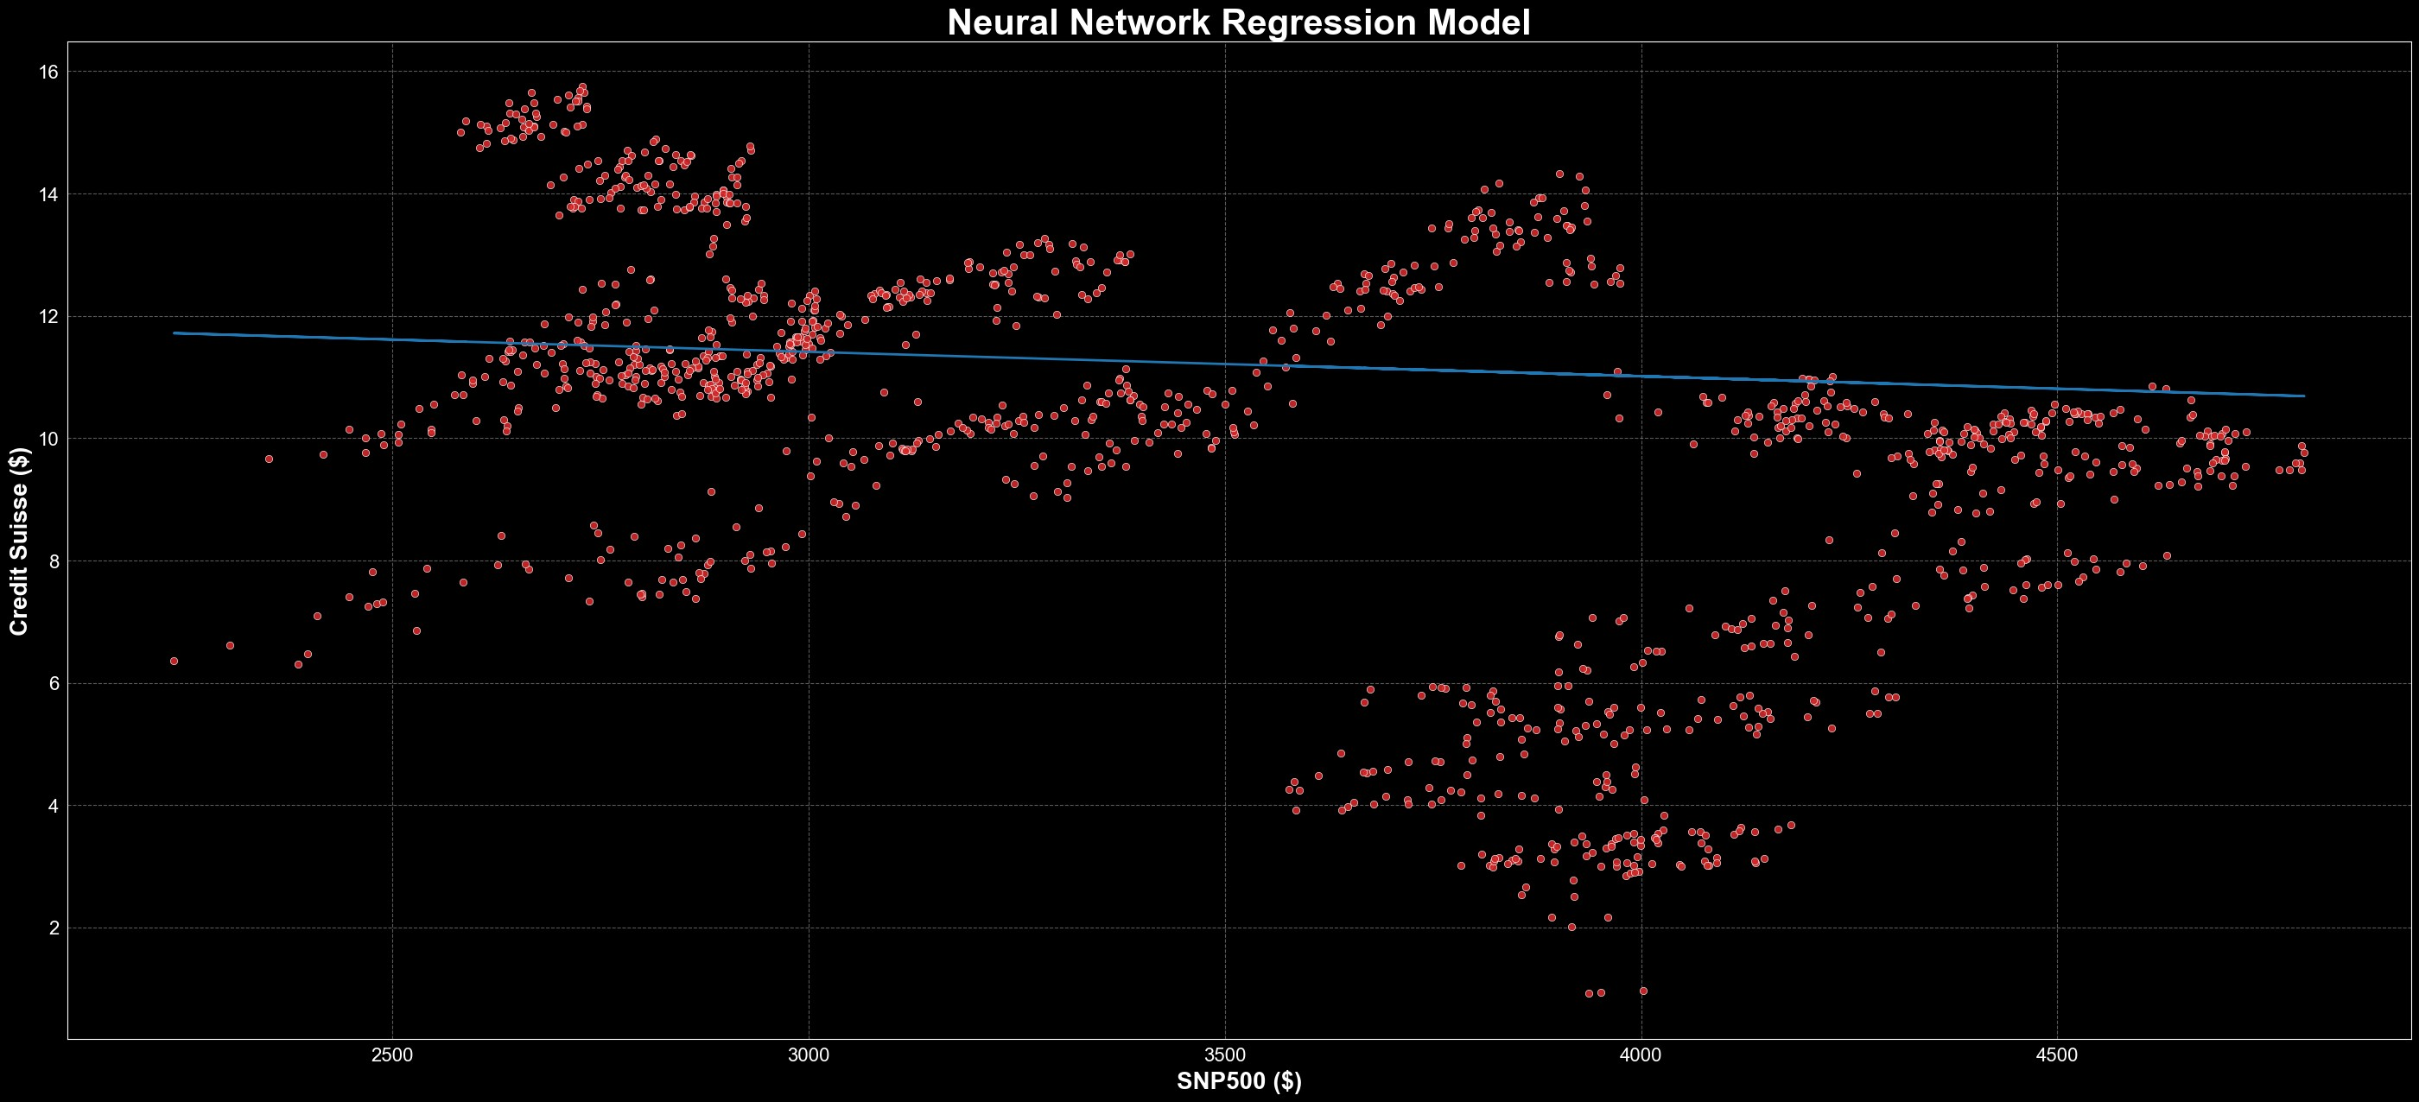

Neural Network shows slightly little downward correlation between SNP500 and Credit suisse. neural network model is not the best way to determine if there is a correlation between two variables. A better way to do this is through a correlation analysis or linear regression analysis.

## CREDIT SUISSE & FTSE100

In [151…

credit_suisse **=** yf**.**Ticker("CS")**.**history(period**=**"5y") ftse100 **=** yf**.**Ticker("^FTSE")**.**history(period**=**"5y")

In [152…

**from** forex_python.converter **import** CurrencyRates

In [153…

c **=** CurrencyRates()

exchange_rate **=** c**.**get_rate('USD', 'GBP')

credit_suisse["Close"] **=** credit_suisse["Close"] **\*** exchange_rate credit_suisse["Open"] **=** credit_suisse["Open"] **\*** exchange_rate credit_suisse["High"] **=** credit_suisse["High"] **\*** exchange_rate credit_suisse["Low"] **=** credit_suisse["Low"] **\*** exchange_rate

In [154…

*# Preprocess the data by extracting the "Close" prices for Credit Suisse*

y **=** credit_suisse["Close"]**.**values

x **=** ftse100["Close"]**.**values**.**reshape(**-**1, 1)

In [155…

y**.**shape

Out[155]: (1258,) In [156…

x**.**shape

Out[156]: (1262, 1)

In [157…

x **=** x[4:]

x**.**shape

Out[157]: (1258, 1) In [158…

**from** keras.layers **import** Dense, Dropout

In [159…

*# Initialize the neural network model*

model **=** Sequential()

model**.**add(Dense(64, input_shape**=**(1,), activation**=**'relu')) model**.**add(Dropout(0.2))

model**.**add(Dense(128, activation**=**'relu')) model**.**add(Dropout(0.2)) model**.**add(Dense(256, activation**=**'relu')) model**.**add(Dropout(0.2)) model**.**add(Dense(1, activation**=**'linear'))

In [160…

*# Compile the model*

model**.**compile(optimizer**=**'adam', loss**=**'mean_squared_error')

*# Train the model*

model**.**fit(x, y, epochs**=**250, batch_size**=**32, verbose**=**1)

|  |  |  |  |  |  |
| --- | --- | --- | --- | --- | --- |
| Epoch | 1/250 |  | | | |
| 40/40 | [==============================] | - 1s | 2ms/step | - loss: | 112108.1875 |
| Epoch | 2/250 |  |  |  |  |
| 40/40 | [==============================] | - 0s | 2ms/step | - loss: | 24145.7812 |
| Epoch | 3/250 |  |  |  |  |
| 40/40 | [==============================] | - 0s | 2ms/step | - loss: | 12658.5410 |
| Epoch | 4/250 |  |  |  |  |
| 40/40 | [==============================] | - 0s | 2ms/step | - loss: | 9162.3779 |
| Epoch | 5/250 |  |  |  |  |
| 40/40 | [==============================] | - 0s | 2ms/step | - loss: | 6844.7734 |
| Epoch | 6/250 |  |  |  |  |
| 40/40 | [==============================] | - 0s | 2ms/step | - loss: | 5425.7324 |
| Epoch | 7/250 |  |  |  |  |
| 40/40 | [==============================] | - 0s | 2ms/step | - loss: | 3857.2588 |
| Epoch | 8/250 |  |  |  |  |
| 40/40 | [==============================] | - 0s | 2ms/step | - loss: | 2906.1746 |
| Epoch | 9/250 |  |  |  |  |
| 40/40 | [==============================] | - 0s | 2ms/step | - loss: | 2298.6489 |
| Epoch | 10/250 |  |  |  |  |
| 40/40 | [==============================] | - 0s | 2ms/step | - loss: | 1898.8218 |
| Epoch | 11/250 |  |  |  |  |
| 40/40 | [==============================] | - 0s | 2ms/step | - loss: | 1353.1500 |
| Epoch | 12/250 |  |  |  |  |
| 40/40 | [==============================] | - 0s | 2ms/step | - loss: | 933.7247 |
| Epoch | 13/250 |  |  |  |  |
| 40/40 | [==============================] | - 0s | 3ms/step | - loss: | 783.3883 |
| Epoch | 14/250 |  |  |  |  |
| 40/40 | [==============================] | - 0s | 2ms/step | - loss: | 600.6353 |

|  |  |  |  |  |  |
| --- | --- | --- | --- | --- | --- |
| Epoch  40/40 | 15/250  [==============================] | - 0s | 2ms/step | - loss: | 516.9771 |
| Epoch | 16/250 |  |  |  |  |
| 40/40 | [==============================] | - 0s | 2ms/step | - loss: | 355.8154 |
| Epoch | 17/250 |  |  |  |  |
| 40/40 | [==============================] | - 0s | 3ms/step | - loss: | 297.3196 |
| Epoch | 18/250 |  |  |  |  |
| 40/40 | [==============================] | - 0s | 2ms/step | - loss: | 260.0709 |
| Epoch | 19/250 |  |  |  |  |
| 40/40 | [==============================] | - 0s | 2ms/step | - loss: | 230.9619 |
| Epoch | 20/250 |  |  |  |  |
| 40/40 | [==============================] | - 0s | 2ms/step | - loss: | 199.2812 |
| Epoch | 21/250 |  |  |  |  |
| 40/40 | [==============================] | - 0s | 2ms/step | - loss: | 157.5069 |
| Epoch | 22/250 |  |  |  |  |
| 40/40 | [==============================] | - 0s | 3ms/step | - loss: | 133.6286 |
| Epoch | 23/250 |  |  |  |  |
| 40/40 | [==============================] | - 0s | 2ms/step | - loss: | 128.6620 |
| Epoch | 24/250 |  |  |  |  |
| 40/40 | [==============================] | - 0s | 2ms/step | - loss: | 91.5371 |
| Epoch | 25/250 |  |  |  |  |
| 40/40 | [==============================] | - 0s | 2ms/step | - loss: | 93.5894 |
| Epoch | 26/250 |  |  |  |  |
| 40/40 | [==============================] | - 0s | 3ms/step | - loss: | 80.8802 |
| Epoch | 27/250 |  |  |  |  |
| 40/40 | [==============================] | - 0s | 2ms/step | - loss: | 62.4284 |
| Epoch | 28/250 |  |  |  |  |
| 40/40 | [==============================] | - 0s | 3ms/step | - loss: | 63.1368 |
| Epoch | 29/250 |  |  |  |  |
| 40/40 | [==============================] | - 0s | 2ms/step | - loss: | 59.8204 |
| Epoch | 30/250 |  |  |  |  |
| 40/40 | [==============================] | - 0s | 2ms/step | - loss: | 50.1905 |
| Epoch | 31/250 |  |  |  |  |
| 40/40 | [==============================] | - 0s | 2ms/step | - loss: | 53.0755 |
| Epoch | 32/250 |  |  |  |  |
| 40/40 | [==============================] | - 0s | 2ms/step | - loss: | 47.4847 |
| Epoch | 33/250 |  |  |  |  |
| 40/40 | [==============================] | - 0s | 2ms/step | - loss: | 37.1428 |
| Epoch | 34/250 |  |  |  |  |
| 40/40 | [==============================] | - 0s | 2ms/step | - loss: | 30.9005 |
| Epoch | 35/250 |  |  |  |  |
| 40/40 | [==============================] | - 0s | 2ms/step | - loss: | 34.6390 |
| Epoch | 36/250 |  |  |  |  |
| 40/40 | [==============================] | - 0s | 2ms/step | - loss: | 33.7869 |
| Epoch | 37/250 |  |  |  |  |
| 40/40 | [==============================] | - 0s | 2ms/step | - loss: | 30.8541 |
| Epoch | 38/250 |  |  |  |  |
| 40/40 | [==============================] | - 0s | 2ms/step | - loss: | 25.9107 |
| Epoch | 39/250 |  |  |  |  |
| 40/40 | [==============================] | - 0s | 2ms/step | - loss: | 28.3282 |
| Epoch | 40/250 |  |  |  |  |
| 40/40 | [==============================] | - 0s | 2ms/step | - loss: | 31.3064 |
| Epoch | 41/250 |  |  |  |  |
| 40/40 | [==============================] | - 0s | 2ms/step | - loss: | 27.9882 |
| Epoch | 42/250 |  |  |  |  |
| 40/40 | [==============================] | - 0s | 2ms/step | - loss: | 30.1238 |
| Epoch | 43/250 |  |  |  |  |

|  |  |  |  |  |  |
| --- | --- | --- | --- | --- | --- |
| 40/40 | [==============================] | - 0s | 2ms/step | - loss: | 32.7356 |
| Epoch | 44/250 |  |  |  |  |
| 40/40 | [==============================] | - 0s | 2ms/step | - loss: | 26.4706 |
| Epoch | 45/250 |  |  |  |  |
| 40/40 | [==============================] | - 0s | 2ms/step | - loss: | 29.0070 |
| Epoch | 46/250 |  |  |  |  |
| 40/40 | [==============================] | - 0s | 2ms/step | - loss: | 28.5526 |
| Epoch | 47/250 |  |  |  |  |
| 40/40 | [==============================] | - 0s | 3ms/step | - loss: | 28.1488 |
| Epoch | 48/250 |  |  |  |  |
| 40/40 | [==============================] | - 0s | 2ms/step | - loss: | 22.5964 |
| Epoch | 49/250 |  |  |  |  |
| 40/40 | [==============================] | - 0s | 2ms/step | - loss: | 24.3917 |
| Epoch | 50/250 |  |  |  |  |
| 40/40 | [==============================] | - 0s | 2ms/step | - loss: | 26.4382 |
| Epoch | 51/250 |  |  |  |  |
| 40/40 | [==============================] | - 0s | 3ms/step | - loss: | 21.5413 |
| Epoch | 52/250 |  |  |  |  |
| 40/40 | [==============================] | - 0s | 2ms/step | - loss: | 33.2938 |
| Epoch | 53/250 |  |  |  |  |
| 40/40 | [==============================] | - 0s | 2ms/step | - loss: | 24.6699 |
| Epoch | 54/250 |  |  |  |  |
| 40/40 | [==============================] | - 0s | 2ms/step | - loss: | 25.8763 |
| Epoch | 55/250 |  |  |  |  |
| 40/40 | [==============================] | - 0s | 4ms/step | - loss: | 24.3169 |
| Epoch | 56/250 |  |  |  |  |
| 40/40 | [==============================] | - 0s | 3ms/step | - loss: | 18.4116 |
| Epoch | 57/250 |  |  |  |  |
| 40/40 | [==============================] | - 0s | 2ms/step | - loss: | 29.6184 |
| Epoch | 58/250 |  |  |  |  |
| 40/40 | [==============================] | - 0s | 2ms/step | - loss: | 21.4903 |
| Epoch | 59/250 |  |  |  |  |
| 40/40 | [==============================] | - 0s | 2ms/step | - loss: | 18.3270 |
| Epoch | 60/250 |  |  |  |  |
| 40/40 | [==============================] | - 0s | 2ms/step | - loss: | 24.7928 |
| Epoch | 61/250 |  |  |  |  |
| 40/40 | [==============================] | - 0s | 3ms/step | - loss: | 26.9117 |
| Epoch | 62/250 |  |  |  |  |
| 40/40 | [==============================] | - 0s | 3ms/step | - loss: | 14.1537 |
| Epoch | 63/250 |  |  |  |  |
| 40/40 | [==============================] | - 0s | 2ms/step | - loss: | 15.1278 |
| Epoch | 64/250 |  |  |  |  |
| 40/40 | [==============================] | - 0s | 2ms/step | - loss: | 14.5849 |
| Epoch | 65/250 |  |  |  |  |
| 40/40 | [==============================] | - 0s | 2ms/step | - loss: | 22.0244 |
| Epoch | 66/250 |  |  |  |  |
| 40/40 | [==============================] | - 0s | 2ms/step | - loss: | 17.1629 |
| Epoch | 67/250 |  |  |  |  |
| 40/40 | [==============================] | - 0s | 2ms/step | - loss: | 18.8494 |
| Epoch | 68/250 |  |  |  |  |
| 40/40 | [==============================] | - 0s | 2ms/step | - loss: | 21.8502 |
| Epoch | 69/250 |  |  |  |  |
| 40/40 | [==============================] | - 0s | 2ms/step | - loss: | 14.7913 |
| Epoch | 70/250 |  |  |  |  |
| 40/40 | [==============================] | - 0s | 2ms/step | - loss: | 17.7023 |
| Epoch | 71/250 |  |  |  |  |
| 40/40 | [==============================] | - 0s | 2ms/step | - loss: | 19.3665 |

|  |  |  |  |  |  |
| --- | --- | --- | --- | --- | --- |
| Epoch  40/40 | 72/250  [==============================] | - 0s | 3ms/step | - loss: | 15.8987 |
| Epoch | 73/250 |  |  |  |  |
| 40/40 | [==============================] | - 0s | 2ms/step | - loss: | 15.0903 |
| Epoch | 74/250 |  |  |  |  |
| 40/40 | [==============================] | - 0s | 2ms/step | - loss: | 20.0167 |
| Epoch | 75/250 |  |  |  |  |
| 40/40 | [==============================] | - 0s | 2ms/step | - loss: | 14.8186 |
| Epoch | 76/250 |  |  |  |  |
| 40/40 | [==============================] | - 0s | 2ms/step | - loss: | 24.2631 |
| Epoch | 77/250 |  |  |  |  |
| 40/40 | [==============================] | - 0s | 2ms/step | - loss: | 24.3613 |
| Epoch | 78/250 |  |  |  |  |
| 40/40 | [==============================] | - 0s | 2ms/step | - loss: | 19.6638 |
| Epoch | 79/250 |  |  |  |  |
| 40/40 | [==============================] | - 0s | 3ms/step | - loss: | 16.7904 |
| Epoch | 80/250 |  |  |  |  |
| 40/40 | [==============================] | - 0s | 4ms/step | - loss: | 14.7545 |
| Epoch | 81/250 |  |  |  |  |
| 40/40 | [==============================] | - 0s | 2ms/step | - loss: | 20.6851 |
| Epoch | 82/250 |  |  |  |  |
| 40/40 | [==============================] | - 0s | 2ms/step | - loss: | 17.8511 |
| Epoch | 83/250 |  |  |  |  |
| 40/40 | [==============================] | - 0s | 3ms/step | - loss: | 17.4584 |
| Epoch | 84/250 |  |  |  |  |
| 40/40 | [==============================] | - 0s | 2ms/step | - loss: | 19.4125 |
| Epoch | 85/250 |  |  |  |  |
| 40/40 | [==============================] | - 0s | 2ms/step | - loss: | 14.7660 |
| Epoch | 86/250 |  |  |  |  |
| 40/40 | [==============================] | - 0s | 2ms/step | - loss: | 12.9025 |
| Epoch | 87/250 |  |  |  |  |
| 40/40 | [==============================] | - 0s | 2ms/step | - loss: | 18.9702 |
| Epoch | 88/250 |  |  |  |  |
| 40/40 | [==============================] | - 0s | 2ms/step | - loss: | 16.7888 |
| Epoch | 89/250 |  |  |  |  |
| 40/40 | [==============================] | - 0s | 2ms/step | - loss: | 13.6761 |
| Epoch | 90/250 |  |  |  |  |
| 40/40 | [==============================] | - 0s | 2ms/step | - loss: | 12.5549 |
| Epoch | 91/250 |  |  |  |  |
| 40/40 | [==============================] | - 0s | 2ms/step | - loss: | 12.3058 |
| Epoch | 92/250 |  |  |  |  |
| 40/40 | [==============================] | - 0s | 2ms/step | - loss: | 14.9316 |
| Epoch | 93/250 |  |  |  |  |
| 40/40 | [==============================] | - 0s | 3ms/step | - loss: | 15.9552 |
| Epoch | 94/250 |  |  |  |  |
| 40/40 | [==============================] | - 0s | 2ms/step | - loss: | 17.2473 |
| Epoch | 95/250 |  |  |  |  |
| 40/40 | [==============================] | - 0s | 2ms/step | - loss: | 12.7825 |
| Epoch | 96/250 |  |  |  |  |
| 40/40 | [==============================] | - 0s | 2ms/step | - loss: | 14.9940 |
| Epoch | 97/250 |  |  |  |  |
| 40/40 | [==============================] | - 0s | 3ms/step | - loss: | 26.8107 |
| Epoch | 98/250 |  |  |  |  |
| 40/40 | [==============================] | - 0s | 2ms/step | - loss: | 12.4374 |
| Epoch | 99/250 |  |  |  |  |
| 40/40 | [==============================] | - 0s | 2ms/step | - loss: | 15.2540 |
| Epoch | 100/250 |  |  |  |  |

|  |  |  |  |  |  |
| --- | --- | --- | --- | --- | --- |
| 40/40 | [==============================] | - 0s | 2ms/step | - loss: | 13.9344 |
| Epoch | 101/250 |  |  |  |  |
| 40/40 | [==============================] | - 0s | 2ms/step | - loss: | 16.1804 |
| Epoch | 102/250 |  |  |  |  |
| 40/40 | [==============================] | - 0s | 2ms/step | - loss: | 12.5823 |
| Epoch | 103/250 |  |  |  |  |
| 40/40 | [==============================] | - 0s | 2ms/step | - loss: | 16.2969 |
| Epoch | 104/250 |  |  |  |  |
| 40/40 | [==============================] | - 0s | 3ms/step | - loss: | 11.5930 |
| Epoch | 105/250 |  |  |  |  |
| 40/40 | [==============================] | - 0s | 2ms/step | - loss: | 12.1515 |
| Epoch | 106/250 |  |  |  |  |
| 40/40 | [==============================] | - 0s | 2ms/step | - loss: | 14.5696 |
| Epoch | 107/250 |  |  |  |  |
| 40/40 | [==============================] | - 0s | 2ms/step | - loss: | 11.0423 |
| Epoch | 108/250 |  |  |  |  |
| 40/40 | [==============================] | - 0s | 2ms/step | - loss: | 13.1002 |
| Epoch | 109/250 |  |  |  |  |
| 40/40 | [==============================] | - 0s | 2ms/step | - loss: | 13.1287 |
| Epoch | 110/250 |  |  |  |  |
| 40/40 | [==============================] | - 0s | 2ms/step | - loss: | 13.7187 |
| Epoch | 111/250 |  |  |  |  |
| 40/40 | [==============================] | - 0s | 2ms/step | - loss: | 11.1524 |
| Epoch | 112/250 |  |  |  |  |
| 40/40 | [==============================] | - 0s | 2ms/step | - loss: | 11.6636 |
| Epoch | 113/250 |  |  |  |  |
| 40/40 | [==============================] | - 0s | 3ms/step | - loss: | 12.0611 |
| Epoch | 114/250 |  |  |  |  |
| 40/40 | [==============================] | - 0s | 2ms/step | - loss: | 12.6403 |
| Epoch | 115/250 |  |  |  |  |
| 40/40 | [==============================] | - 0s | 3ms/step | - loss: | 12.3370 |
| Epoch | 116/250 |  |  |  |  |
| 40/40 | [==============================] | - 0s | 2ms/step | - loss: | 12.7986 |
| Epoch | 117/250 |  |  |  |  |
| 40/40 | [==============================] | - 0s | 2ms/step | - loss: | 14.8276 |
| Epoch | 118/250 |  |  |  |  |
| 40/40 | [==============================] | - 0s | 2ms/step | - loss: | 15.6242 |
| Epoch | 119/250 |  |  |  |  |
| 40/40 | [==============================] | - 0s | 2ms/step | - loss: | 9.9763 |
| Epoch | 120/250 |  |  |  |  |
| 40/40 | [==============================] | - 0s | 2ms/step | - loss: | 12.8535 |
| Epoch | 121/250 |  |  |  |  |
| 40/40 | [==============================] | - 0s | 2ms/step | - loss: | 12.9085 |
| Epoch | 122/250 |  |  |  |  |
| 40/40 | [==============================] | - 0s | 2ms/step | - loss: | 10.4671 |
| Epoch | 123/250 |  |  |  |  |
| 40/40 | [==============================] | - 0s | 4ms/step | - loss: | 12.2869 |
| Epoch | 124/250 |  |  |  |  |
| 40/40 | [==============================] | - 0s | 2ms/step | - loss: | 11.7275 |
| Epoch | 125/250 |  |  |  |  |
| 40/40 | [==============================] | - 0s | 3ms/step | - loss: | 11.6791 |
| Epoch | 126/250 |  |  |  |  |
| 40/40 | [==============================] | - 0s | 2ms/step | - loss: | 12.6186 |
| Epoch | 127/250 |  |  |  |  |
| 40/40 | [==============================] | - 0s | 2ms/step | - loss: | 12.5605 |
| Epoch | 128/250 |  |  |  |  |
| 40/40 | [==============================] | - 0s | 3ms/step | - loss: | 11.6494 |

|  |  |  |  |  |  |
| --- | --- | --- | --- | --- | --- |
| Epoch  40/40 | 129/250  [==============================] | - 0s | 2ms/step | - loss: | 15.8437 |
| Epoch | 130/250 |  |  |  |  |
| 40/40 | [==============================] | - 0s | 2ms/step | - loss: | 11.5068 |
| Epoch | 131/250 |  |  |  |  |
| 40/40 | [==============================] | - 0s | 2ms/step | - loss: | 11.3558 |
| Epoch | 132/250 |  |  |  |  |
| 40/40 | [==============================] | - 0s | 3ms/step | - loss: | 10.4703 |
| Epoch | 133/250 |  |  |  |  |
| 40/40 | [==============================] | - 0s | 2ms/step | - loss: | 10.3163 |
| Epoch | 134/250 |  |  |  |  |
| 40/40 | [==============================] | - 0s | 2ms/step | - loss: | 10.3389 |
| Epoch | 135/250 |  |  |  |  |
| 40/40 | [==============================] | - 0s | 2ms/step | - loss: | 11.0496 |
| Epoch | 136/250 |  |  |  |  |
| 40/40 | [==============================] | - 0s | 2ms/step | - loss: | 10.7497 |
| Epoch | 137/250 |  |  |  |  |
| 40/40 | [==============================] | - 0s | 2ms/step | - loss: | 11.0689 |
| Epoch | 138/250 |  |  |  |  |
| 40/40 | [==============================] | - 0s | 3ms/step | - loss: | 10.9875 |
| Epoch | 139/250 |  |  |  |  |
| 40/40 | [==============================] | - 0s | 3ms/step | - loss: | 11.6130 |
| Epoch | 140/250 |  |  |  |  |
| 40/40 | [==============================] | - 0s | 2ms/step | - loss: | 10.8864 |
| Epoch | 141/250 |  |  |  |  |
| 40/40 | [==============================] | - 0s | 2ms/step | - loss: | 11.9314 |
| Epoch | 142/250 |  |  |  |  |
| 40/40 | [==============================] | - 0s | 2ms/step | - loss: | 12.4327 |
| Epoch | 143/250 |  |  |  |  |
| 40/40 | [==============================] | - 0s | 3ms/step | - loss: | 14.6726 |
| Epoch | 144/250 |  |  |  |  |
| 40/40 | [==============================] | - 0s | 2ms/step | - loss: | 12.5369 |
| Epoch | 145/250 |  |  |  |  |
| 40/40 | [==============================] | - 0s | 2ms/step | - loss: | 10.1776 |
| Epoch | 146/250 |  |  |  |  |
| 40/40 | [==============================] | - 0s | 2ms/step | - loss: | 10.1378 |
| Epoch | 147/250 |  |  |  |  |
| 40/40 | [==============================] | - 0s | 3ms/step | - loss: | 10.6622 |
| Epoch | 148/250 |  |  |  |  |
| 40/40 | [==============================] | - 0s | 2ms/step | - loss: | 10.9564 |
| Epoch | 149/250 |  |  |  |  |
| 40/40 | [==============================] | - 0s | 2ms/step | - loss: | 11.7159 |
| Epoch | 150/250 |  |  |  |  |
| 40/40 | [==============================] | - 0s | 2ms/step | - loss: | 10.5266 |
| Epoch | 151/250 |  |  |  |  |
| 40/40 | [==============================] | - 0s | 3ms/step | - loss: | 13.2002 |
| Epoch | 152/250 |  |  |  |  |
| 40/40 | [==============================] | - 0s | 2ms/step | - loss: | 10.6198 |
| Epoch | 153/250 |  |  |  |  |
| 40/40 | [==============================] | - 0s | 3ms/step | - loss: | 11.9776 |
| Epoch | 154/250 |  |  |  |  |
| 40/40 | [==============================] | - 0s | 2ms/step | - loss: | 10.4010 |
| Epoch | 155/250 |  |  |  |  |
| 40/40 | [==============================] | - 0s | 2ms/step | - loss: | 10.6400 |
| Epoch | 156/250 |  |  |  |  |
| 40/40 | [==============================] | - 0s | 3ms/step | - loss: | 10.0758 |
| Epoch | 157/250 |  |  |  |  |

|  |  |  |  |  |  |
| --- | --- | --- | --- | --- | --- |
| 40/40 | [==============================] | - 0s | 2ms/step | - loss: | 11.0498 |
| Epoch | 158/250 |  |  |  |  |
| 40/40 | [==============================] | - 0s | 2ms/step | - loss: | 11.1585 |
| Epoch | 159/250 |  |  |  |  |
| 40/40 | [==============================] | - 0s | 2ms/step | - loss: | 9.7133 |
| Epoch | 160/250 |  |  |  |  |
| 40/40 | [==============================] | - 0s | 2ms/step | - loss: | 10.2849 |
| Epoch | 161/250 |  |  |  |  |
| 40/40 | [==============================] | - 0s | 3ms/step | - loss: | 10.9232 |
| Epoch | 162/250 |  |  |  |  |
| 40/40 | [==============================] | - 0s | 2ms/step | - loss: | 10.5189 |
| Epoch | 163/250 |  |  |  |  |
| 40/40 | [==============================] | - 0s | 3ms/step | - loss: | 10.1461 |
| Epoch | 164/250 |  |  |  |  |
| 40/40 | [==============================] | - 0s | 2ms/step | - loss: | 12.1645 |
| Epoch | 165/250 |  |  |  |  |
| 40/40 | [==============================] | - 0s | 2ms/step | - loss: | 10.8810 |
| Epoch | 166/250 |  |  |  |  |
| 40/40 | [==============================] | - 0s | 3ms/step | - loss: | 9.9378 |
| Epoch | 167/250 |  |  |  |  |
| 40/40 | [==============================] | - 0s | 2ms/step | - loss: | 14.3815 |
| Epoch | 168/250 |  |  |  |  |
| 40/40 | [==============================] | - 0s | 2ms/step | - loss: | 11.2885 |
| Epoch | 169/250 |  |  |  |  |
| 40/40 | [==============================] | - 0s | 4ms/step | - loss: | 10.8374 |
| Epoch | 170/250 |  |  |  |  |
| 40/40 | [==============================] | - 0s | 4ms/step | - loss: | 10.7823 |
| Epoch | 171/250 |  |  |  |  |
| 40/40 | [==============================] | - 0s | 3ms/step | - loss: | 10.1916 |
| Epoch | 172/250 |  |  |  |  |
| 40/40 | [==============================] | - 0s | 3ms/step | - loss: | 10.9079 |
| Epoch | 173/250 |  |  |  |  |
| 40/40 | [==============================] | - 0s | 2ms/step | - loss: | 10.6876 |
| Epoch | 174/250 |  |  |  |  |
| 40/40 | [==============================] | - 0s | 2ms/step | - loss: | 9.9753 |
| Epoch | 175/250 |  |  |  |  |
| 40/40 | [==============================] | - 0s | 2ms/step | - loss: | 11.1332 |
| Epoch | 176/250 |  |  |  |  |
| 40/40 | [==============================] | - 0s | 2ms/step | - loss: | 9.6604 |
| Epoch | 177/250 |  |  |  |  |
| 40/40 | [==============================] | - 0s | 3ms/step | - loss: | 10.3471 |
| Epoch | 178/250 |  |  |  |  |
| 40/40 | [==============================] | - 0s | 2ms/step | - loss: | 10.0717 |
| Epoch | 179/250 |  |  |  |  |
| 40/40 | [==============================] | - 0s | 3ms/step | - loss: | 9.7601 |
| Epoch | 180/250 |  |  |  |  |
| 40/40 | [==============================] | - 0s | 2ms/step | - loss: | 9.9894 |
| Epoch | 181/250 |  |  |  |  |
| 40/40 | [==============================] | - 0s | 2ms/step | - loss: | 14.6059 |
| Epoch | 182/250 |  |  |  |  |
| 40/40 | [==============================] | - 0s | 2ms/step | - loss: | 10.5480 |
| Epoch | 183/250 |  |  |  |  |
| 40/40 | [==============================] | - 0s | 2ms/step | - loss: | 9.6687 |
| Epoch | 184/250 |  |  |  |  |
| 40/40 | [==============================] | - 0s | 2ms/step | - loss: | 9.9771 |
| Epoch | 185/250 |  |  |  |  |
| 40/40 | [==============================] | - 0s | 3ms/step | - loss: | 9.5606 |

|  |  |  |  |  |  |
| --- | --- | --- | --- | --- | --- |
| Epoch  40/40 | 186/250  [==============================] | - 0s | 3ms/step | - loss: | 10.3088 |
| Epoch | 187/250 |  |  |  |  |
| 40/40 | [==============================] | - 0s | 2ms/step | - loss: | 10.1681 |
| Epoch | 188/250 |  |  |  |  |
| 40/40 | [==============================] | - 0s | 3ms/step | - loss: | 10.7547 |
| Epoch | 189/250 |  |  |  |  |
| 40/40 | [==============================] | - 0s | 3ms/step | - loss: | 11.1517 |
| Epoch | 190/250 |  |  |  |  |
| 40/40 | [==============================] | - 0s | 2ms/step | - loss: | 10.7906 |
| Epoch | 191/250 |  |  |  |  |
| 40/40 | [==============================] | - 0s | 2ms/step | - loss: | 10.2115 |
| Epoch | 192/250 |  |  |  |  |
| 40/40 | [==============================] | - 0s | 3ms/step | - loss: | 10.6327 |
| Epoch | 193/250 |  |  |  |  |
| 40/40 | [==============================] | - 0s | 2ms/step | - loss: | 9.6791 |
| Epoch | 194/250 |  |  |  |  |
| 40/40 | [==============================] | - 0s | 3ms/step | - loss: | 11.1618 |
| Epoch | 195/250 |  |  |  |  |
| 40/40 | [==============================] | - 0s | 2ms/step | - loss: | 10.7405 |
| Epoch | 196/250 |  |  |  |  |
| 40/40 | [==============================] | - 0s | 2ms/step | - loss: | 10.1283 |
| Epoch | 197/250 |  |  |  |  |
| 40/40 | [==============================] | - 0s | 2ms/step | - loss: | 11.2806 |
| Epoch | 198/250 |  |  |  |  |
| 40/40 | [==============================] | - 0s | 3ms/step | - loss: | 9.8216 |
| Epoch | 199/250 |  |  |  |  |
| 40/40 | [==============================] | - 0s | 2ms/step | - loss: | 9.1689 |
| Epoch | 200/250 |  |  |  |  |
| 40/40 | [==============================] | - 0s | 3ms/step | - loss: | 11.1139 |
| Epoch | 201/250 |  |  |  |  |
| 40/40 | [==============================] | - 0s | 2ms/step | - loss: | 11.0455 |
| Epoch | 202/250 |  |  |  |  |
| 40/40 | [==============================] | - 0s | 2ms/step | - loss: | 10.0862 |
| Epoch | 203/250 |  |  |  |  |
| 40/40 | [==============================] | - 0s | 2ms/step | - loss: | 10.4113 |
| Epoch | 204/250 |  |  |  |  |
| 40/40 | [==============================] | - 0s | 3ms/step | - loss: | 9.8511 |
| Epoch | 205/250 |  |  |  |  |
| 40/40 | [==============================] | - 0s | 2ms/step | - loss: | 9.8214 |
| Epoch | 206/250 |  |  |  |  |
| 40/40 | [==============================] | - 0s | 2ms/step | - loss: | 9.6006 |
| Epoch | 207/250 |  |  |  |  |
| 40/40 | [==============================] | - 0s | 2ms/step | - loss: | 9.6381 |
| Epoch | 208/250 |  |  |  |  |
| 40/40 | [==============================] | - 0s | 4ms/step | - loss: | 11.0725 |
| Epoch | 209/250 |  |  |  |  |
| 40/40 | [==============================] | - 0s | 2ms/step | - loss: | 9.1599 |
| Epoch | 210/250 |  |  |  |  |
| 40/40 | [==============================] | - 0s | 2ms/step | - loss: | 10.2337 |
| Epoch | 211/250 |  |  |  |  |
| 40/40 | [==============================] | - 0s | 3ms/step | - loss: | 9.5471 |
| Epoch | 212/250 |  |  |  |  |
| 40/40 | [==============================] | - 0s | 3ms/step | - loss: | 9.7818 |
| Epoch | 213/250 |  |  |  |  |
| 40/40 | [==============================] | - 0s | 2ms/step | - loss: | 9.7196 |
| Epoch | 214/250 |  |  |  |  |

|  |  |  |  |  |  |
| --- | --- | --- | --- | --- | --- |
| 40/40 | [==============================] | - 0s | 3ms/step | - loss: | 10.9514 |
| Epoch | 215/250 |  |  |  |  |
| 40/40 | [==============================] | - 0s | 2ms/step | - loss: | 9.9404 |
| Epoch | 216/250 |  |  |  |  |
| 40/40 | [==============================] | - 0s | 2ms/step | - loss: | 10.0737 |
| Epoch | 217/250 |  |  |  |  |
| 40/40 | [==============================] | - 0s | 2ms/step | - loss: | 9.5830 |
| Epoch | 218/250 |  |  |  |  |
| 40/40 | [==============================] | - 0s | 3ms/step | - loss: | 9.4898 |
| Epoch | 219/250 |  |  |  |  |
| 40/40 | [==============================] | - 0s | 2ms/step | - loss: | 9.2166 |
| Epoch | 220/250 |  |  |  |  |
| 40/40 | [==============================] | - 0s | 2ms/step | - loss: | 9.9661 |
| Epoch | 221/250 |  |  |  |  |
| 40/40 | [==============================] | - 0s | 3ms/step | - loss: | 9.7176 |
| Epoch | 222/250 |  |  |  |  |
| 40/40 | [==============================] | - 0s | 3ms/step | - loss: | 10.2947 |
| Epoch | 223/250 |  |  |  |  |
| 40/40 | [==============================] | - 0s | 2ms/step | - loss: | 9.6951 |
| Epoch | 224/250 |  |  |  |  |
| 40/40 | [==============================] | - 0s | 2ms/step | - loss: | 10.4189 |
| Epoch | 225/250 |  |  |  |  |
| 40/40 | [==============================] | - 0s | 3ms/step | - loss: | 10.3410 |
| Epoch | 226/250 |  |  |  |  |
| 40/40 | [==============================] | - 0s | 2ms/step | - loss: | 10.2860 |
| Epoch | 227/250 |  |  |  |  |
| 40/40 | [==============================] | - 0s | 2ms/step | - loss: | 9.9784 |
| Epoch | 228/250 |  |  |  |  |
| 40/40 | [==============================] | - 0s | 2ms/step | - loss: | 9.5284 |
| Epoch | 229/250 |  |  |  |  |
| 40/40 | [==============================] | - 0s | 2ms/step | - loss: | 10.1875 |
| Epoch | 230/250 |  |  |  |  |
| 40/40 | [==============================] | - 0s | 2ms/step | - loss: | 9.4595 |
| Epoch | 231/250 |  |  |  |  |
| 40/40 | [==============================] | - 0s | 2ms/step | - loss: | 9.2250 |
| Epoch | 232/250 |  |  |  |  |
| 40/40 | [==============================] | - 0s | 2ms/step | - loss: | 9.4933 |
| Epoch | 233/250 |  |  |  |  |
| 40/40 | [==============================] | - 0s | 2ms/step | - loss: | 9.6681 |
| Epoch | 234/250 |  |  |  |  |
| 40/40 | [==============================] | - 0s | 3ms/step | - loss: | 9.1024 |
| Epoch | 235/250 |  |  |  |  |
| 40/40 | [==============================] | - 0s | 3ms/step | - loss: | 9.0779 |
| Epoch | 236/250 |  |  |  |  |
| 40/40 | [==============================] | - 0s | 2ms/step | - loss: | 10.2677 |
| Epoch | 237/250 |  |  |  |  |
| 40/40 | [==============================] | - 0s | 2ms/step | - loss: | 9.5208 |
| Epoch | 238/250 |  |  |  |  |
| 40/40 | [==============================] | - 0s | 3ms/step | - loss: | 9.7747 |
| Epoch | 239/250 |  |  |  |  |
| 40/40 | [==============================] | - 0s | 2ms/step | - loss: | 9.0801 |
| Epoch | 240/250 |  |  |  |  |
| 40/40 | [==============================] | - 0s | 3ms/step | - loss: | 9.9712 |
| Epoch | 241/250 |  |  |  |  |
| 40/40 | [==============================] | - 0s | 2ms/step | - loss: | 9.2375 |
| Epoch | 242/250 |  |  |  |  |
| 40/40 | [==============================] | - 0s | 2ms/step | - loss: | 9.1576 |

|  |  |  |  |  |  |
| --- | --- | --- | --- | --- | --- |
| Epoch  40/40 | 243/250  [==============================] | - 0s | 2ms/step | - loss: | 9.1194 |
| Epoch | 244/250 |  |  |  |  |
| 40/40 | [==============================] | - 0s | 4ms/step | - loss: | 9.3661 |
| Epoch | 245/250 |  |  |  |  |
| 40/40 | [==============================] | - 0s | 4ms/step | - loss: | 9.1392 |
| Epoch | 246/250 |  |  |  |  |
| 40/40 | [==============================] | - 0s | 2ms/step | - loss: | 9.1513 |
| Epoch | 247/250 |  |  |  |  |
| 40/40 | [==============================] | - 0s | 3ms/step | - loss: | 9.8605 |
| Epoch | 248/250 |  |  |  |  |
| 40/40 | [==============================] | - 0s | 3ms/step | - loss: | 9.1269 |
| Epoch | 249/250 |  |  |  |  |
| 40/40 | [==============================] | - 0s | 2ms/step | - loss: | 9.5310 |
| Epoch | 250/250 |  |  |  |  |
| 40/40 | [==============================] | - 0s | 2ms/step | - loss: | 10.7612 |

Out[160]: <keras.callbacks.History at 0x7fc8ba279a00> In [161…

*# Use the trained model to make predictions for the price of Credit Suiss*

pred_y **=** model**.**predict(x)

40/40 [==============================] - 0s 1ms/step

In [162…

plt**.**style**.**use('dark_background') plt**.**figure(figsize**=**(35,15))

sns**.**scatterplot(x**=**x**.**flatten(), y**=**y**.**flatten(), color**=**'tab:red', alpha**=**0.9) plt**.**plot(x, pred_y, color**=**'tab:blue', linewidth**=**2)

plt**.**title('Neural Network Regression Model', fontsize**=**30, color**=**"White", plt**.**xlabel("FTSE100 (£)", fontsize**=**20, fontweight**=**'bold') plt**.**ylabel("Credit Suisse (£)", fontsize**=**20, fontweight**=**'bold') plt**.**tick_params(axis**=**"both", labelsize**=**16)

plt**.**grid(linestyle**=**'--', color**=**'gray', alpha**=**0.7) plt**.**show()

